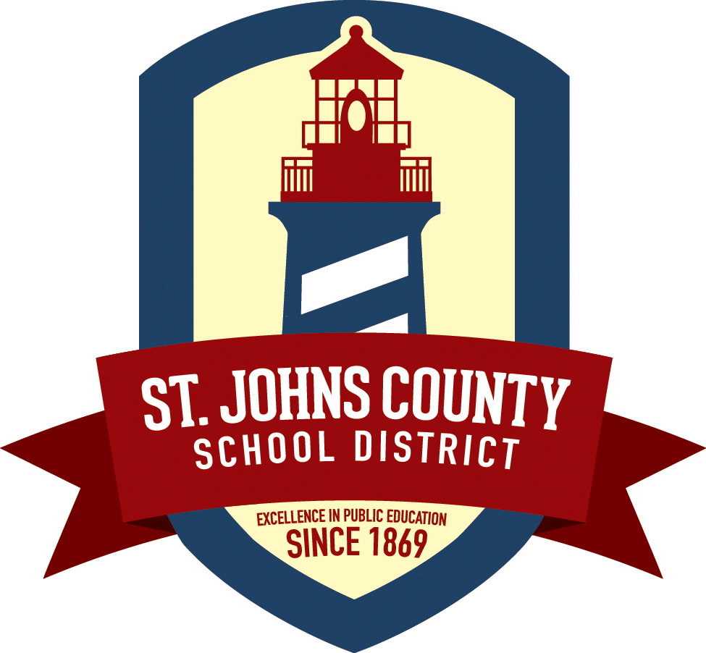

The Evelyn Hamblen Center

Gaines Alternative School

The Transition School

Patricia McMahon, Principal

Student-Parent/Guardian Compact

The Gaines and Transition Schools will provide a specialized curriculum designed to help students make attitudinal changes necessary for them to be successful both academically and socially. In order for this to occur, the student agrees to:

- I will address all staff and peers politely and display appropriate conduct.
- I will be in regular attendance.
- I will follow the dress code of the school.
- I/we will be responsible for providing school supplies every day.
- I will complete all class work and homework assignments.
- I will deliver school notices, newsletters, homework to my parents/guardian as requested by the school.
- I will abide by the school rules and regulations:
- In designated eating areas
- In the classroom
- During school functions
- When entering /leaving campus
- On school provided transportation
- I will not leave campus without permission.
- I will not possess, use or attempt to distribute any drugs/alcohol/other contraband.
- I will not fight or use physical/verbal force against anyone at any time.

I fully understand that I am responsible for my actions. Additionally, I understand that I may not return to any other school in St. Johns County until I have completed this program.

___________________________________________ ______________
Student Signature Date

I have read this compact and will support my child’s commitment to it.

____________________________________________ _______________
Parent/Guardian Signature Date

1 Christopher Street, St Augustine, FL 32084

1 Christopher Street, St Augustine, FL 32084

