The following is to ensure school-level parent and family engagement plans meet the requirements of Section 1116(b) of the Elementary and Secondary Education Act (ESEA), as amended by the Every Student Succeeds Act (ESSA)
Assurances
The above named school agrees to the following assurances:
- Involve parents of children served in Title I, Part A in decisions about how Title I Part A funds are spent;
- Carry out the programs, activities, and procedures in accordance with the definitions in Section 8101 of ESEA;
- Jointly develop/revise plan with parent and make available to the local community;
- Involve parents and families in planning, reviewing, and improving schoolwide program plan;
- Use the findings of parent and family engagement plan review to design strategies for more effective engagement, and to review, if necessary, the school’s parent and family engagement plan;
- Provide each family with timely notice information regarding their right to request information on the professional qualifications of the student’s classroom teachers and paraprofessionals;
- Notify each family, in a timely manner, when their child has been assigned, or has been taught for four or more consecutive weeks, by a teacher(s) who is out of field;
- Provide each family with an individualized student report about the performance of their child(ren) on the State assessments [ESEA Section 1116]
Mission Statement
1. Does the mission statement include:  How the parent and family engagement plan is a shared responsibility?  How the parent and family engagement plan will assist in providing high quality instruction for all learners? | The mission of Ocoee Elementary School is to lead our students to success with the support and involvement of families, community and the school. We strive to help parents and children understand all appropriate social and academic behaviors are tied to the Cardinal Code: Safe, Responsible, Respectful and Kind. Following the Cardinal Code results in all students “Focused on the Learning and Achieving Success... Everybody, Everyday”.  Parental and Family involvement is key in achieving this success. We are dedicated to working with parents and families to develop a plan for activities and workshops that support high quality instruction needed for all learners. We will host multiple curriculum nights aligned to grade level standards to model instructional strategies for home and school. Examples: Math Night, Literacy Night, FSA Night, Science Nights

Involvement of Parents
2. Does the plan include:  How the school will involve the parents and families in an organized, ongoing, and timely manner in the planning, review and improvement of Title I programs, including involvement in decision making of how funds for Title I will be used [ESEA Section 1116]? | Ocoee Elementary School believes in involving parents in all of the Title One programs. The SAC provides assistance in implementing and evaluating the various school level initiatives. More than 50% of the members of SAC are parent (non-employee) representatives. The PTA Board is made up of parents with the addition of a teacher liaison. Monthly board meetings are held to discuss parent involvement. PTA Input/Feedback is requested in the form of surveys and/or questions/answers at meetings. Parents are given the opportunity to review the parent involvement plan and offer their input prior to approval. Parents are given an extensive survey in the Spring of each school year which seeks their input on activities, training, and materials needed to help their child. Results of parent surveys are reviewed by the SAC to determine needed changes. During the SAC meeting when the PFEP and/or SIP are developed, the committee assists in the decision-making. Ocoee Elementary School will utilize multiple avenues to get information out to parents regarding various meetings and all parental involvement events. The different ways we will inform parents are: newsletters, marquee messages, messages in students' planners, Connect Orange phone messages, Classroom Dojo, and putting dates/events on our school internet and parent calendars. These events will illicit parental involvement and participation in all SAC meetings, PTA meetings, curriculum nights, Title I Annual Meeting, parent conference nights, and other school hosted events.

Coordination and Integration with Other Federal Programs
3. Does the plan include:  How the school will coordinate and integrate parent and family engagement programs and activities?  How the school will coordinate and integrate parent and family activities that teach parents how to help their child(ren) at home [ESEA Section 1116]? | Ocoee Elementary ’s “Parental and Family Engagement  Liaison” will coordinate and integrate parent and family engagement programs and activities with at least one event per month this school year. This will include activities will teach parents how to help their child(ren) at home through the implementation of various best known practices that are linked to learning.  Below you will find the delineated program and coordination for each school-based program
Program | Coordination
Title One | Funding provides staff development opportunities on how to help parents understand their child’s academic content and assessments as well as how to support their child’s learning. Funds will also provide Family Night activities that are focused on teaching parents about the standards, assessments and curriculum and strategies for helping their children at home. Funds will also support tutoring program (AST) offered on specific days to support our students with reading and math.
VPK | The school provides two full day Pre-K classes at Ocoee Elementary School to promote early childhood education to increase school readiness skills.
Title II | The school will continue to work on informing parents of Florida Standards. Teachers will learn about these standards through Title II funds.
Title III | Provides funding for our ELL students’ Imagine Learning to support their oral language development.
Title X | McKinney Vento Program provides support to our homeless students.

Annual Parent Meeting
4. Does the plan include:  A description of the specific steps the school will take to conduct the annual meeting to inform parents and families of participating children about the school’s  Title I program?  A description of the nature of the Title I Program that is shared with parents (schoolwide or targeted assistance)?  A description of how the meeting will cover adequate yearly progress (AYP), school choice, and the rights of parents are covered at the annual meeting? | Ocoee Elementary will host an annual Title I meeting to inform parents and families of children participating in Title I program at the beginning of the school year. We will host a single meeting to educate parents and plan for the meeting to be before our Open House night as this is a night we typically have a large percentage of families attend. Parents and families will be informed of the nature of the Title I program through the Title 1 presentation provided by the OCPS Title 1 departments. The presentation will include information on Annual Yearly Progress (AYP), School Choice, and Parent’s Rights. Below are the specific steps that Ocoee Elementary will take to conduct the Title I Annual Meeting.
Activity/ Task | Person Responsible | Timeline | Evidence of Effectiveness
Annual Parent meeting Date posted on school marquee and DoJo | Kandace Goshe | Two weeks prior before the meeting – August 2020 | Picture of marquee/DoJo message, number of participants on sign in sheet
Annual Parent meeting via Connect Orange phone message and DoJo | Kandace Goshe | Week of meeting- September 2020 | Connect Orange Script/ Dojo message, number of participants on sign in sheet
Flyer sent home to parents | Leslie Rafferty | One week prior to meeting August 2020 | Dated flyer, number of participants on sign in sheet
Prepare Classroom Sign In Sheets | Leslie Rafferty | Week of meeting- September 2020 | Number of participants on sign in sheet
Develop agenda, handouts, presentation and materials required | Leslie Rafferty | One week prior to meeting August 2020 | Sign in sheets, agenda and materials that address required components
Conduct Annual Meeting | Kandace Goshe and Leslie Rafferty | Week of meeting- September 2020 | Sign in sheets, agenda and materials that address required components

Flexible Parent Meetings
5. Does the plan include:  How will the school offer a flexible number of meetings, such as meeting in the morning or evening?  How will the school provide, with Title I funds, transportation, child care or home visits, as such services relate to parent and family engagement [ESEA Section 1116]? | Meetings will be held before and after school or in the evening based on individual parental preferences. A variety of activities will be held before school, afterschool, or evenings to accommodate varying parent work schedules. Parent conferences will be held before, during and after the school day. The school will also host four conference weeks with Wednesdays being an extended afternoon dedicated to conferences for late working parents.  As it pertains to services related to parent and family engagement, the school will provide the following:  - Transportation to a minimum of 1 Parent Academy  - Cover the staffing for childcare with an OCPS staff member(s) for parents to utilize during parent meetings

Building Capacity
6. Does the plan include:  How the school will implement activities that will build the capacity for meaningful parent/family involvement?  How will the school implement activities that will build relationships with the community to improve student achievement?  How the school will provide material and training to assist parents/families to work with their child(ren)?  How the school will provide other reasonable support for parent/family engagement activities [ESEA Section 1116]? | We will host a variety of family nights on a monthly basis throughout the school year to showcase the learning that our students are receiving in core academic areas. At these events, we will have hands-on activities to educate parents about how they can become involved with their child’s learning at home in multiple and meaningful ways. Our Parent Engagement Liaison (PEL) will be a main point of contact for parents to receive resources, support, and information about activities that engage parents and family. Below are the specific steps that Ocoee Elementary will take to build capacity for meaningful parent and family engagement.  We will encourage attendance to the OCPS Parent Academies and Virtual Academies.  We will commit to hosting one virtual academy at our school and provide transportation to one face-to-face academy.
Activity/ Task | Person Responsible | Correlation to Student Achievement | Timeline | Evidence of Effectiveness
Meet Your Teacher | Kandace Goshe, Leslie Rafferty, Nelly Ramirez and Classroom teachers | Increase parent awareness | August 2020 | Sign-in sheets, Script from Connect Orange, Teacher welcome letters/newsletters
Open House | Kandace Goshe, Leslie Rafferty, Nelly Ramirez and Classroom teachers | Increase parent understanding of academics, increase parental understanding of grade level expectations | September 2020 | Sign in sheets, grade level handouts, school marquee, DoJo and flyer
Literacy Night | Mary O’Dell and Arnetta Menelas | Increase parent understanding of literacy, fluency, comprehension and reading. Parents will participate with hands on activities that can use at home. | November 2020 | Sign in sheets, grade level handouts, school marquee, DoJo and flyer
FSA Night | Leslie Rafferty | Provide information for parents about the design and components of the new state assessment to better prepare their students. Increase awareness of expectations and assessment | February 2021 | Sign in sheets, grade level handouts, school marquee, DoJo and flyer
Science Night | Dana Williams | Increase student achievement in math and science and increase parental understanding of grade level expectations through related activities that support students’ skills, hands-on experiences, and activities they can use at home to help their child. | January 2021 | Sign-in sheets, photos, handouts, school marquee, and flyers
Math Night | Dana Williams | Increase student achievement in math to increase parental understanding of grade level expectations through related activities that support students’ skills, hands-on experiences, and activities they can use at home to help their child. | October 2020 | Sign-in sheets, photos, handouts, school marquee, and flyers
Parent Conferences | Classroom Teachers | Teachers will provide feedback on students’ progress, explain / discuss student data to increase parents understanding of the curriculum expectations, and will provide resources for parents to support their child at home. | Four times a year at progress report card times | Conference notes and forms
SAC Meetings | Felicia Smith and Kandace Goshe | Increase the school’s understanding of parental point of view by giving parents a voice in the operations and structure of the school, we will achieve their buy-in and further develop the parent/school relationship | Monthly | Sign In sheets, agenda and notes
PTA Meetings | Felicia Smith | Increase the school’s understanding of parental point of view by giving parents a voice in the operations and structure of the school, we will achieve their buy-in and further develop the parent/school relationship. | Monthly | Sign In sheets, agenda and notes

Staff Development
7. Does the plan include:  A description of the professional development activities the school will provide to educate the teachers, specialized instructional support personnel, principals, other school leaders and other staff:  - with the assistance of parents/families, in the value and utility of contributions of parents/families?  - in how to reach out to, communicate with, and work with parents/families as equal partners?  - in implementing and coordinating parent/family programs, and in building ties between parents/families and the school [ESEA Section 1116]? | Throughout the year, Ocoee Elementary will strive to build Capacity of all school staff through various professional development activities are provided to educate the teachers, specialized instructional support personnel, administrators, other school leaders and other staff to build capacity in parent and family engagement. Below are the specific activities and tasks that Ocoee Elementary will implement to build capacity for meaningful parent and family engagement.
Activity/ Task | Person Responsible | Correlation to Student Achievement | Timeline | Evidence of Effectiveness
The Importance of Parental Involvement / Parent Module 1 | Nelly Ramirez | Increased parent participation, communication, and knowledge | October 2020 | Completed Exit Slips and PD sign in sheets
Building Ties Between Home and School / Parent Module 2 | Nelly Ramirez | Increased parent participation, communication, and knowledge | January 2021 | Completed Exit Slips and PD sign in sheets
Implementation and Coordination of Parent Involvement Programs / Parent Module 3 | Nelly Ramirez | Increased parent participation, communication, and knowledge | March 2021 | Completed Exit Slips and PD sign in sheets
Communicating and Working with Parents / Parent Module 4 | Nelly Ramirez | Increased parent participation, communication, and knowledge | May 2021 | Completed Exit Slips and PD sign in sheets

Other Activities
8. Does the plan include:  How other activities, such as the parent resource center, the school will conduct to encourage and support parents and families in more meaningful engagement in the education of their child(ren) [ESEA Section 1116]? | Ocoee Elementary will use various school and district resources to assist parents and families with their needs including our Partners in Education, Ocoee Oaks Church. Parents will be encouraged to attend the OCPS district provided Parent Academy throughout the year as well. The following are some of the school resources available to parents and families:  - The ESE and Guidance office have a resource center that includes information about but not limited to the following  - Homeless Education  - Retention,  - Counseling Services  - Exceptional Education Services  - Behavioral Support Services o And other resources outside of the school  Below are the specific activities and tasks that Ocoee Elementary will use to encourage and support parents and families in more meaningful engagement in the education of their child(ren)
Activity/ Task | Person Responsible | Timeline | Evidence of Effectiveness
Love Pantry | Guidance Counselor, Parent Engagement Liaison | Ongoing | Sign-in-Sheets
Virtual Academy | Parent Engagement Liaison, Media Specialist | Ongoing | Outcome Measurement Form

Communication
9. Does the plan include:  How the school will provide timely information about the Title I programs?  How the school will describe and explain the curriculum at the school, the forms of assessment used to measure student progress and the achievement levels students are expected to obtain?  How, if requested by parents, the school provides opportunities for regular meetings to formulate suggestions and to participate, as appropriate, in decisions relating to the education of their child(ren)/  How the school will submit parents/ families comments if the schoolwide plan is not satisfactory to them [ESEA Section 1116]? | Ocoee Elementary will use newsletters and meetings to provide information such as the Annual Title 1 meeting, PTA, SAC and MPLC meetings. Curriculum and Informational Nights will be geared to provide parents with information on the academic assessments and curriculum implementation for the year as well as criteria for proficiency demonstration. Parents have expressed a preference for activities where they interact with their children while learning. Scheduling of conferences will take into consideration the work schedule of the parents and parents will be offered flexibility of appointment times - before, during or after the school day. Parents are offered various opportunities to provide feedback ask questions or voice their concerns. They can do this via meetings, phone calls, written notes or by scheduling a conference.  Advertising will be sent two weeks prior to event via newsletters. Connect Orange messages will be sent out on the week prior to the event. Written communication will be sent out in English and Spanish. Reminders will also be written in the students' agendas. Events will be posted on the school website and the marquee in front of the school.  Student's progress and grades are noted on progress reports and report cards, as well as Progress Book. Parents will also be given access to Progress Book to check status on their children's academics. Parents will be provided with their child's progress by means of mid-quin progress reports, weekly progress reports from Progress Book, and Report Card Conference Nights. A student planner has been purchased for each child to write homework and includes a space for parents and teachers to write notes back and forth to one another. Email and Classroom Dojo will be utilized for increased communication options between school, teachers, and parents.

Accessibility
10. Does the plan include:  A description of how the school will provide full opportunities for participation in parent/family engagement activities for all parents/families?  A description of how the school will share information related to school an parent/family programs, meetings, school reports, and other activities in an understandable, uniform format, and in languages that the parents/families can understand? | The school will provide bilingual services at meetings and parent teacher conferences to assist parents of English Language Learners. We have many staff members to assist in translating school information when needed. The school will provide translations for parents primarily for parents who speak Spanish. For other languages, we will seek outside assistance. Newsletters will be provided in parent home language whenever feasible. Notices will also be broadcast via the school marquee. Connect Orange messages will be used as a follow up to written notifications to access parents in English, Spanish, and those parents who do not read at all. A report is generated following a Connect Orange which enables the school registrar to update parent phone numbers in SMS to ensure that all families are receiving the Connect Orange messages. The needs of parents with disabilities will be met by providing visual aids, utilizing audio enhancement systems, and adapting the physical environment if necessary. An elevator is also available for individuals with mobility issues who need to attend events on the second floor. A condensed version of the PAFEP will be summarized into a brochure that will be printed in English and Spanish and will be provided to parents. The brochure will outline the major components of the PAFEP policy.

Discretionary Activities
11. Does the plan include:  Any activities that are not required, but will be paid for through Title I, Part A funding (for example: home visits, transportation for meetings, activities related to parent/family engagement, etc.) | Ocoee Elementary will utilize Title I, Part A funding for additional activities to support student achievement. Although not required, these activities support student achievement.  Below are additional activities and tasks that Example Elementary will implement that are funded by Title I, Part A.
Activity/ Task | Person Responsible | Correlation to Student Achievement | Timeline | Evidence of Effectiveness
Maximizing parental involvement and participation in their children’s education by arranging school meetings at a variety of times, or conducting in-home conferences between teachers or other educators, who work directly with participating children, with parents who are unable to attend those conferences at school | Kandace Goshe  Felicia Smith  Dana Williams  Arnetta Menelas  Leslie Rafferty  Nelly Ramirez | Aligning parent’s knowledge/skills to those being taught to scholars by teachers will equip parents with the tools needed to support their student at home. | August 2020-May 2021 | Sign In sheets, Parent Survey
Developing appropriate roles for community-based organizations and businesses, including faith-based organizations, in parental involvement activities | Lisa Brzakala | Students will be able to see the community members that are also vested in helping in their educational success. | August 2020-May 2021 | Sign In sheets

Barriers
12. Does the plan include:  A description of the barriers that hindered participation by parents during the previous school year?  A description of the steps the school will take during the upcoming school year to overcome the barriers (with particular attention paid to parents/families who are disabled, have limited English proficiency, and parents/families of migratory children [ESEA Section 1116]? | Ocoee Elementary, after reviewing the previous years’ Parent and Family Engagement Plan and accompanying feedback, acknowledges the existence of the following barriers to parent and family engagement:  - Language Barrier  - Economically disadvantaged  - Work Schedules  Below are the specific steps that Ocoee Elementary will take to address barriers:
Barriers (Including the Specific Subgroup) |  | Steps the School will Take to Overcome
Parents have limited English Proficiency and/or literacy. |  | Translators will be provided. Communication is sent home in the native language whenever feasible, and interpreters are made available during school events, if feasible. We will continue to contact the multilingual department and Migrant Ed. For support.
Parents are economically disadvantaged. |  | Childcare will be investigated. We had staff volunteers offer childcare so that parents can attend meetings. Food may need to be offered to entice parents to attend.
Parents have limited time to attend functions due to work schedules. |  | Flexible meeting times will be offered. Activities will be interactive and involve the entire family.

School-Parent Compact
13. Does the plan include:  As a component of the school-level parental involvement policy/plan, each school shall jointly develop, with parents for all children served under this part, a school-parent compact that outlines how parents, the entire school staff, and students will share the responsibility for improved student academic achievement? | Provide a scanned copy with this document of the School-Parent Compact and evidence of parent input in the development of the compact.  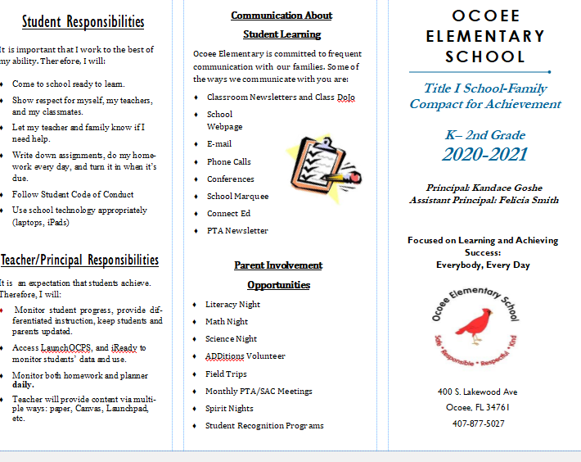  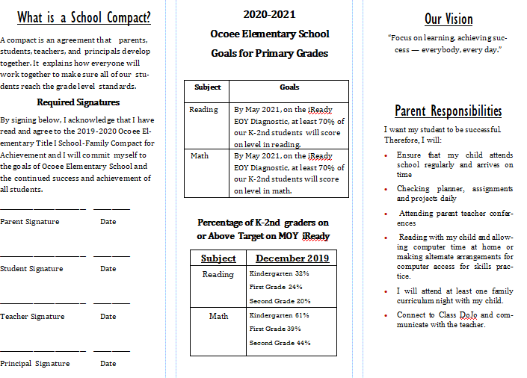  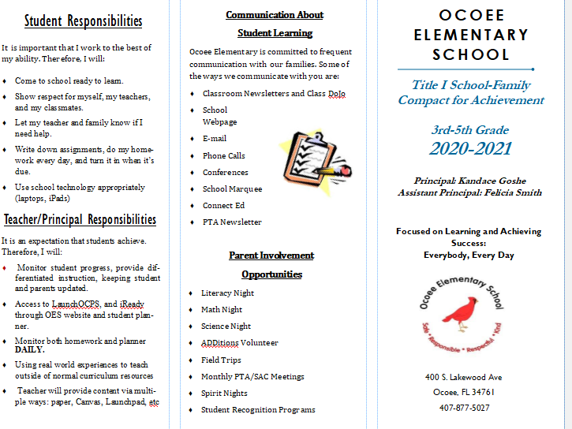  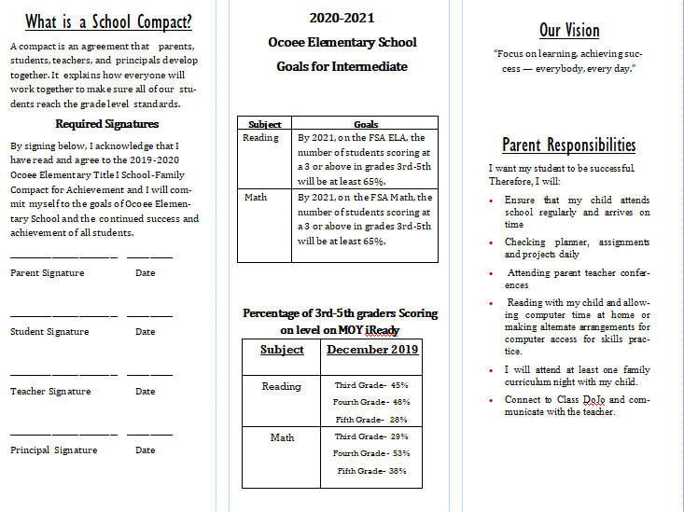  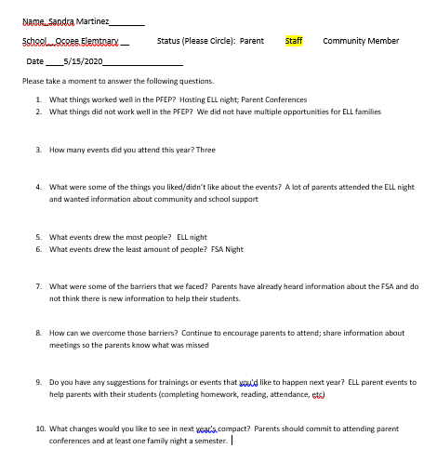  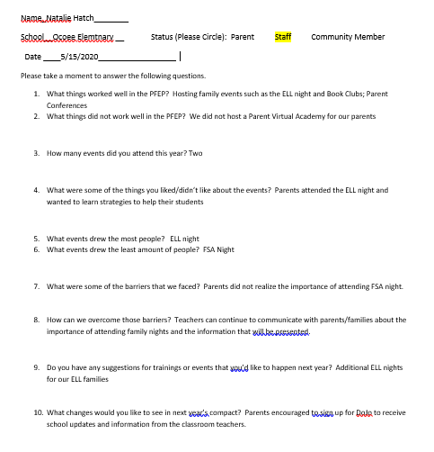  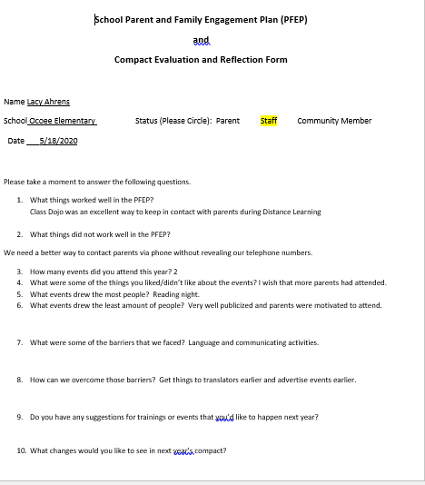

Adoption
The parental involvement policy/plan has been developed jointly with, and agreed on with, parents of children participating in Title I, Part A programs, as evidence by
This policy/plan was adopted by the school on and will be in effect for the period of .
The School will distribute this policy to all parents of participating Title I, Part A children on or before .

Signature of Authorized Personnel
Date

Provide evidence that this policy/plan has been developed with the input from parents based on the review of the previous school years Parent and Family Engagement Plan if applicable.
The following documents can be submitted as evidence:
- Parent survey of previous year’s events and activities
- Any SAC and PTA artifacts where Title I/PFE topics were on the agenda
- Parent Feedback Summary of PFEP Evaluation
- Parent and Family Engagement Activities Tracking Form

