2020-2021

Parent & Family

Engagement Plan

For: Wadsworth Elementary

INSTRUCTIONS
- Complete the following sections of the Parent & Family Engagement Plan (PFEP).
- To be considered complete each section needs to have all the components included.
- Upload to your Google folder by April 1, 2020
- Complete the SIP section (found at the end) when your school SIP is completed.

Evaluation of

2019-2020 School Year PFEP

BUILDING CAPACITY
Content & Type of Activity | Number of Participants | Impact on Student Achievement (include data evidence information, if applicable)
Meet the Teacher | 1,307 | Increased number of parents signed up for Skyward grade access
Curriculum Night | 471 | IReady ELA AP1-AP2 Proficiency rose from 35% to 56%  IReady Math AP1-AP2 Proficiency rose from 23% to 47%
Donuts with Grown Ups (2 events) | 368 | Referrals decreased in Q1 by 91 referrals YTD
All Pro Dads (4 events) | 42 | Referrals decreased in Q1 by 91 YTD, by 99 YTD in Q2, and Q3 by 98 YTD
ELL Parent PLC | 34 | Imagine Learning program participation increased resulting in improved IReady ELA AP1-AP2 proficiency from 11% to 25%
STEM Autonomous Robotics Event | 149 | Science Quarterly proficiency grades 3-6 Q1: 64%, Q2: 67%, and Q3: 69%
Tech the Halls | 157 | IReady Math AP1-AP2 Proficiency rose from 23% to 47%
Publix Math Night ( 2 events) | 90 | IReady Math AP1-AP2 Proficiency rose from 23% to 47%
Math Parent PLC | 9 | IReady Math AP1-AP2 Proficiency rose from 23% to 47%
Dr. Suess Night | 237 | Panorama Parent Survey Family Engagement section increase of 7 from the 18-19 school year

BEST PRACTICES

Include a description of the parent and family engagement activity or strategy implemented the previous year that was most effective including content/purpose and a description of the activity and data to support, if applicable.
For engaging families for feedback, sending skyward emails and the monthly parent newsletter yielded the best results in getting feedback from parents. The use of social networks such as Facebook and Twitter to announce WES events proved to be a popular avenue for parents and families to stay engaged and connected.

DEFINITION OF FAMILY ENGAGEMENT
What is your school’s definition of Family Engagement?

We will create an environment where our families feel welcome, participate in their student’s day
to day learning and understand that they have a voice in the decisions made to impact their
students’ achievement. We strive to engage our families in active learning with students during
family events and provide the best resources for supporting students at home.

FAMILY ENGAGEMENT MISSION STATEMENT
- The parent and family engagement plan is a shared responsibility.
- The parent and family engagement plan will assist in providing high quality instruction for all learners.
The Wadsworth Elementary Mission is aligned with the Flagler School District’s Mission statement
to strive to be the nation’s premier learning organization. To accomplish this, all stakeholders work
as a team to develop the whole child through successful school experiences in an environment of
mutual respect and personal growth.
Wadsworth Elementary School’s goal as it relates to parent involvement, is to ensure that all
parents are involved as partners to ensure the academic success of all students. By having the
school leadership team meet with parents and community leaders, they will all work as a team to
develop the Parent and Family Engagement Plan for the 2020-2021 school year. All members of this
team will be allowed to express their ideas and plans on how to provide high quality instruction for
all learners as well as involve both parents and community leaders as part of this instruction.
Members of the leadership team will discuss high yield strategies from the 2019-2020 school year
that are already in place.

ENGAGEMENT OF PARENTS
Describe:
- how the school will involve the parents and families in an organized, ongoing, and timely manner, in the planning, review and improvement of Title I Parent and Family Engagement Plan, including involvement in decision making of how funds for Title I will be used.
- provide evidence of involving parents and families in planning, reviewing and improvement of Title I Parent & Family Engagement Plan, including involvement in decision making of how funds for Title I will be used. This can be meeting agenda and notes as well as parent sign-in sheets.
The school will involve parents in an organized, ongoing and timely manner in the
planning, review, and improvement of Title I programs. This includes the involvement
in decisions regarding how funds for parental involvement are used through School
Advisory Council which is comprised of Wadsworth Elementary School
Administration, staff, parents, and community members.
Membership is open to all who wish to attend. Members are invited to join through the
use of the school website, skyward email, during parent/teacher “Meet the Teacher”
orientation, the school marquee, our social media accounts, and the monthly school
newsletter.

COORDINATION AND INTEGRATION WITH OTHER FEDERAL PROGRAMS
Describe:
- how the school will coordinate and integrate parent and family engagement programs and activities regarding Foster, FIT, ESOL and Unaccompanied Homeless Youth.
- how the school will coordinate and integrate parent and family activities that teach parents how to help their child(ren) at home. [ESEA Section 1116]

Program | Coordination
Title I Parent Resource Room | Wadsworth Elementary School Administration
PTO, SAC, and ESOL Parent Leadership Council | Wadsworth Elementary School Administration, PTO, SAC, Title I Parent Specialist, Guidance Department
VPK/Pre-K ESE | Flagler County participates in the Volusia/Flagler Early Learning Coalition. Children who are in PreK ESE, and who are at least 4 years old by September 1st can participate in VPK classes for appropriate mainstreaming. VPK and child care students also participate in activity/PE time with age appropriate Pre-K ESE students.
Parent Nights | Standards based parent information nights and family nights will be provided. Title I funds will pay for materials and stipends for teachers who present during the information nights.

ANNUAL PARENT MEETING and COMMUNICATION
Describe:
- how families will be informed of the nature of the Title I program and how the school will provide families timely information about the Title I program
- the specific steps the school will take to conduct the annual meeting to inform parents and families of participating children about the school’s Title I program
- how families will be provided a description and explanation of
  - curriculum used at the school
  - forms of academic assessment used to measure student progress
  - achievement levels of the Florida State Standards
- how the meeting will cover school choice, input of parents on and the rights of parents at the annual meeting
- if parents request, how the school will provide opportunities for regular meetings to formulate suggestions and to participate, as appropriate, in decisions relating to the education of their child(ren)
- how the school will handle parents/families comments if the school-wide plan is not satisfactory to the parent/family. [ESEA Section 1116]

Activity/Tasks | Person(s) Responsible | Timeline
Announcement of Title I Annual Parent Meeting posted on school website, school social media, send home flyers and school newsletter. | School Title I Parent Liaison/School Administration | August, 2020
Announcement of meeting posted on school marquee, social media and send-home flyers | School Title I Parent Liaison/School Administration | September, 2020
Broadcast phone calls to invite parents, guardians, and community members. (Notices are also sent via Skyward email). | School Title I Parent Liaison/School Administration | September, 2020
Develop agenda, sign in sheet, PowerPoint presentation | School Title I Parent Liaison/School Administration | September, 2020
Host Annual Public Title I Meeting | School Title I Parent Liaison/School Administration | September, 2020
Meeting Notes and Powerpoint posted on School Website | School Title I Parent Liaison/School Administration | September, 2020

FLEXIBLE PARENT MEETINGS
Describe:
- how the school offers a flexible number of meetings, such as meetings in the morning or evening.
- if the school provides transportation, child care or home visits, as such services relate to parent and family engagement. [ESEA Section 1116] using Title I funds.

The school will offer a flexible number of meetings, such as meetings in the morning and evening. Morning meetings will include Parent/Teacher Conferences scheduled twice a year. Evening meetings will include PTO, SAC, TITLE 1, Standards based Curriculum Nights (Math, ELA, and Science/Technology), Parent Technology Night, Parent/Teacher Conferences, STREAM Night, Dr. Seuss Night and Publix Math Nights. Refreshments, childcare and translation services will be provided, as needed.

Wadsworth also utilizes our social worker for home visits in cases that the needs arrive for positively impacting our students’ welfare academically or socially. We will also offer at least one technology enhanced meeting (Parent Tech Night) to allow parents to attend digitally.

BUILDING PARENT & FAMILY CAPACITY
Describe:
- evidence-based activities that will build the capacity for meaningful parent/family engagement
- any other evidence-based activities, such as, but not limited to a Family Reading & Resource Center, the school will conduct to encourage and support parents and families in more meaningful engagement in the education of their child(ren). [ESEA Section 1116]
- evidence-based activities that will build relationships with the community to improve student achievement
- any evidence-based materials, resources and/or trainings provided to assist parents/families to work with their child(ren)
- other reasonable support for evidence-based parent/family engagement activities.

Content and Type of Activity | Person(s) Responsible & Timeline | Anticipated Impact on Student Achievement | Evidenced-based documentation & tier | Measure of Effectiveness on Academic Achievement
Literacy Night (includes writing). Parents, students, and community members will be provided with standards based materials and activities to work with at home. | WES Curriculum Team | Increased achievement in reading | Providing Strategies and Materials to Families  Tier 3 | iReady growth reports
Publix Math Night  Parents and community members will be provided with standards based materials and activities to work with their children in an authentic way. | WES Curriculum Team | Increased achievement in math | Math at home adds up to achievement in school  Tier 1 | iReady growth reports
STREAM Science Night-Parents, students, and community members will be provided with standards based materials and activities to interact with and create meaningful connections with science, technology, engineering, arts, and math. | WES Curriculum Team | Increased achievement in science and math | Approaches to Parental Involvement for Improving the Academic Performance of Elementary School Children in Grades K-6  Tier 2 | Science Quarterly data and iReady math growth reports
Dr. Seuss Literacy Night. Parents, students, and community members will be provided with standards based games and activities to work on at home. | WES Curriculum Team | Increased achievement in ELA | Promoting Family Literacy Through the Five Pillars of Family and Community Engagement (FACE)  Tier 2 | iReady growth reports

Mindset & Engagement Strategies Parent/Student Interactive learning community | Leadership Team/Curriculum Team | Increased parent understanding/knowledge of ways to support learning at home to increase student achievement across the content areas. | The Importance of Family Involvement in Education  Tier 4 | Panorama Parent Spring Survey for Learning behaviors Increases  Increased student achievement as measured by D & F reports

BUILDING STAFF DEVELOPMENT for PARENT & FAMILY ENGAGEMENT
Describe:
- the STAFF development activities the school will provide to SUPPORT the teachers, specialized instructional support personnel, principals, other school leaders and other staff with the assistance of parent/families, to include
  - the value and utility of contributions of parents/families. [ESEA Section 1116]
  - how to reach out to, communicate with, and work with parents/families as equal partners. [ESEA Section 1116]
  - the assistance of parent/families, in implementing and coordinating parent/family programs, and in building ties between parents/families and the school. [ESEA Section 1116]

Content and Type of Activity | Person(s) Responsible & Timeline | Anticipated Impact on Student Achievement | Evidenced-based documentation | Measure of Effectiveness on Academic Achievement
Parent Communication & Teacher Family Engagement Training | (Principal) | Increased student achievement and decreased behavior referrals | Teaching the Teachers: Preparing Educators to Engage Families for Student Achievement  Tier 4 | Use of Title I Compact and Parent Call log; increased use of planners/iPads for communication. Increase in iReady and FSA scores, lower behavior calls/referrals.
Training of Self-contained ESE Teachers | Leadership Team | Increased student achievement, decrease behavior issues and increase Parent Communication | Parent Involvement, Academic Achievement and the Role of Student Attitudes and Behaviors as Mediators  Tier 2 | Increase in iReady and FSA scores, lower behavior calls/referrals, and increase use of Parent Log
Training of Office Staff | Leadership Team | Positive interactions will bring about parents being more engaged at the school; this engagement will result in an increase in student achievement | How Family, School, and Community Engagement Can Improve Student Achievement and Influence School Reform  Tier 3 | Decrease in behavior calls/referrals and increase in parent engagement
Training of Para-Professionals | Leadership Team | Positive interactions will bring about parents being more engaged at the school; this engagement will result in an increase in student achievement | Promoting Family Literacy Through the Five Pillars of Family and Community Engagement (FACE)  Tier 2 | Decrease in behavior calls/referrals and increase in parent engagement

FAMILY SURVEY
Using your 2019-2021 Title I family survey results, choose a topic (Barriers to Engagement, Family Support, Learning Behaviors or Family Engagement) to address this coming school year.
Family Engagement
TOPIC: Learning Behaviors

ACTIONS and ACTIVITIES | Person(s) Responsible | What needs to be completed? | Timeline | Measure of Effectiveness
Literacy Night | Curriculum Team | -Create agenda for the evening that includes grade level specific at-home activities and ways to increase student enjoyment of reading  -Parent communication of time and date of event | October 2020  March 2020 | Panorama Parent Spring Survey for Learning behaviors Increases
Mindset & Engagement Strategies Parent/Student Interactive learning community | Leadership Team/Curriculum Team | -Create agenda to include grade appropriate activities that show how to foster an open mindset as well as ways to engage students while offering support at home  -Parent communication of time and date of event | November 2020 | Panorama Parent Spring Survey for Learning behaviors Increases  Increased student achievement as measured by D & F reports

ACCESSIBILITY
Describe:
- how the school will provide full opportunities for participation in parent/family engagement activities for all parents/families.
- how the school will share information related to school and parent/family programs, meetings, school reports, and other activities in an understandable, uniform format, and in languages that parents/families can understand.
- “to the extent practicable, how the school shall provide opportunities for the informed participation of parents and family members (including parents and family members who have limited English proficiency, parents and family members with disabilities, and parents
and family members of migratory children), including providing information and school reports required under section 1111 in a format and, to the extent practicable, in a language such parents understand.” [ESEA Section 1116]

The school will provide full opportunities for involvement in activities for all parents (including
parents with limited english proficiency, disabilities, migratory children and FIT) by ensuring
that facilities are handicap accessible, letters and information are provided in English,
Spanish, Russian, Portuguese, and Haitian Creole, when feasible. TRANSACT is the service
that is used to provide translated documents to non-English speakers. Translators will be
provided at parent night activities and meetings, when possible. Additionally, the school
provides (through a partnership with Adult Education) ESOL Family Literacy classes which
provides opportunities for parents and community members who have a first language other
than English to learn English during the school day three days per week. We also provide
flexible parent meetings in order to be sure parents and family members are able to attend
activities at different times accommodating their schedules.

DISCRETIONARY ACTIVITIES (optional)
- Describe any activities that are not required, but will be paid through Title I, Part A Funding (for example, home visits, transportation for meetings, activities related to parent/family engagement. etc.)

Activity | Description of Implementation Strategy | Person(s) Responsible | Anticipated Impact on Student Achievement | Timeline
Arranging school meetings at a variety of times. | Conducting in-home conferences with information from teachers, other educators, and guidance who work directly with participating children for parents who are unable to attend in person. | WES Administration,  WES Guidance,  District social worker | Increased student achievement in all content areas; decrease in number of behavior referrals | August, 2020 through  May, 2021

BARRIERS
Describe:
- the barriers that hindered participation by parents during the 2019-2020 school year.
- the steps the school will take during the upcoming school year to overcome these barriers (with particular attention paid to parents/families who are economically disadvantaged, disabled, have limited English proficiency, have limited literacy, or are of any racial or ethnic minority background, or are parents /families of migratory children).

Barrier | Steps to Overcoming Barrier | Persons Responsible | Timeline
Time of Day of Activities | Providing meetings before school, after school and evening hours. | Administration/  Leadership Team | August, 2020 through  May, 2021
Childcare needs | Provide Child Care during events (using students from High Schools) | Administration/  Leadership Team | August, 2019 through  May, 2020
Language Barriers | Include translation services, when feasible, for parents who speak a language other than English. | Administration and ESOL Coordinator | August, 2020 through  May, 2021
Transportation related challenges | Provide live streaming of events when applicable | Administration/  Leadership Team | August, 2020 through  May, 2021

Attach evidence of parental input on this PFEP.
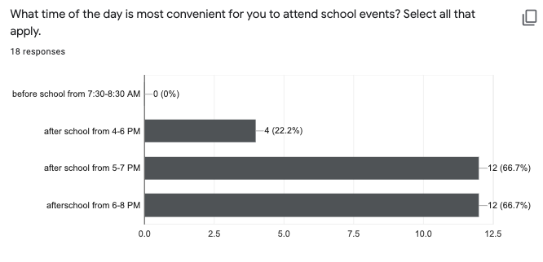
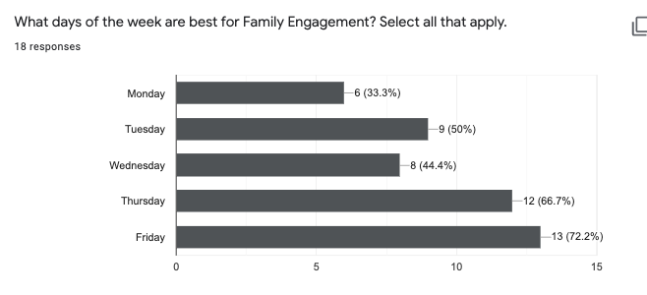
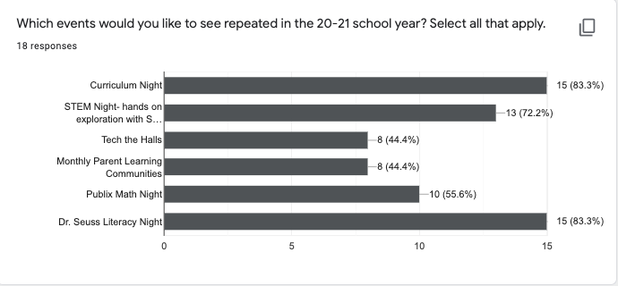
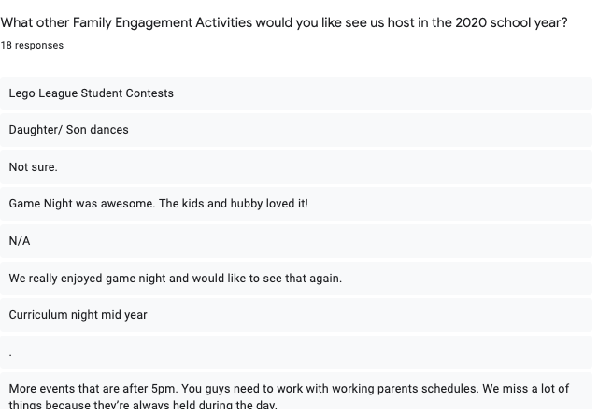

Attach your school compact and evidence of parental input on your school’s compact.
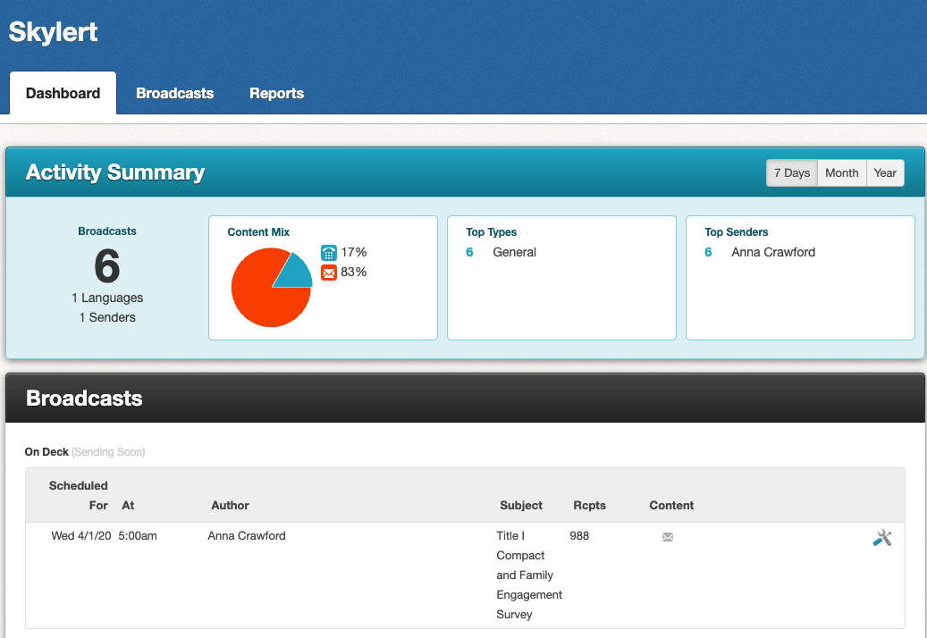

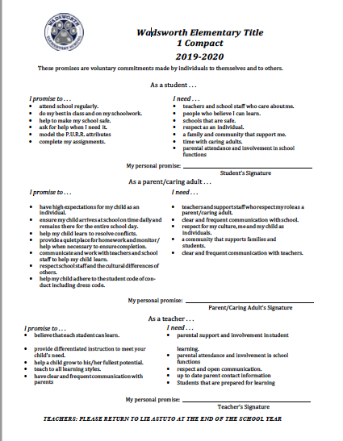

PFEP Assurances

- Assurance 11a, Parent Consultation: Schools will ensure that consistent with 1116, they will conduct outreach to all parents and family members for meaningful consultation for planning and implementation of programs, activities, and procedures using family engagement funds.
- Assurance 11b, School Parent and Family Engagement Policy: Schools will ensure that as outlined in Section 1116(b)(1-4), they will
  - distribute to, parents and family members of participating children a written parent and family engagement policy, agreed on by such parents, that shall describe the means for carrying out the requirements of section 1116 (c-f) and Assurance 11c-f. Parents shall be notified of the policy in an understandable and uniform format and, to the extent practicable, provided in a language the parents can understand. Such policy shall be made available to the local community and updated periodically to meet the changing needs of parents and the school.
  - may amend that policy, if necessary, to meet the requirements of this subsection.
  - If the plan under section 1112 is not satisfactory to the parents of participating children, the school shall submit any parent comments with their PFEP
- Assurance 11c, Policy Involvement: Schools will, as outlined in Section 1116(c)(1-5)
  - Convene an annual meeting, at a convenient time, to which all parents of participating children shall be invited and encouraged to attend, to inform parents of their school's participation under this part and to explain the requirements of this part, and the right of the parents to be involved.
  - Offer a flexible number of meetings, such as meetings in the morning or evening, and may provide, with funds provided under this part, transportation, child care, or home visits, as such services relate to parental involvement.
  - Involve parents, in an organized, ongoing, and timely way, in the planning, review, and improvement of programs under this part, including the planning, review, and improvement of the school parent and family engagement policy and the joint development of the schoolwide program plan under section 1114(b)except that if a school has in place a process for involving parents in the joint planning and design of the school's programs, the school may use that process, if such process includes an adequate representation of parents of participating children.
  - Provide parents of participating children — (A) timely information about programs under this part; (B) a description and explanation of the curriculum in use at the school, the forms of academic assessment used to measure student progress, and the achievement levels of Florida’s challenging academic standards; and (C) if requested by parents, opportunities for regular meetings to formulate suggestions and to participate, as appropriate, in decisions relating to the education of their children, and respond to any such suggestions as soon as practicably possible.
  - If the schoolwide program plan under section 1114(b)is not satisfactory to the parents of participating children, submit any parent comments on the plan to the LEA.
- Assurance 11d, Shared Responsibilities for High Student Academic Achievement: As outline in section 1116(d)(1-2), the school will jointly develop with parents for all children served under this part a school-parent compact that outlines how parents, the entire school staff, and students will share the responsibility for improved student academic achievement and the means by which the school and parents will build and develop a partnership to help children achieve the Florida's challenging academic standards. Such compact shall — (1) describe the school's responsibility to provide high-quality curriculum and instruction in a supportive and effective learning environment that enables the children served under this part to meet the Florida’s challenging academic standards, and the ways in which each parent will be responsible for supporting their children's learning, volunteering in their child's classroom; and participating, as appropriate, in decisions relating to the education of their children and positive use of extracurricular time; and (2) address the importance of communication between teachers and parents on an ongoing basis through, at a minimum — (A) parent-teacher conferences in elementary schools, at least annually, during which the compact shall be discussed as it relates to the individual child's achievement; (B) frequent reports to parents on their children's progress; (C) reasonable access to staff, opportunities to volunteer and participate in their child's class, and observation of classroom activities; and (D) ensuring regular two-way, meaningful communication between family members and school staff, and, to the extent practicable, in a language that family members can understand.
- Assurance 11e, Building Capacity for Involvement: To ensure effective involvement of parents and to support a partnership among the school involved, parents, and the community to improve student academic achievement, the school under this part will meet the requirements outlined in section 1116(e)(1-14).
- Assurance 11f, Accessibility: Schools, to the extent practicable, shall provide opportunities for the informed participation of parents and family members (including parents and family members who have limited English proficiency, parents and family members with disabilities, and parents and family members of migratory children), including providing information and school reports required under section 1111 in a format and, to the extent practicable, in a language such parents understand.
- Assurance 11g, Family Engagement in Education Programs: In a state operating a program under part E of Title IV, the school that receives assistance under this part shall inform parents and organizations of the existence of the program.

______________________________________ ___________________________________
Principal’s Signature Date Signed

2020-2021

SCHOOL IMPROVEMENT PLAN GOALS
Complete this section AFTER your school has completed your SIP.
GOALS | How will this goal be communicated to families? | How will you assist families in supporting this goal?
Literacy & High Expectations
Early Warning Systems
Graduation Rate
Acceleration
Enhanced Acceleration

2019-2020
REVIEW
SCHOOL IMPROVEMENT PLAN GOAL

GOALS: 19-20 SIP | OUTCOMES & IMPACT ON STUDENT ACHIEVEMENT
If we implement school wide lesson plans that include the various elements of the Learning Focused template (i.e. essential questions, higher order thinking questions and vocabulary instruction) then students will achieve one years growth in one years time in ELA and Math as measured by iReady Diagnostic Growth Report results from windows 1-3. | Current Reading iReady data Annual Typical Growth  73% - Kindergarten  54% - 1st grade,  87% - 2nd grade  88% - 3rd grade  103% - 4th grade  138% - 5th grade  125% - 6th grade  Current Math iReady data Annual Typical Growth  69%- Kindergarten  49% - 1st grade  85% - 2nd grade  50% - 3rd grade  65% - 4th grade  75% - 5th grade  93% - 6th grade
The number of students with one or more suspensions by grade level will decrease from 75 to 50 in one year. The number of students with an attendance average below 90% will decrease from 102 to 77. The number of students with a course failure in ELA or Math will decrease from 55 to 30. The number number of students scoring a level 1 on the FSA will decrease from 133 to 100. | Kindergarten has one student with more than one suspension, first grade has two students, second has one student, third grade has four students, fourth grade has two students, fifth grade has nine students, and sixth grade has three students with more than one suspension.  Attendance is trending upward as compared to last year.  August 2018: 95.17%, 2019: 95.71% +.23  September 2018: 95.09%, 2019: 95.34% +.25  October 2018: 92.77%, 2019: 95.09% +2.29  November 2018: 93.83%, 2019: 94.74% +.91  December 2018: 92.21%, 2019: 94.19% +1.98  Kindergarten currently has 5 students with a course failure, first grade has 9 students, second grade has 19 students, third grade has 23 students, fourth grade has 24 students, fifth grade has 69 students, and sixth grade has 25 students with a course failure.
If we implement school-wide Learning Focused Implementation Plan that includes coaching on the various elements of the Learning Focused implementation plan (lesson plans, distributed summarizing, writing, graphic organizers, vocabulary instruction, H.O.T Questions, Text Structure and Rubrics) for all grade levels, then students will achieve one years growth in one years time in ELA and Math as measured by iReady Diagnostic Typical Growth Report results from windows 1-3. | Current Reading iReady data Annual Typical Growth  73% - Kindergarten  54% - 1st grade,  87% - 2nd grade  88% - 3rd grade  103% - 4th grade  138% - 5th grade  125% - 6th grade  Current Math iReady data Annual Typical Growth  69%- Kindergarten  49% - 1st grade  85% - 2nd grade  50% - 3rd grade  65% - 4th grade  75% - 5th grade  93% - 6th grade
If we implement accelerated classroom profiles for high achieving students, then students will achieve one years growth in one years time in ELA and Math as measured by iReady Diagnostic Growth Report results from windows 1-3. This will be implemented as the DREAMS program (Kindergarten to 5th Grade) and the STEM Focused classrooms in Grades 4,5 and 6. Sixth grade has advanced classes to meet the secondary criteria. | Current iReady Annual Typical Growth data:  Dreams program:  Kindergarten- 86% Math / 95% Reading  First Grade -52% Math / 73% Reading  Second Grade - 77% Math / 74% Reading  Third Grade -54% Math / 109% Reading  Fourth Grade -96% Math / 92% Reading  Fifth grade- 79% Math / 223% in Reading  Advanced placement students in Sixth grade:  Average of 160% in Math / 83% in Reading  STEM Academy:  Fourth Grade- 66% Math /155% Reading  Fifth grade- 91% Math / 73% Reading  Sixth Grade-115% Math / 144% Reading
If we implement research-based practices, (i.e. control of task difficulty, teaching in small, interactive groups, using "think alouds", advanced organizers/activate prior knowledge, teach self monitoring, present learning in multiple ways, teach memory strategies, use student interests, collaborate with IEP team), to teach students with disabilities for all grade levels, then student scale score achievement in ELA, Math, and Science will increase on the FSA. | Current iReady Annual Typical Growth Data  ESE/Support Facilitation:  K/1- 27% Reading / 58% Math  2- 51% Reading / 86% Math  3-111% Reading / 53% Math  4- 128% Reading / 71% Math  5- 146 % Reading / 85% Math  6- 116% Reading / 71% Math  ESE/EBD Self Contained:  1-3: 37% Reading / 0% Math  3-6: 0% Reading / 33% Math  6: 105 % Reading/ 27% Math  Speech/Language:  SLP A K-6: Reading 92%  SLP B K-6: Reading 86%

