Parent and Family Engagement Plan (PFEP)
SIP 2021
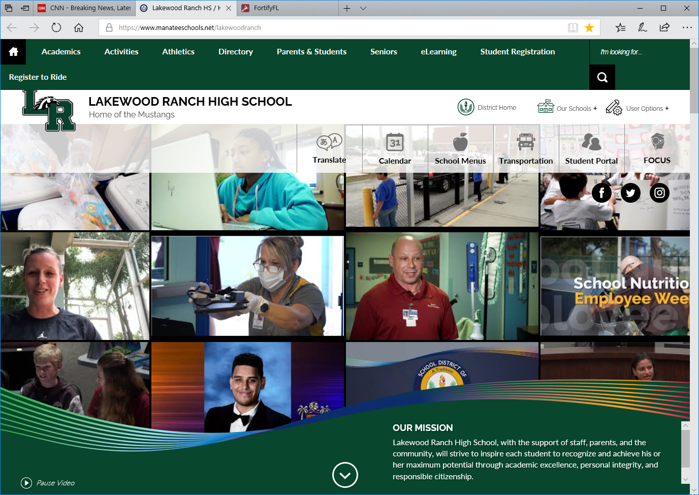

Lakewood Ranch maximizes opportunities to communicate with families toward increased involvement by utilizing various technology including a well-developed website that launches with the school’s mission and vision statements.
Connect Ed – automated voice messaging system.
Mustangs Ahead – Online newsletter.
The Loop – Online Parent/Parent communication.
LRHS Parent Association
SAC

