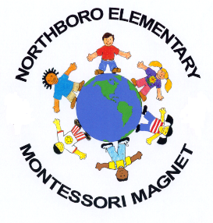
Northboro Elementary
2019-2020 Parent and Family Engagement Policy (PFEP) Summary Guide

Parent and Family Mission Statement: Northboro Elementary strives to create a cooperative learning community which empowers parents to take an active role in their child’s education
Involvement of Families/Stakeholders: Several meetings will take place throughout the school year to encourage families to get involved in the school. In addition to monthly School Advisory Council (SAC) meeting and Parent Teacher Organization bi-monthly meetings, we will hold three parent trainings. The parent trainings will each have an individual focus- Literacy- October 24; Math- November 14; and Science- January 23.
In addition to the parent workshops, we will host our Annual Title One meeting. Flyers will go home with the students and a reminder robo call-out will be sent the day before the event. During the meeting the following components will be shared, suggestions taken and changes made to: Title One School-wide Plan, Comprehensive Needs Assessment (CNA), and the Title One Student-Parent Compact. At the CAN meeting, funding allocations for the upcoming school year will be shared.
This year’s meeting was held on September 25 at 8:30AM and 5:00PM.
Accessibility: We strive to have all of our communication in Spanish as well as English. Northboro staff who speak parent's native language are available for parent meetings and conferences to ensure proper communication. Furthermore, we’ve reached out to a local high school Spanish club to support our school-wide events to ensure we have enough translators.
Building Capacity: In our parent trainings, activities and strategies to assist students of all ages represented at Northboro will be shared. Parents will be invited through flyers with an RSVP attachment. This will assist us in catering the workshop to the attendees.
Coordination and Integration: During our parent trainings, we will invite outside agencies to support our families and students. The agencies will provide information to the families as well as share ways to get connected outside of school.
Communication: Title I information and services (Annual meeting, tutorial programs, parent training, parent conferences, etc.) will be shared via multi-lingual flyers in the backpacks; marquee announcement; flyers; newsletters; call-outs.
Information regarding student expectations and achievement will be communicated to families via Open House; Curriculum Night; Student agendas/parent signatures on assessments; report cards; progress reports; Diagnostic Reports; PMP, iReady proficiency reports; Parent Conference Fair and individual parent conferences.
The Parent and Family Engagement Plan is our comprehensive communication to outline how Northboro can support family involvement in the school. We look forward to seeing you at school and taking an active role in your child’s education.

