2501 Seacrest Blvd | Delray Beach | Florida 33444

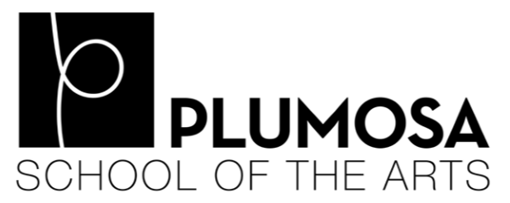
Cathy Reynolds, Principal

Plumosa School of the Arts
2019-2020 Parent and Family Engagement Plan (PFEP) Summary

Parent and Family Engagement Mission Statement
Plumosa School of the Arts is committed to involving families in shared decision-making and encouraging families to become active participants in their child’s educational process by effectively communicating instructional goals, creating an environment that is inviting for families, and establishing the school as the center of the community.

Annual Title 1 Meeting
Each year, families are invited to attend this meeting at the beginning of the school year to learn more about our school-wide Title 1 program and the requirements of Title 1. At this meeting, there will be opportunities to review many of the documents that guide our work with families and help shape our Title 1 program.

Parent and Family Engagement Trainings
Based on parent input from the stakeholder meeting, we will provide the following activities to assist families in understanding the State and District mandated curriculum and assessments to help families improve their children’s academic achievement:
- Curriculum night will inform families of FSA, grade level assessments, curriculum and grade level expectations.
- Parent academies, AVID family night, and Literacy night will be implemented for families to learn strategies to help their children at home.
- STEAM/STEM night will be held to involve families to work with their children at home with real world concepts in math and science.

Shared Decision-Making
Families will be invited to many meetings throughout the year to receive academic information and provide input on ways the school, parents and students can share responsibility for student success. This information will be used to create the school’s Parent and Family Engagement Plan (PFEP) and School-Parent Compact. Annually families will review the School-wide plan and data reports to determine necessary changes. Use of parent and family engagement funds will also be discussed. Families will receive information in a timely manner and in appropriate languages.

Communication
We have reviewed feedback to decide how we will communicate with families. Based on your input, we will communicate in many ways, including our school’s webpage, ParentLink, ClassDojo and/or Remind Me; through emails and phone calls from teachers and school administration; by flyers sent home with your student; and through notes in your student’s agenda book. If you find that communication doesn’t seem to be getting home, please let us know. Our goal is to keep communication between the home and school open and ongoing.

Accessibility for all Families
We encourage all families to attend meetings and events and will provide the supports needed to ensure our families are able to participate. We provide translated documents and Community Language Facilitators (CLFs), childcare, accessible meeting space, and multiple meeting days and times based on family feedback. We ask that parents notify the school if other assistance is needed. We want all families to be a part of their child’s education!

Volunteers
Families are encouraged to volunteer at our school to help students and teachers be successful. To find out more about volunteer opportunities, please contact our school’s volunteer coordinator, Mrs. Gina Gelfand. We’d love to have your help!

Our Plan
This Parent and Family Engagement Plan was written in partnership with families and other members of our school community. We welcome any suggestions you may have to improve our family engagement practices. There are many ways to do so. If you have comments now, you may write them on the lines below. You are also encouraged to attend our annual Stakeholder Input Meeting in the spring and complete the Title 1 Parent and Family Engagement Survey sent home each year.

Please sign below to let us know you’ve read the PFEP summary. The signed portion should be returned to your child’s classroom teacher.

_ _ _ _ _ _ _ _ _ _ _ _ _ _ _ _ _ _ _ _ _ _ _ _ _ _ _ _ _ _ _ _ _ _ _ _ _ _ _ _ _ _ _ _ _ _ _ _ _ _ _ _ _ _

I have reviewed the Parent and Family Engagement Plan Summary for Plumosa School of the Arts.

________________________________________ ____________________
Family Member Signature Date

________________________________________ ____________________
Student’s Signature Date

Comments:

________________________________________________________________________________

________________________________________________________________________________

___________________________________________________________________________________________

