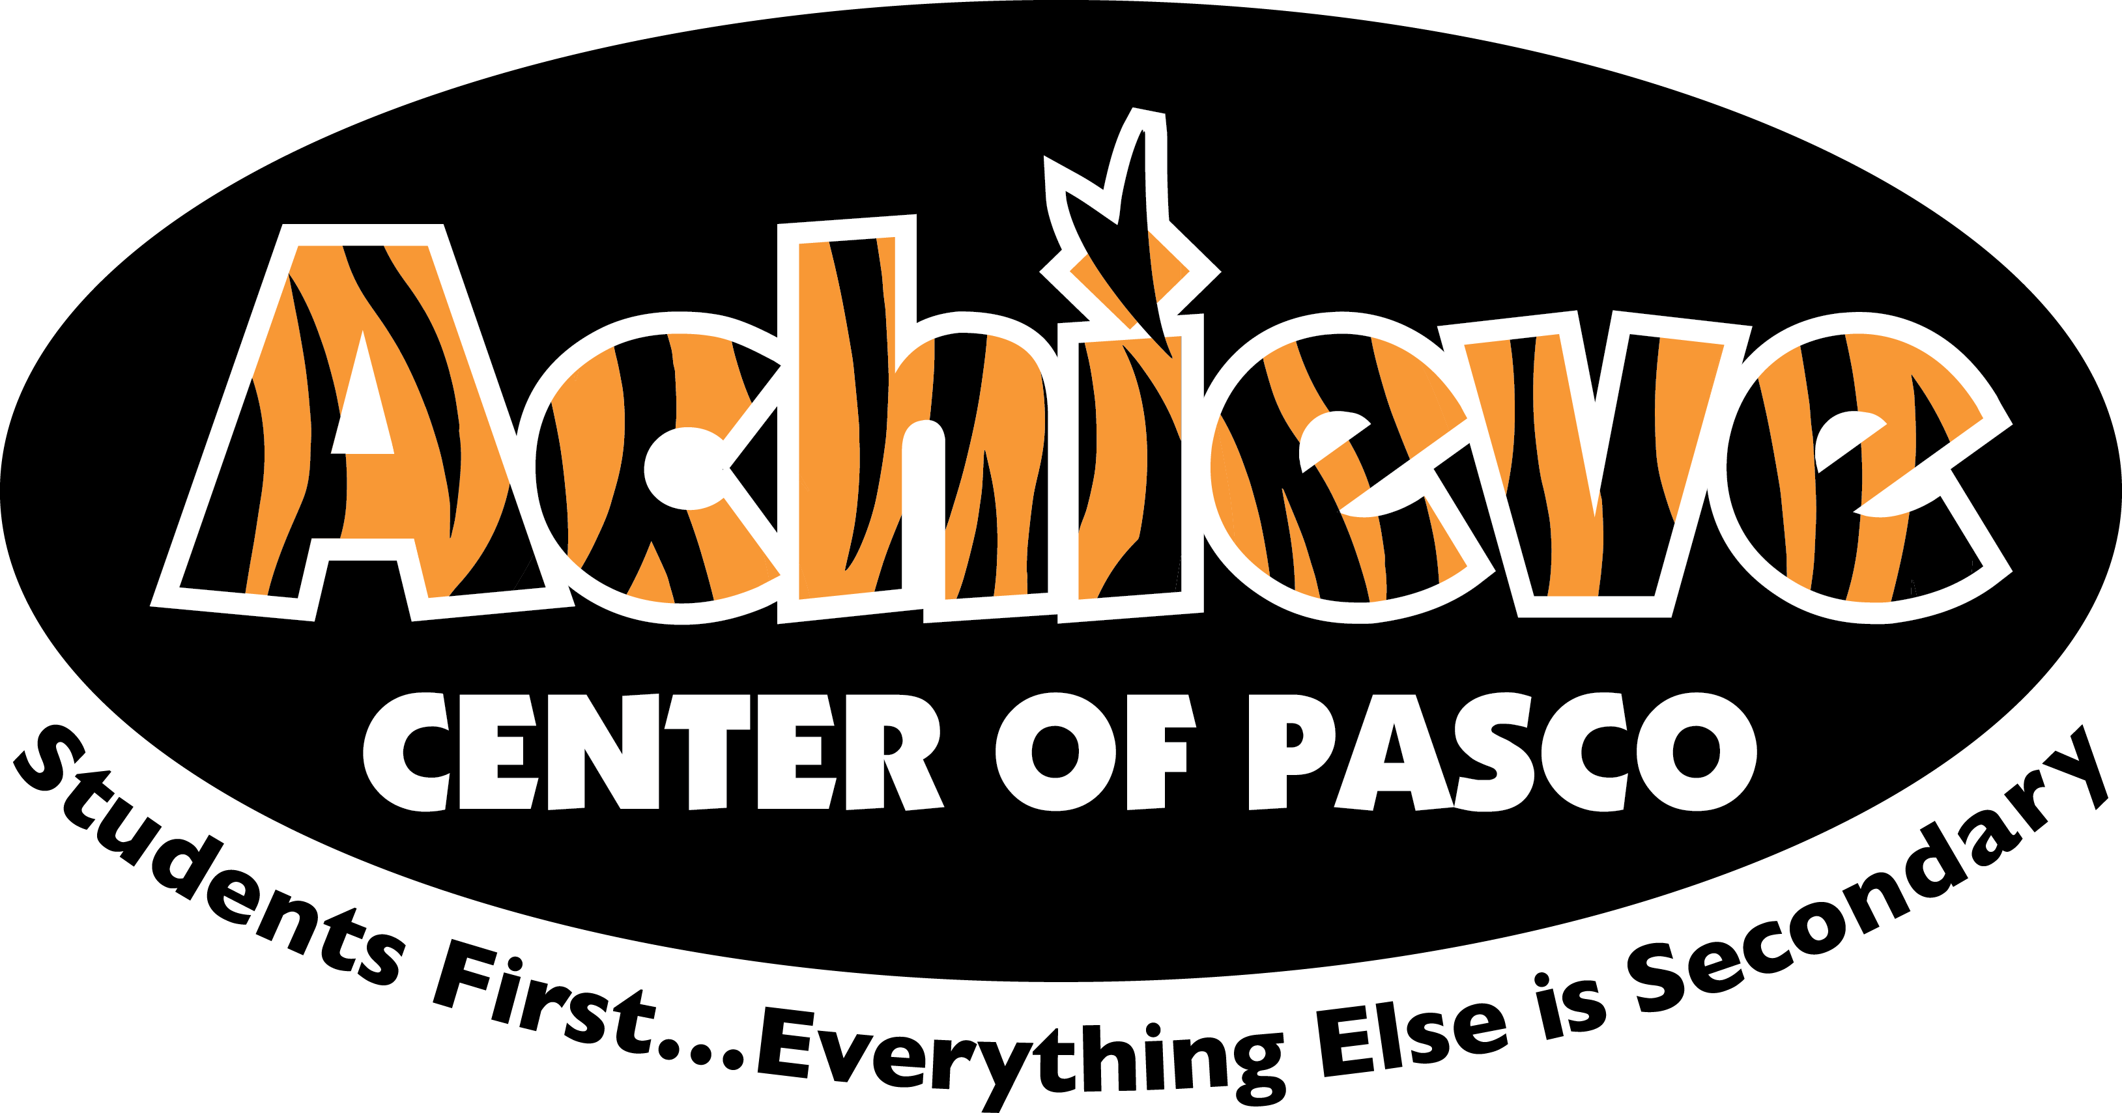
2020-2021 Parent Involvement

Achieve Center of Pasco Mission

Our mission is to provide a safe and engaging learning environment where students are encouraged and empowered. We strive to inspire student success through individualized academic support as well as social/emotional instruction focused on creating productive citizens of the community.

Parent Involvement Plan 2021
Achieve Center of Pasco
2020-2021
ACP Goals for 2021
-(SBP) Teachers and staff will deliver standards-based, blended lessons with specially designed instruction that will increase the number of On-Track students by 15% in course success. (HII)

-(Alt. Ed.) Teachers and staff will deliver instructional aid to support students using online academic platforms to increase course completion and eligibility to transition back to home zoned schools on time by 60% of students. (HII) (DDD)

-Teachers and staff will deliver social and emotional lessons, including Growth Activities, in the classroom that will increase the number of On-Track students by 15% in behavior and 65% of students on Level 4 by end of Semester 1. (HII)

-In collaborative PLCs, Staff will utilize the Online Academic Platform (APEX), Early Warning System and Level System Data to identify and problem solve students not making progress. This will result in a 15% increase of students On-Track in Academics and Behavior. (DDD)(CC)

Parent Involvement:
Student success is impacted by school and parent partnerships. Our school will connect with our parents in the following ways to support each other to enhance student success:

-Connect parents to community mental health providers.
-Connect parents with community food and financial supports.
-Provide seasonal items from food drives at the school.
-Provide hygiene and basic supplies to students when needed.
-Utilize ABC funds for students as individual needs dictate.
-Connect with Foster Care agencies to provide continuity for students.
-Connect School Nurse to parents for guidance on medical supports in the community.
-Invite parents into our school processes and decision making.
-Communicate in various formats to reach all stake holders.
-Continue Toys for Tots partnership.

