CROSSPOINTE STEM ELEMENTARY SCHOOL
3015 S. Congress Ave
Boynton Beach, FL 33426
(561) 292-4100 Fax: (561)-292-4150
Principal: Dr. Annmarie Dilbert Assistant Principal: Mrs. Gina North

Crosspointe Elementary School
2020-2021 Title 1 Parent and Family Engagement Plan Summary

Parent Involvement
At Crosspointe Elementary, we recognize the importance of forming supportive partnerships with our parents and community members that will greatly impact the students that we service. In order for this to occur we understand that we need to promote effective parental involvement. Crosspointe welcomes and encourages our parents and community members to join our monthly School Advisory Council (SAC) meetings along with the additional events outlined in this plan. We hope to work together with you as equal partners during your child’s educational process.

Annual Title I Meeting
Parents are invited to attend this meeting at the beginning of each school year to learn more about the requirements of Title I and our schoolwide Title I Programs. At this meeting there will be opportunities to review Title I documents and give input on the following:
- School-Parent Compact
- Title I Family Involvement Plan/Policy
- Parent’s Right to Know
- Title I budget

Accessibility for all Families
We plan to accommodate all families by providing the following:
- Allowing input on days and times of meetings
- Having our Language Facilitators at all meetings
- All documents translated
- Provide childcare so parents can attend meetings

Parent Involvement Activities
We will continue to provide the following events and activities to assist parents in understanding the state curriculum and assessments in order for parents to continue to assist with the improvement of their child’s academic achievement:
Curriculum Night – These events will explain to parents the curriculum that their child will be responsible for mastering and how to give parents strategies to assist their child.
Monthly Newsletter – Newsletters will inform parents of upcoming events and meetings and highlight specific strategies and websites that will support learning at home.
Multicultural Night – Parents will be invited to this interactive event to be exposed to the various cultures of our school population. Parent resources will be provided in their native language to assist parents at home.
STEM Night – This event will involve parents with their children in rotating through multiple hands-on activities that are aligned to Florida Standards.
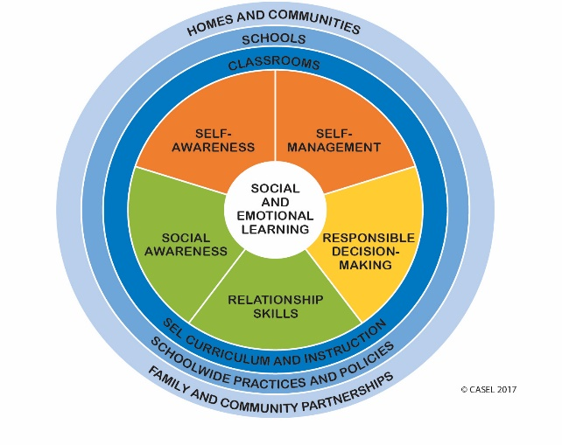
SEL “7 to 7” (Social Emotional Learning during the school day and out of school time)
In pre-kindergarten to fifth grade, we explicitly teach a classroom based program in Morning Meeting designed to increase students’ academic success and decrease challenging behaviors by promoting the competencies of SEL: Self-Awareness, Social Awareness, Self-Management, Relationship Skills and Responsible Decision-Making.

How can parents or caregivers help at home?
A simple hug, genuine eye contact, and a positive thought for the day can help your child wake up to a world of love and inspiration at home. Before they go to bed, we encourage you to have a short daily one-on-one conversation about the highs and lows of the day. Without technology, you may build family connections through conversations and create a safe haven for both celebrating wins and dealing with challenging situations.

Shared Decision Making
Through the school’s SAC, parents will review and give input while writing the school’s Family Involvement Policy/Plan (PIP) and evaluate the plan annually. Parents will also give input in writing the School-Parent Compact. Parents will review the Title I Family Involvement Survey results to determine necessary changes. Use of parental involvement funds will also be discussed. Parents will receive information in a timely manner and will be informed of student curriculum and assessments. Parents will have opportunities to discuss schoolwide programming and review data reports.

Communication
Parents will be provided information in their native language and will be communicated through:
Flyers Conferences
Student planners / communication folders School Advisory Council
Remind App
Facebook / Twitter
Family Involvement Surveys will be distributed to parents for input

Volunteers
Parents are encouraged to volunteer at Crosspointe in a variety of capacities that address the needs of the students and school.
This parent involvement plan has been jointly developed and distributed to the parents of Crosspointe Elementary students. Please review and send the return portion below to your child’s teacher.

I have reviewed the School Policy/Plan
Parent Signature _________________________________________ Date _________________
Student Signature ________________________________________ Date _________________

