C. L. OVERTURF 6TH GRADE CENTER  Mary Wood – Principal  Tiffany Scranton - Asst. Principal  1100 S. 18th Street  Palatka, FL 32177  (386)329-0569  http://putnamclo.ss7.sharpschool.com/  2020-2021  Parent and Family  Engagement Plan  As a schoolwide Title I school, we assure the following measures to promote and support parents/families as equal partners in supporting student achievement:  · Invite and encourage parents/families to jointly review, revise, and improve the Schoolwide Plan, the Parent and Family Engagement Plan, and the Parent-Student-Teacher Compact;  · Invite and encourage parent/family attendance to the school’s Annual Title I Meeting;  · Involve parents/families in decisions about how Title I, Part A funds are spent;  · Provide parent/families with timely information in an understandable format Right-to-Know information, and upon request, the professional qualifications of classroom teachers and paraprofessionals;  · Provide an individualized student report on their child’s performance on State tests; and  · Provide a description within the PFEP of how the school will carry out the requirements of Section 1118 of ESSA. | Involvement of Parents
 | Describe the process of making this plan an ongoing shared responsibility and how parents/families provide input to review and improve this plan. | At CLO, all stakeholders are invited to participate and collaborate on the Parent and Family Engagement Plan. To continue the shared responsibility, input is continually sought throughout the year from CLO families at quarterly SAC meetings.  This year, due to COVID guidelines, we are holding our meetings virtually via zoom video conferencing. Agendas, minutes and sign-in sheets (or logs from the virtual zoom meetings) serve as documentation of parent participation. Title 1 requirements are covered at each meeting throughout the year and input is sought regarding parent involvement strategies and the title 1 parent involvement funds. The PFE plan constantly serves as a working document.
 | How do you use the review of the previous year’s plan to retain, revise, or replace strategies to design more effective engagement? | At the initial Title One Parent meeting, the previous year’s Parent Involvement Plan is reviewed, input for changes discussed, new engagement strategies brainstormed, and finally, the plan is voted upon.
 | How will you involve parents/families in the decision making of how Title I Parent and Family Engagement funds are spent? | As part of the initial Title One Parent Meeting (zoom), we discussed past expenditures of Title1 funds. We went over Title 1 requirements for Parent Involvement funding. We brainstormed the needs of this year and how funds might best be spent in COVID times. During the live discussion, the idea was presented to add picnic tables rather than Fall Festival.  Parents unanimously voted with 98% in favor of purchasing picnic tables to create an outside parent-student cafe space. The new picnic tables will enable parents to lunch with their students spaced out in fresh air - this would not have been possible without the new tables due to COVID spacing in our regular cafeteria.  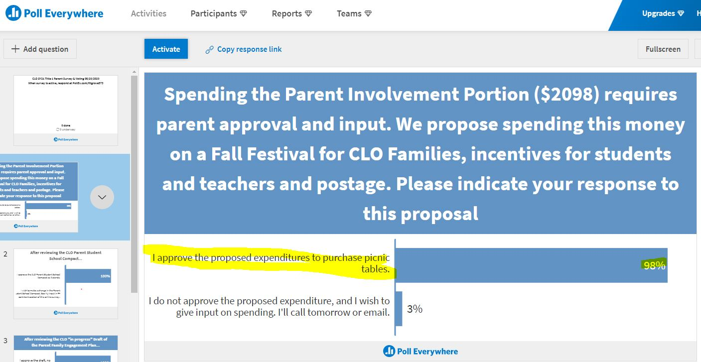
 | What evidence do you have to document parent/family participation in writing/reviewing your PFEP? What evidence do you have that documents parent/family input in spending PFE funds?  Evidence should include an agenda clearly stating the purpose of review/revise the PFEP and a sign in sheet. | Typically, agendas for meetings, sign-in sheets, and meeting minutes all serve to document parent/family participation in writing and reviewing the plan as well as having input for spending of FPEP funds. This year, due to COVID restrictions, we have the evidence of zoom logs and poll everywhere voting results. For audit purposes, zoom logs from Chat box as well as poll everywhere data is saved in the schools Title 1 Audit Box folder on the Google drive.  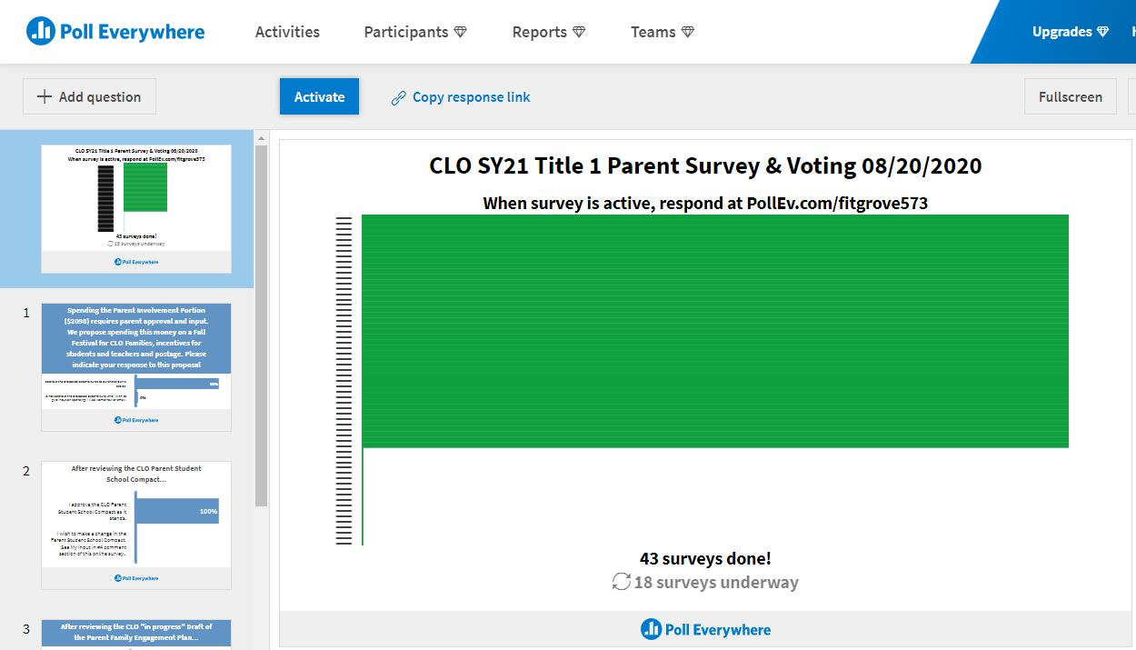
 | Describe how the school will share comments/concerns received from parents/families with stakeholders concerning the Schoolwide Plan and PFEP. How will this plan be made available to the community? | Comments/concerns received from parents/families with stakeholders concerning the  Schoolwide Plan and PFEP are documented in minutes or in a comment section of an online platform. At the quarterly Title One parent meetings throughout the year we review stakeholder comments and concerns to revise the plan as needed.  The plan is continuously made available to all stakeholders through the school website and  a hard copy can be viewed in the front office at the school.

Flexible Parent Meetings
Describe how the school provides flexible dates and times for activities, workshops, events, so that all parents may have an opportunity to attend. | We typically offer meetings at varying dates/times to allow for maximum participation.  Due to COVID restrictions this year we offered both a daytime and an evening Zoom Title 1 parent meeting session to allow even more parents to participate when physically coming to the school is problematic for them or if circumstances regarding the pandemic prevent face to face meetings. We didn’t allow lack of technology or internet access to be a limitation. School messenger, phone and emails were sent to all families inviting them that we will have computers available for anyone without internet or computer access.
Describe what childcare, home visits and/or transportation services are provided by your school to allow all parents to participate in the education of their child. | While we don’t offer daycare, we do structure our meetings to allow for whole family presence & participation. Home visits are conducted by administration, teachers, and guidance as needed. If a parent doesn’t have a means of transportation, administration will provide a means for participation - virtually or in person.
Date and time you will hold your Annual Title I Meeting | Thursday, August 20, 2020. 3 & 6 p.m.
Notification and Invitation:  - How will the school inform and invite parents/families in a timely manner about the Annual Meeting?  - How will the school assure the notification and invitations are in a language all parents can understand? | Notifications and invitations for the annual meeting are sent out weeks in advance. These invitations are posted on the school's Facebook page and are sent out via School Messenger as both a phone call, as an email, and as text message. For our non-English speaking families, both Facebook and School Messenger have translation features to ensure families can access the information.
Information:  Please describe how your meeting will cover the required information about:  - Benefits to all students in a Title I schoolwide program;  - Right-to-know 4-week out-of-field letters & teacher and paraprofessional qualification information,;  - explanation of curriculum;  - assessments used to measure student progress,;  - expected achievement levels on state tests;  - PFE funds;  - School Compact and;  - opportunities provided for engagement. | To guide and assure all Title 1 critical information is covered, an agenda is set and slide slide presentation is presented. The powerpoint presentation is saved in the CLO Title 1 Shared folder on the Google drive. The presentation covers all the required information at the Title I Annual Meeting.
Barriers:  - What barriers will you address to encourage parents/families to attend? Ex: Childcare, Transportation, Meals, Translations | The online Zoom participation venue eliminates the barrier of childcare and transportation. A new barrier that surfaces would be internet and device access. We diminished that barrier by advertising that any family without a device and internet access could come to CLO to participate in the meeting.
Evaluations:  - How will you get feedback from parents about the meeting? | Parents have the option to give feedback regarding the meeting content in a variety of ways. They can email administration, send Facebook messages, or attend the meeting as scheduled to collaborate and give feedback.
Parents who do not attend?  - How will you get the information home to parents who did not attend the meeting? | A recording of the 3 p.m. Title 1 Parent zoom meeting was posted and shared for all stakeholders via the School Messenger system. Additionally, Title 1 requirements and information is posted on the school website.
Building Capacity of Parents to Support Their Child
Explain how parents/families are invited to participate in activities such as parent trainings that are linked to student achievement.
- How will your school help parents gain an understanding of such topics as: the State’s standards, state assessments, achievement levels of proficiency, and how to monitor their child's progress?
Throughout the Fall, the School Messenger system is used to share information with our families. State Standards of focus, assessments, and specific achievement levels of proficiency. A critical component of the “push out” information is including what families can do to help their child. Instructions on how to access the Skyward Parent Portal is shared - in the hopes that parents will log in and monitor their child’s progress in courses and progress on district assessments to predict proficiency on state assessments.
Additionally, following the 3 iready diagnostic assessments, individual student data along with a letter explaining the student’s current standing and next steps to ensure growth.

- What training or materials will you provide to help parents work with their child to improve their child’s academic achievement
Training materials vary and include links to videos and websites. These are shared via School Messenger System throughout the school year.

Title - Topic | Impact on Student Achievement | Materials | Tentative Date/Time  Is this flexible to accommodate  parent schedules? | Transportation | Refreshments | Childcare | Translation
Annual Initial Yearly Title 1 Parent Meeting | If families gain knowledge of Title 1 rights, assessments and goals for the year then our families will better be equipped to encourage, intervene and support their child...ultimately leading to higher student achievement. | Title1 Powerpoint information | Aug. 20, 2020. 2 & 6 p.m. via Zoom | No -online meeting due to Covid. | No -online meeting due to Covid. | No -online meeting due to Covid. | No -online meeting due to Covid.
Sem I Fall Festival | Building a community spirit through collective sharing of an enjoyable event builds rapport between families and staff. Relationships built foster better communication. The better the communication, families will be able to encourage, intervene and support their child...ultimately leading to higher student achievement. Additionally, at the festival, we have a data segment where families earn tickets by reviewing their child’s data with a teacher. Being aware of their child’s current progress, and receiving tips for how to help their child will lead to improved student achievement. | Iready Math, Iready reading diagnostic 1 report, ALEKs report | November 2020 | No -online meeting due to Covid. | No -online meeting due to Covid. | No -online meeting due to Covid. | Yes, Spanish translator available.
Data & Dinner | They always say that sharing a meal is foundational to good relationships. Dinner and Data brings our families out and they get to have a session with a staff member to review new updates on current standing with district assessment. As with any of our data chats, parents are given tips for what to look for and how to help their child. Being aware of their child’s current progress, and receiving tips for how to help their child will lead to improved student achievement. | Reports: iready, ALEKS, grade & attendance reports | January 2021 | As needed | Yes | No | Yes, Spanish translator available.
Spring Push | Spring Push serves twofold. We begin the transition process to middle school by inviting parents to come learn about next year’s options. At the meeting we have staff members available to review new updates on current standing with district assessments. As with any of our data chats, parents are given tips for what to look for and how to help their child. Being aware of their child’s current progress, and receiving tips for how to help their child will lead to improved student achievement. | Reports: iready, ALEKS, grade & attendance reports | March 2021 | As needed | No | No | Yes, Spanish translator available.
- How do you assess the needs of parents?  - How does parent input inform what types of events or workshops you have at your school? | Parent input is welcomed at all times. Through feedback in surveys, SAC meetings, correspondence on the school’s FB page, emails to administration and teacher, and face to face/virtual meetings, parents can share their needs regarding helping their children be as successful as possible. As specific needs arise, administration, along with the SAC Team identifyt workshops or meetings for parents to address those needs.  CLO evaluates the effectiveness of parent activities through attendance and survey feedback data. We compare sign in roster attendance from year to year and parent input at all meetings and events. Agendas and sign in sheets are used for documentation. This year, virtual meeting minutes and attendance will be used to collect a baseline for comparison in future years for how well this platform works. Likewise, the virtual meetings can be compared to face to face meetings to determine if meeting virtually increases involvement.  Community organizations and business partners volunteer at the school or assist with school-related activities in efforts to increase student achievement.
- How do you evaluate the effectiveness of capacity building activities? | Parent input regarding workshops and events is requested weekly Tiger Times School Messenger push out communications. Depending on the feedback and responses, we plan additional capacity building events. Sometimes capacity is developed via one on one communication via principal, Assistant Principal, counselor, dean and teachers.
- Explain how your school implements activities that build relationships with the community, business partners, and churches, to improve student achievements. | CLO is centrally located in the “hub” of the city of Palatka. We partner with various organizations to serve our students and greater community: PAL -Palatka Athletic League, Palatka High School - sporting events and musical theater, St. James Methodist Church, North Point Youth Organization, and various others.  Organizations utilize our facility and in turn, our students benefit either from inclusion in the activity, through donations, or other reciprocation such as mentoring. Ultimately, there is an academic component to any event - we always include a learning component or data review to facilitate families being able to support their child’s academic achievement.
- Examples of capacity building events/activities: literacy training, using technology, Florida standards/curriculum, testing, progress monitoring, transition
information, (K, MS, HS), College and Career, Graduation requirements & scholarships.
- Agendas must document that parent/family activities had an academic component that facilitated parents and family being able to support their child’s
Academic achievement. Sign-in sheets are required documentation.

Building the Capacity of Staff (Professional Development)
This is a requirement under ESSA
Please describe the professional development activities the school will provide to educate teachers, pupil services personnel, principals, and other staff on….
- how to reach out to, communicate with, and work with parents/families as equal partners,
- the value and utility of contributions of parents/families
- how to implement and coordinate parent/family programs
- how to build ties between parents/families and the school
Please describe below how you will provide professional development
Topic-Title | Purpose?  How does this activity help staff build  school/parent relationships? | Implementation format:  (workshop, book study, etc.)  Presenter? | Who is the audience? | Tentative Date/Time
Caring Schools Community Training | Caring Schools Community is the district's SEL state mandated curriculum. Melissa guided homeroom teachers to deliver short mini-lessons on a weekly basis while students eat breakfast. As needed Soc. Studies may pick up some content that takes more time.  Emotions have been high and many are stressed. Processing emotions and coaching students to cope is a critical function of the TA/homeroom segment in the mornings. Activities and lessons build student -teacher relationships and families are included as students seek information as part of their activities. | Blended, company presenter zia Zoom and CLO counselor Melissa Hibbs | CLO Staff | August 5, 2020 8-4
Mental Wellness & Suicide Awareness Training | Teachers are trained in two-way communication and the benefits of reaching out to parents as equal partners build ties  between parents/families at the classroom level and are more likely to keep ongoing  contact/communication with parents which in turn benefits students. The virtual  components of this are  addressed as well considering all that the pandemic has brought on for so many CLO families | Digital | CLO Staff | Sept-Oct, 2020
Canvas Training | Teachers were taught/shown how to utilize Canvas effectively so that student assignments can be monitored by both the parent and the teacher. | Digital | CLO Staff | August 5, 2020
Tiger Times | Weekly Tiger Times digital Family Newsletter give training with screenshots and instructions on how to utilize the and navigate the Skyward Parent Portal to access attendance, schedule, grades and messaging to teachers. | Digital | CLO Families | August-Dec. 2020

Communication
Describe how you notify each family in a timely manner in an understandable format when their child has been assigned, or has been taught for four or more consecutive weeks by a teacher who is out of field? | 4-week Out of Field letters are backpacked home in September to inform parents of any teachers who are teaching out of field.
Describe how you provide each family with timely notice in an understandable format information regarding their right to request information on the professional qualifications of their student’s classroom teachers and paraprofessionals.  Include how the Teacher Certification Letter is sent to parents at the beginning of the year. | During the initial annual Title 1 Parent Night, families are informed via presentation of their rights. They are told in an easy format that if their child is taught by a teacher out of field, they will receive a letter within the first 4 weeks of school. Then within the first 4 weeks the letters are backpacked home.
Describe how parents are informed of the curriculum, forms of assessment used to measure student progress, and the achievement levels students are expected to obtain. | Curriculum updates are shared via School Messenger advising parents of the current units of study and focus standards. During the initial Title 1 meeting, we explain the state assessment, as well as our district progress monitoring assessments: iready, ALEKS, R180. Following the initial Diagnostic assessments, a copy of the results was backpacked home with an easy to follow explanation of the targets and where their child is currently performing relative to the expectation.
Describe how the school will provide each family on individualized report about their child’s performance on state assessments. | Individual score reports typically are sent home with students following a state assessment.
Describe how you ensure that your school holds parent-teacher conferences during which the compact is discussed as it relates to the individual child’s achievement. How is this requirement documented that it occurred? (This is a requirement for elementary schools only, but it is a legislated requirement). | THe compact is reviewed during the Title 1 annual Parent meeting. As needed, the compact functions as a springboard for home interventions during parent conferences

Coordination and Integration – If any of the programs below do not apply to your school please indicate N/A as your response.
Describe how you coordinate and integrate parent and family engagement activities in the programs listed below to help parents help their child at home.
- Homeless | Liaison works with Guidance to service homeless children.
- Migrant | Guidance coordinates meetings with parents and shares relevant information
- HeadStart | Na
- Title II | Select teachers are working with “Teaching and Learning” with Jennifer Azula at the district office where they are engaging in PD. This training may be virtual this year at times due to the pandemic.
- Title III - ELL | Title III Support Leader is available if needed to support ELL students.
- Title IV | Title IV supplies the Wellness curriculum if the school is doing this.
- Title V | Provides funds for professional development
- ESE | ESE Department provides services to all students with an IEP.
- Neglected and  Delinquent | Federal Programs staff is available if needed to support neglected and delinquent youth.
- SAC | At CLO all parents are invited to attend SAC meetings. Agenda, Minutes and sign in sheets document parent participation and correlation to student academic achievement. Funding of Title 1 dollars to schools is discussed and input is given before decisions are made in accordance with SAC voting guidelines.
- PIDAC/MPAC (Migrant Parent Advisory Council) | PIDAC is a district advisory group. Schools submit names of parents of their students to serve on this committee. The committee discusses school related issues, activities and events in order to gain feedback from a variety of stakeholders across the district who then can take back information discussed to the individual schools.  PIDAC meetings are held monthly at the PCSD School Board Room for parents to participate on a District level.
- PTO/PTA | Currently, CLO’s SAC functions as the PTO.
- Community  Agencies | Vary
- Business  Partners | CLO is in the process of expanding our Business Partner list.
- Other

Accessibility
What opportunities do parents have to participate in their child’s education?  - Volunteer?  - Mentor?  - SAC?  - PTO/PTA?  - Other? | Parents have a variety of ways they can participate in their child’s education. They are invited to participate as a member of the SAC group. For those who cannot physically attend meetings, CLO is trying to utilize virtual platforms as an alternative method for meeting as well. The hope is that even more parents can connect and feel involved by being able to take part remotely from home through the use of technology.  Likewise, parents have an opportunity to serve as a volunteer or as a mentor to other students provided they are cleared through the RAPTOR system.  Finally, parents are encouraged to be involved in less formal structures by simply staying involved with their child’s progress at school through connecting with teachers via email, Skyward, FB (school page), phone, or face to face. All teachers will be utilizing Canvas as an online platform for assigned work. This will provide consistent means for parents to check assignment progress status on a regular basis.
What forms of communication do you provide parents in an understandable and uniform format as it relates to:  - school and parent programs  - meetings  - school reports  - other activities | CLO provides communication in the parent's language, both English and/or Spanish as frequently as possible; other languages are provided as needed. We strive to meet the needs and requests of all parents and make any changes to accommodate accordingly. All areas of the school are wheelchair accessible. Title III may provide transportation and services for migrant families that are eligible. Information is sent home through the School Messenger system as well as through the school Facebook page. Parent conferences are also scheduled through the front office for further clarification and explanation of specific information as needed.
What barriers hinder participation by parents in parental engagement activities?  What steps will you take this school year to overcome these barriers - with particular attention to parents who are economically disadvantaged, are disabled, have limited English proficiency, have limited literacy, or are of any racial or ethnic minority background.  Please address the subgroup populations that are included in your schoolwide plan as performing below the state average. How will you support the parents and families of these subgroups to help their children at home? | Time is a barrier at QIR. The steps taken to overcome this barrier include adjusting meeting times to accommodate parents, using phone conferences, and using emails. In addition, CLO will be using virtual platforms for meetings when possible to help eliminate some parent barriers to being involved.  Transportation is a barrier as well, some families do not have a vehicle. The steps taken to overcome this barrier are: using phone conferences, using video chats, and posting available information on the school webpage and/or social media platforms such as Facebook when possible.
How does your school provide information to parents in their native language?  What languages do you provide?  Do you provide translators or facilitators at parent events/workshops? Or, do you provide workshops in a parent’s native language? Explain. | CLO provides communication in the parent's language, both English and/or Spanish as frequently as possible; other languages are provided as needed. We strive to meet the needs and requests of all parents and make any changes to accommodate accordingly. All areas of the school are wheelchair accessible. Title III may provide transportation and services for migrant families that are eligible. Information is sent home through the School Messenger system as well as through the school Facebook page. Parent conferences are also scheduled through the front office for further clarification and explanation of specific information as needed.
How will the school encourage and support additional opportunities for more meaningful engagement for parents/families in the education of their child?  - Parent/Family Resource Centers  - Parent Liaison  - Data Reviews  - SAC  - PTO  - PIDAC  - Other | Our Title 1 events are designed to be appealing yet educational - providing data and needed information. The school counselor serves as a regular parent liaison helping bridge the home-school connection.

