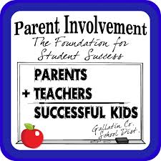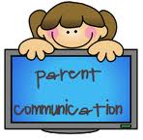

• Inform parents through school wide parent communications (letters, invitations, handbooks, announcements, IRIS Callout, meetings and activities) provided in English and Spanish.

• Hold parent workshops throughout the year to assist parents in understand a variety of topics that impact their child’s education.

**2015-2016 Parent Involvement Plan:**

Sunrise is committed to:

• Involve all parents in the planning, review, and improvement of Title I programs.

• Distribute Title I Booklets to all families at the start of the school year and to new students.

• Implement activities which will build parental involvement, support a partnership among the school, parents, and the community as well as improve student academic achievement.

• Coordinate and integrate parental involvement programs and activities that teach parents how to help their children at home.

• Market the Parent Resource Center to encourage and support parents in the education of their children.

# **Sunrise Elementary School Mission:**

# 

***Sunrise Elementary School is dedicated to meeting the needs of its diverse population through academics, character development, and community involvement.***

**Evening Events:**

Sunrise Elementary School will provide evening events for all families to engage in fun, interactive learning opportunities. The activities are easily replicated at home using common, everyday objects. In addition, parents are offered training opportunities to further develop the academic relationship with their child.

Parent Conferences:

Parents are encouraged to arrange parent conference(s) with Sunrise Elementary School Staff. We try our best to accommodate parents through flexible scheduling times. We ask that parents promptly respond to staff requests for parent conferences. Communication between parents and school personnel is vital to student success.

**Resource Center:**

Sunrise Elementary School will host the Title I Parent Resource Center on the first and third Wednesday of every month from 12:00-2:00 p.m. In addition, the parent resource center will be available at several evening events. Please take advantage of the variety of FREE resources available to you. It is a simple checkout process. See Bea Roldan Ortiz in the front office for more information.

**Evening Events:**

**September:**

Parent Portal Training- Learn how to access student(s) grades to monitor at home.

**October:**

Parent Conference/Compact Night– Meet the teacher and review student(s) initial progress.

**November:**

Understand the Standards- Review and analyze grade level requirements and participate in a Question and Answer session to better understand Florida’s Academic Standards.

**December:**

Literacy Night- Learn fun and engaging ways to encourage reading at home. Get a free book.

**January:**

Math/Science Night- Learn fun and engaging ways to encourage practice math and science concepts at home.

**February:**

Understanding the Assessment– Review the different assessments and learn ways to help prepare students.

**Every Month SAC/PTO:**

We welcome Parent Input and meet monthly with flexible meeting times.