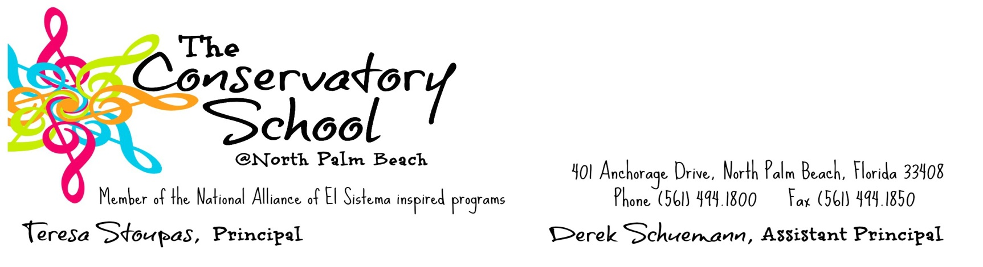
2016-2017 Family Involvement Policy Plan Summary

The Conservatory School is committed to building a strong partnership between parents and the school community. We recognize the importance of parental involvement and the positive impact it has on the success of our students. Below is an outline of the various ways The Conservatory School strives to increase parental involvement on our campus.

Annual Parent Meeting
Parents are invited to attend the meeting at the beginning of the school year to discuss the following:

- What is Title 1?
- Discuss Title 1 Budget

- Discuss Parent’s Right to Know

Building Capacity
Parents are encouraged to join programs and are invited to attend activities that will teach them how to help their child at home. Events are held on campus.
- VPK Program
- Primary Project
- COPA Instrumental Music Program
- School Advisory Council Meetings
- Curriculum Night
- Literacy Night
- Math Night
- Parent Conferences
- Build-a-Violin
- Cardboard Challenge

Communication
We communicate with parents in a variety of ways.

- One Voice Call Out
- Monthly Newsletter
- Agenda/Home School Folder
- Flyers/Notices in all languages
- Community Language Facilitator
- Progress Reports and Report Cards
- Email Blasts
- Website: www.theconservatoryschool.org

Parent Volunteer Coordinator
Mr. Kramer is our Parent Volunteer Coordinator. Parents are encouraged to register as volunteers and participate in events on campus.

Educationally yours,
Teresa Stoupas, Principal Derek Schuemann, Assistant Principal

Please review and send the return portion below with your child to the classroom teacher.
*********************************************************************************************************
I have reviewed the School Policy/Plan

Parent’s Signature: _________________________________________________________ Date: ______________

Student’s Signature: ________________________________________________________ Date: _____________

