**2016/2017 Title 1/PTC/SAC Meeting Dates**

Thursday, September 8, 2016

Thursday, October 6, 2016

Thursday, November 10, 2016

Thursday, January 5, 2017

Thursday, February 9, 2017

Thursday, March 9, 2017

Thursday, April 6, 2017

Thursday, May 11, 2017

All dates – meeting will start at 6 P.M. in the cafeteria.



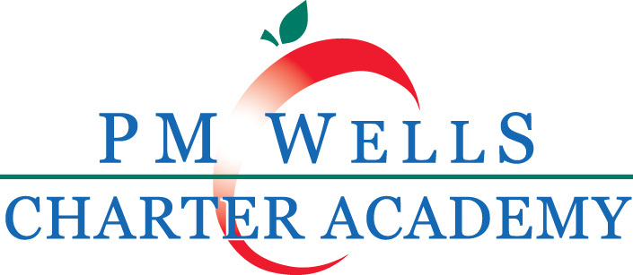

P.M. Wells Charter Academy PIP

Parent Involvement Plan Summary Brochure

2016-2017

Charter Schools USA

School District of Osceola County

**2016/2017 Title 1 Parent Involvement Events**

Open House August 2016

Tutoring Sept. 2016-Mar 2017

Parent Progress Report Night Sept. 2016

Parent Data Chat Night Sept. 2016

English 101 For Parents Sept. 2016-May 2017

Parent Classes Sept. 2016-May 2017

Parent Data Chat Night Jan. 2017

CMA/NWEA Parent University Feb. 2017

**2016/2017 Title 1 Parent Involvement Plan**

If you would like to view

the Parent Involvement

Plan and the School

Improvement Plan in its

entirety, you may request

a copy from the school’s

front office.

**2014/2015 Title 1 Parent Involvement Events**

Tutoring Sept. 2014- May 2015

Science Night Part I Sept. 2014

Math Night Oct. 2014

Benchmark Testing and Throughout

FCAT night

Parent/Teacher Conferences Oct.2014/Nov. 2014/

Feb. 2015

Spelling Bee Dec. 2014

Science Fair Jan. 2015

FCAT Parent University Jan. or Feb. of 2015

Science Night Part II Feb. 2015

Writing Night Feb. 2015

Reading Night Mar. 2015

Multicultural Family May 2015

Craft Night

Family Summer Institute May 2015

**2014/2015 Title 1 Parent Involvement Plan**

If you would like to view the Parent

Involvement Plan and the School

Improvement Plan in its entirety, you may

request a copy from the schools front

office.

**How can I as a parent get involved in my child’s school?**

P.M. Wells Charter Academy will invite parents to the Title 1 Annual Meeting. At this time, parents are able to speak and are given the Parent Involvement Plan/Title 1 Compact with specific information on the subjects that are taught, and information on how parents can help their children at home. Teachers will collect sign-in-sheets, so they can be kept for attendance documentation. The Title I meeting will have parents and their children. An agenda will be discussed as well as the rights the parents and their children have while attending a Title I school. During this meeting we will have a sign in sheet and minutes will be taken.

P.M. Wells Charter Academy Annual Title I meeting will be held on night to accommodate parent schedules. During the meeting, parents will be informed about the Title I program and the Title 1 Resource Center, that comes to our school twice a month. The Title 1 Resource Center will provide different materials that will assist parents in helping their children reach their fullest potential. Parents will also receive information on opportunities to participate in volunteer activities within the school. We will have several different activities to get more parents involved like: Reading Night, Writing Night, Science Night, Tutoring for all grades, and our Family Summer Institute.

Communication to our parents is provided in English and in Spanish. We also have a translator at all of our SAC/PTC and Title I meetings. Any meetings scheduled are posted on the office door, cafeteria door, media room window, and notices are sent home on Wednesday and Friday.

These notices are written in English and Spanish. P.M. Wells Charter Academy also has a newsletter used to communicate events that will be taking place at the school. Newsletters are in English and Spanish. We also use our outdoor marquee as a means of communicating to our community and our parents. For those parents’ or students who are hearing impaired, we have sign language to accommodate those needs.

P.M. Wells Charter Academy has ESOL students. Those students are seen and offered assistance by ESOL teachers. We also have ESE for our IDEA students. Our ESE teachers push into classrooms and offer aid to students with an IEP and for any others needing assistance in the classroom. Our ESE teachers are there for all students, not only the student with an IEP.

P.M. Wells Charter Academy will offer morning, afternoon and evening Parent/Teacher conferences to accommodate parents’ schedule. Our teachers are also available for meetings upon an appointment which is convenient for all parties. We also offer telephone meetings if needed. Our school office is open from 8:00am - 4:00pm Monday, Tuesday, Thursday, and Friday. Wednesday we are open from 8:00 - 3:00pm.

All info is available through our Parent link, the website and all correspondences are sent home via book bag.

If you have questions contact Ms. Reagan Hall at [**RHall@pmwellscharter.org**](mailto:RHall@pmwellscharter.org) or 321-697-1020Bottom of Form