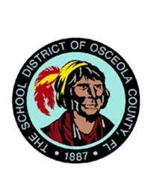
How can I be involved?

• Talk with your child’s teachers and principal to find out how you and your school can work
together to improve your child’s performance.
• Look at your child’s performance and be sure you understand
where your child stands in reading and mathematics.
• Spend time at the school as a volunteer or visitor.
• Take part in after school events, attend open houses and parent nights.
• Support your child’s future; show that education is important.

• Attend the School Advisory Council (SAC) meetings at 7:30 a.m. on the first Wednesday of each month.
• Complete parent involvement surveys sent home each year and at the end of each parent event.
• Attend Parent Teacher Organization (PTO) meetings at 4:30pm on the third Tuesday of the month.
Coordination with
Federal Programs

• Title III provides resources to parents of students who are learning English as a second language. This includes instructional resources as well as translation services for all meetings and events.
• Title II provides resources for teachers and staff to learn strategies and resources to promote parent involvement within the school.
• Title X provides assistance to Families In Transition (FIT) including transportation, health and social services to those who are in need.
• IDEA provides assistance to parents who have students with special needs.

Flora Ridge Elementary is proud to be a Title I school of Osceola County.
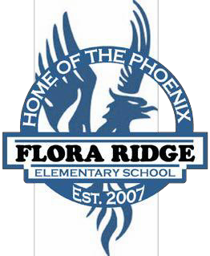

Title I Parent Involvement Plan

2017-2018

Peter Hodges
Principal

Parental Involvement in the School

Parental involvement is key to student success. Flora Ridge Elementary developed the Parent Involvement Plan to describe how we involve parents in the development of policy, activities, and notification of resources to make sure parents of all students can participate in their education. This plan was developed with the assistance and approval of the parents of our students, as well as teachers, community members, and central office personnel.

If you would like to view the Parent Involvement Plan and the School Improvement Plan in its entirety, you may request a copy from the school’s front office or view it on the school website at fres.osceolaschools.net

Flora Ridge Elementary makes every attempt to provide information in multiple languages. All information will be sent home in both English and Spanish. If you require translation in another language for any notices please contact your child’s teacher or the school at 407-933-3999.

Parent Involvement Meetings and Family Nights

Annual Title I Parent Meeting: Receive information on your rights as a Title I parent and what resources are available to you and your child. Meetings will be offered both in the morning and in the evening.

Florida Standards Open House: Meet your child’s teacher and see what standards they will be learning in the upcoming year and then work with your child on various activities in these standards.

Watch D.O.G.S Dads Kick-Off: Calling all dads or other fatherly figures! We need your support in our schools so that our students can succeed academically. Come learn how you can be a part of this great program!

Nachos and Numbers:
Students and parents will munch on nachos while working together to learn math standards as well as have strategies to take home.

Scoops Night-: A night filled with Reading strategies and activities that can be used at home so your child will become a more successful reader.

Science Fair Night: Science Activities Galore! Come on out to be a scientist and discover the world around you. We will also be revealing the winners of our school-wide Science Fair.

Multi-Cultural Night: Come travel around the world and learn about other cultures, food, heritage and traditions. Visit a variety of countries. No passports needed!

Flora Ridge Elementary has scheduled activities on a variety of dates and times, based on parent surveys and input. If you have any questions, concerns, or are in need of translation services for our events, please contact Flora Ridge Elementary at 407-933-3999.

