The Parental Involvement Plan (PIP)
The PIP for 2017-2018 Focuses on how Discovery Intermediate parents outlined for the community how the school would achieve all the student academic goals proposed and the action plan for all parents to support their children.
Parental Involvement: All parents are encouraged to participate in the creation of the Title l Parental Involvement Plan yearly.
Coordination and Integration: The school will train and motivate parents to be a part of programs and activities that instruct parents on how to help their children at home.
Annual Parent Meetings: Will be held on two different days and times twice a year in September, 2017 and February, 2018.
Flexible Parent Meeting: Throughout the year Discovery Intermediate will offer a flexible number of meetings to parents in the morning and afternoons.
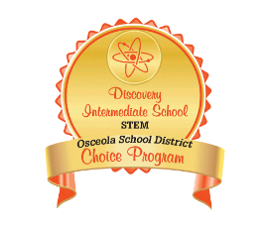
Mr. Glidden Nieves
Nievesg@osceola.k12.fl.us
407-343-7300 ext. 17305
Building Capacity: The school will implement different activities that will promote the capacity for strong parental involvement.
Staff Training: The school will provide professional development activities to educate the teachers and staff in order to build ties between parents and school.
Other Activities: In conjunction with Deerwood Elementary, Discovery has developed a Parent Resource Center (P.R.C.) to be used before and after school by parents in order to gain information on how to assist their children at home.
Communication: Monthly newsletter, emails, flyers, Remind, School Messenger
Accessibility: The marquee located at the front of the school is updated with important events. Also, home newsletters and flyers are sent home in English and Spanish.
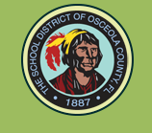
Discovery Intermediate is proud to be a Title I school of the Osceola County.
Presents: Title I Parental Involvement Plan
5350 San Miguel Rd.
Kissimmee, FL 34758
Telephone: 407-343-7300
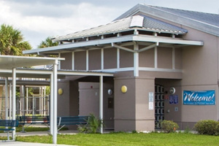
Principal: Mr. Henry Santiago
Assistant Principals: Mr. Gary Dunn & Ms. Deanna Hebbler
Title I Coordinator: Mr. Glidden Nieves
Title I Liaison: Ms. Maria Cuevas

Parental Involvement Plan (PIP)
It was designed by Discovery Intermediate stake holders to provide information to the community on how the school plans on making significant academic gains and how the allocated Federal Funds are to be used to educate parents on achieving those goals. The PIP for 2017-2018 was revised by parent, teachers, administrators, business partners and students at the end of this past school year.
To view the PIP in its entirety, you may request a hard copy, available at the school or to view it online, visit our website:
http://dscv.osceolaschools.net/

What is Title I ?
Title I is a Federally Funded Program which has been established to level the financial and academic fields that present challenges to under privileged families. The objective is to assist students on acquiring the knowledge and skills needed to move forward to higher education or the workforce. Title I, Part A of the Elementary and Secondary Education Act (ESEA) provides grants to LEAs under the United States Department of Education.

Building Capacity
Activity | Resource
Parent Involvement | Title I Coordinator
SAC Meetings | SAC Committee
STEM Nights | STEM Innovators & Discovery Education
FSA Night | Reading & Math Coaches
ESL Night | E.S.O.L. Department
Report Card Nights | Guidance & Teachers
Parent University | Parent Liaison
Parents,Teachers and Students Organization (P.T.S.O.) | Parents

