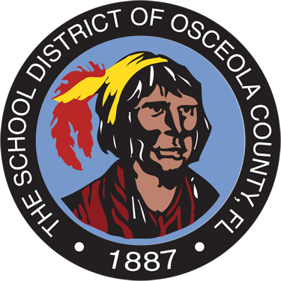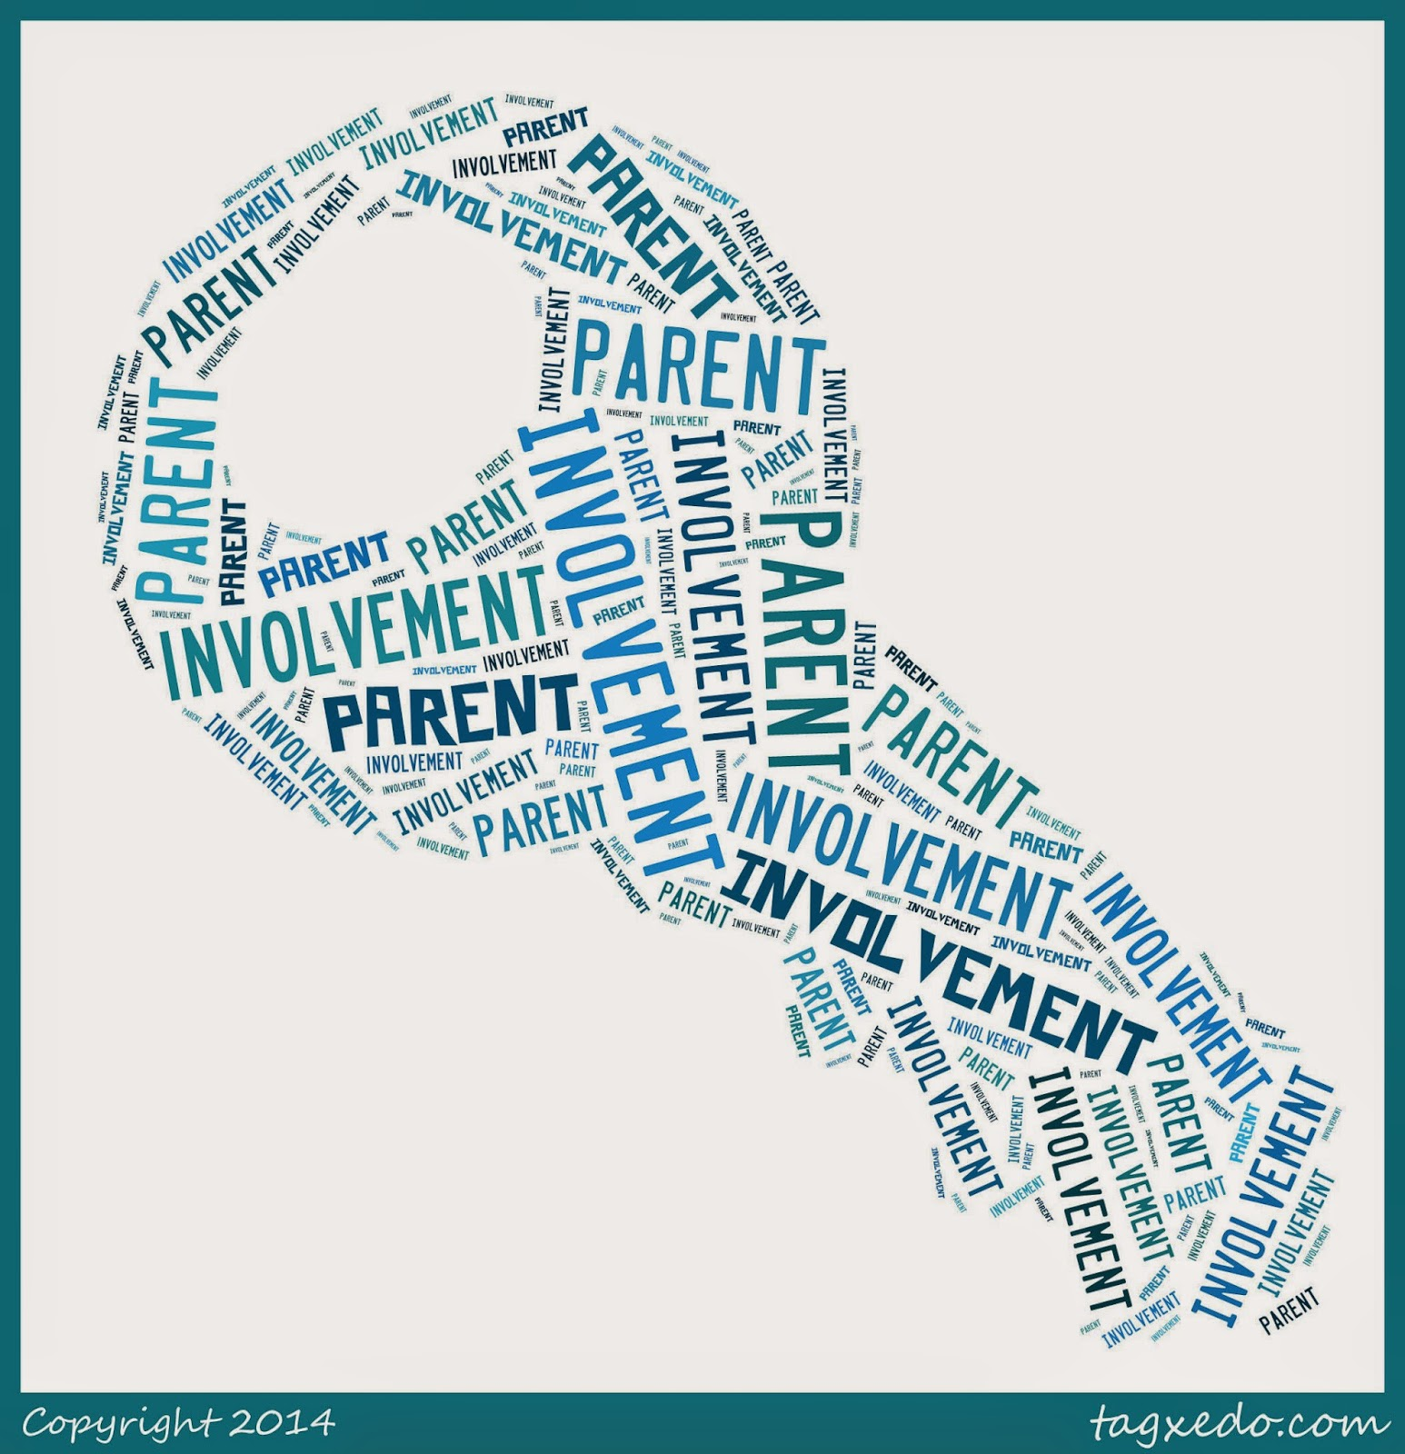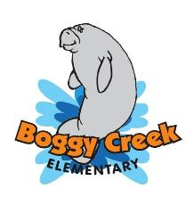

**Join SAC & PTO!**

## How can I get involved?

## Coordination with Federal Programs

* Talk with your child’s teachers and administrators to find out how you and Boggy Creek can work together to improve your child’s performance.
* Review your child’s performance frequently and be sure you understand how your child is progressing in reading, writing, mathematics, science and social studies.
* Become OASIS approved so you may volunteer your time.
* Take part in after school events, attend open house and parent nights
* Support your child’s future; show that education is important.
* Complete parent involvement surveys sent home each year and at the end of each parent event.

School Advisory Council and Parent Teacher Organization meetings are held on the first Thursday of each month at 5:30 p.m. in our school media center. This is a great opportunity for parents to be involved in many important decisions, which affect the learning environment of our children at Boggy Creek!

*Boggy Creek Elementary is proud to be a Title I School of Osceola County, FL*

* **Title III** provides resources to parents of students who are learning English as a second language. This includes instructional resources as well as translation services for all meetings and events.
* **Title II** provides resources for teachers and staff to learn strategies and resources to promote parent involvement with the school.
* **Title X** provides assistance to Families in Transition (FIT) including transportation, health and social services to those who are in need.
* **IDEA** provides assistance to parents who have students with special needs.

### **2017-2018**

### Mrs. Rhonda McMahon

### ***Principal***

Title I

Parent Involvement Plan

## Parent Involvement Meetings and Family Nights

Parent involvement is key to student success. Boggy Creek Elementary School developed the Parent Involvement Plan to describe how we involve parents in the development of policy, activities, and notification of resources to make sure parents of all students can participate in their education. This plan was developed with the assistance and approval of the parents of our students, as well as teachers, community members, administrators and county office personnel.

If you would like to view the Parent Involvement Plan in its entirety you may request a copy from the school’s front office or view it on our website at [www.bces.osceolaschools.net](http://www.bces.osceolaschools.net).

Boggy Creek Elementary makes every attempt to provide information in multiple languages. All information will be sent home in English and Spanish. If you require translation in another language for any notices, please contact your child’s teacher or the school at 407-344-5060.

**September**

**Annual Title I Parent Meeting:** Receive information on your rights as a Title I parent and what resources are available to you and child. Meetings will be offered both in the morning and in the evening.

**Grade Level Night:** Meet your child’s teacher and become aware of what standards they will be learning during the upcoming school year.

**October**

**Fall Literacy Night:** Learn strategies and activities in reading and writing that you can work on with your child at home.

**November**

**Math Night:** Students and parents will work together to learn and interact with math standards. Students and parents will also have strategies to take home!

**November**

**Parent Report Card Conference Night:** Parents will be have the opportunity to conference with their child’s teacher, learn about the 2016-2017 report card and receive their child’s first quarter report card.

**February**

**Science STEM Night:** Parents and students will be able to work through various standards based science stations. STEM = Science, Technology, Engineering and Mathematics.

**Later During the Spring Months**

**Spring Literacy Night:** Learn strategies and activities in reading that you can work on with your child at home.

**~~~~~~~~~~~**

***These are just some of our yearlong parent involvement activities. Boggy Creek Elementary has scheduled activities on a variety of dates and times, based on parent surveys and input. We will send students home with specific dated flyers inviting all parents and students to our events. If you have any questions or concerns, or are in need of translation for our events, please contact Boggy Creek Elementary at 407-344-5060.***

Parent Involvement At Boggy Creek Elementary