Title I

August - October

PFEP

LANCASTER ELEMENTARY 2018-2019

The following is to ensure school-level parent and family engagement plans meet the requirements of Section 1116(b) of the Elementary and Secondary Education Act (ESEA), as amended by the Every Student Succeeds Act (ESSA).
Assurances
The above named school agrees to the following assurances:
Involve parents of children served in Title I, Part A in decisions about how Title I Part A funds are spent;
Carry out the programs, activities, and procedures in accordance with the definitions in Section 8101 of ESEA;
Jointly develop/revise plan with parents and make available to the local community;
❑ Involve parents and families in planning, reviewing, and improving school wide program plan;
Use the findings of the parent and family engagement plan review to design strategies for more effective engagement, and to review, if necessary, the school's parent and family engagement plan;
Provide each family with timely notice information regarding their right to request information on the professional qualifications of the student’s classroom, teachers and paraprofessionals;
Notify each family, in a timely manner, when their child has been assigned, or has been taught for four or more consecutive weeks, by a teacher(s) who is out of field;
Provide each family with an individualized student report about the performance of their child(ren) on the State assessments [ESEA Section 1116]

Mission Statement

1. Does the mission statement include: How the parent and family engagement | Our mission is to provide additional opportunities for parents to participate in their child's education and support the vision of the school.
plan is a shared responsibility? | Parents' input into our Parent and Family Engagement Plan and School Compact is valued. Parents, teachers, and community
How the parent and | members will be solicited for their input at SAC meetings
family engagement  plan will assist in providing high quality instruction for all learners? | throughout the school year. Parents will be engaged in activities  throughout the year that support high quality instruction needed for all learners to be successful.

Involvement of Parents

2. Does the plan | Lancaster Elementary will ensure the organized, ongoing and timely manner of involving parents the following methods:  - Home-to-school and school-to-home communication in English and/or other languages  - Student planners  - Flyers,  - Newsletters,  - Connect Ed messages School Website  - Email  e And other known best practices as needed  At Lancaster Elementary parents and families are involved in the planning, review and improvement of Title I programs, including involvement in the decision making of how funds for Title I funds will be used by:  Attending  - School Advisory Council (SAC) meetings,  - Multilingual Parent Leadership Council (MPLC) meetings  - Annual Title I meeting  Participating In  - Parent/Teacher Association (PTA) activities  Reviewing  - Academic data for funding decision making  - Previous school year Parent and Family Engagement Plan
include:
How the school will
involve the parents
and families in an
organized, ongoing,
and timely manner in
the planning, review
and improvement of
Title I programs,
including involvement
in decision making of
how funds for Title I
will be used [ESEA
Section 1116]?

3. Does the plan include: How the school will coordinate and integrate parent and family engagement programs and activities?  How the school coordinate and integrate parent and family activities that teach parents how to help their child(ren) at home [ESEA Section 1116] ? | We will coordinate and integrate parent and family engagement programs and activities through planned events throughout the year. Our goal is to educate parents on ways and best practices to support their child at home.
Program | Coordination
Pre-K Varying Exceptionalities ESE  - IDEA | Our Pre K Teacher and administrators will work together to coordinate a parent orientation and student transition program for students entering the regular public school program. This will include meetings with parents and our kindergarten team to discuss policies and procedures for kindergarten as well as the specific learning needs and expectations for kindergarten students.
Title I | The Principal and Title I Contact will coordinate with the Title I office to provide opportunities for parental involvement at home, at school and in the community. Professional development modules will be presented to train teachers on effective parental involvement practices. LEA staff will provide guidance and support and monitor the effective implementation of training.
Title II | Higher highly qualified teachers and provide parents information if teachers are out of field. The school will continue to work on informing parents of Florida Standards. Teachers will learn about these standards through Title II funds.
Title Ill | Provides funding for our ELL students' Imagine Learning to support their oral language development. We also have two paraprofessional paid with this fund.
Title X | McKinney Vento Program provides support to our homeless students. The Guidance Counselor and school Social Worker will work with these families to assist in providing services and supports for them.

Annual Parent Meeting

4. Does the plan | Lancaster Elementary will host an annual Title I meeting to inform parents and families of children participating in Title I program at the beginning of the school year. We will host a single meeting to educate parents via the following methods:  - Annual Yearly Progress (AYP) via Power Point Presentation and handouts  - School Choice via district handouts and policies  - The right of parents via brochure and other resources  Parents and families are informed of the nature of the Title I Program by the following statement:  Title I schools receive services from the largest federal aid to education program in existence. Title I has been in existence
include:
A description of the
specific steps the
school will take to
conduct the annual
meeting to inform
parents and families of
participating children
about the school's
Title I program?
A description of the
nature of the Title I
Program that is shared
with parents
(school wide or
Targeted assistance)?

A description of how the meeting will cover adequate yearly progress (AYP), school choice, and the rights of parents are covered at the annual meeting? | since 1965 and continues to level the academic playing field for children victimized by poverty. Title I funds provide services and educational programs to help students achieve. Title I/Migrant Programs administer in excess of $500 million in federal funds to school districts and agencies in Florida for high quality supplemental instruction and support services for educationally disadvantaged children. Our mission is to provide leadership and
 | technical assistance to local education agencies (LEAs) and local
 | operating agencies (LOAs) to implement programs and services
 | that ensure that all children have a fair, equal and significant
 | opportunity to obtain a high-quality education and reach, at a
 | minimum, proficiency on challenging state academic achievement
 | standards and state academic assessments. We provide service
 | to local school districts, agencies, private schools and local
 | neglected and delinquent institutions for Title I, Migrant, and
 | Homeless Programs.
1: | For more information please visit the Florida Department of Education, Office of Title I Programs and Academic Intervention
 | Services at http://www.fldoe.org/bsa/tit1e1/title_compile.asp.
 | Below are the specific steps that Lancaster Elementary will take to
 | conduct annual Title I meeting.
Activity/ Task | Person Responsible | Timeline | Evidence of Effectiveness
Notices sent home to parents in English and Spanish | Title I Coordinator | August 30, 2018 | Copy of notice
Annual meeting date posted on the marquee | PEL | August 30, 2018 | Picture
Agenda and presentation materials developed | Title I Coordinator and School Administrator | August 31, 2018 | Copies of agenda
Connect Orange messaqe sent | School Administrator | September 04, 2018 | Copy of message
Conduct Title I meeting | School Administrator | September 06, 2018 | Sign-in sheets

Flexible Parent Meetings

5. Does the plan | Lancaster Elementary will provide monthly meetings and events with alternating times to include morning and evening attendance opportunities. Morning meetings will be held at 9:00 a.m. and evening meetings will be held at 5:00 p.m. prior to school book fairs, programs, and other school wide activities for convenience.
include:
How will the school
offer a flexible number
of meetings, such as
meeting in the morning
or evening?

How will the school provide, with Title I funds, transportation, child care or home visits, as such services relate to parent and family engagement [ESEA Sectio n 1116]? | Parents will be encouraged to share transportation needs, childcare needs, and any needed accommodations for disabilities prior to all meetings so that we can efficiently provide support. We will also provide ongoing home visits as needed by our school social worker.  The school will provide transportation to parents to one Parent Academy.

Building Capacity

6. Does the plan include:  How the school will implement activities | At Lancaster working as a team is essential and a priority to guarantee academic success of our students. We plan activities which help us build a positive and strong relationship with parents  and the community.  Our Parent Engagement Liaison will be in constant communication with parents via email, phone calls, and letters to make sure they  receive resources, support, and other information.
that will build the capacity for meaningful parent/family
engagement?
How will the school
implement activities
that will build
relationships with the
community to improve
student achievement?
How the school will
provide material and
training to assist
parents/families to
work with their
child(ren)?
How the school will
provide other
reasonable support for
parent/family
engagement activities
[ESEA Section 1116]?
Activity/ Task | Person Responsible | Correlation to Student Achievement | Timeline | Evidence of Effectiveness
 | Instructional Staff | Teachers will  introduce classroom expectations, routines, and establish rapport | August  09, 2018 | Connect Orange Marquee
Meet the Teacher
Open House | Classroom Teachers | Teachers will explain to parents grade level curriculum expectations. | September  06, 2018 | Flyers  Connect Orange

 |  | Teachers will |  | Letters
 |  | conduct individual
 |  | conference to
Conference Night | Classroom Teachers | discuss child' s test results,  expectations , | October  2018
 |  | progress toward
 |  | benchmarks, and
 |  | individual needs.
 |  | Parents and |  | Flyer
Science Night | Instructional Staff | students will interact with science standards through | October  2018 | Connect Orange
 |  | hands on activities.
SAC/PTO meetings | Principal | Parents will actively participate in decision-making process for school | Ongoing | Meeting Minutes

Staff Development

7. Does the plan include: A description of the professional  development activities the school will provide to educate the teachers, specialized  instructional support personnel principals,  other school leaders  and other staff:  - with the assistance  of parents/families, in the value and utility of contributions of  parents/families?  - in how to reach out  to, communicate with, and work with  parents/families as  equal partners?  - in implementing and coordinating  parent/family  programs, and in  buildinq ties between parents/families, and the school [ESEA Section 1116]? | Building the capacity of all school staff is important at Lancaster. In a monthly basis, professional development are provided to educate the teachers.
Teachers are also encourage to participate in professional developments outside our school.
Our school is also doing a Ruby Payne book study with the whole
 | staff so we can all provide adequate support to our students.

Activity/ Task | Person Responsible | Correlation to Student Achievement | Timeline | Evidence of Effectiveness
Parent and Family Engagement Professional | Title I Coordinator | Improved school staff resources to create a welcoming | August,2018 | Sign-in sheets, exit  slips
Development |  | school environment,
Module 1 - Building Strong Partnerships |  | Understand and value the
with Parents and |  | Importance of parent
Families |  | and family
 |  | engagement, and
 |  | maintain strong
 |  | school to home
 |  | partnerships
Parent and Family | Title I Coordinator | Improved ability of | December | Sign-in sheets,
Engagement Professional |  | staff to work with parents and families | 20 18 | exit slips
Development
Module 2:
Building Ties
Between Home and
School
Parent and Family Engagement Professional | Title I Coordinator | Increased parent and family participation in | January,2019 | Sign-in sheets, exit  slips
Development |  | school activities
Module 3: |  | which support
Implementation and |  | student achievement
Coordination of
Parent and Family
Engagement
Proqrams
Parent and Family Engagement Professional | Title I Coordinator | Improved relationship, communication and | March, 2019 | Sign-in sheets, exit  slips
Development |  | collaboration
Module 4:  Communicating |  | between  parents and school
and Working with
Parents as Equal
Partners

Other Activities

8. Does the plan include:  How other activities, such as the parent |  | Lancaster Elementary will use various school resources to assist parents and families with their needs. Our school guidance counselor provides guidance, food, and cloth to our students in  need. In addition she help parents get counseling services when needed.  Our media center offer extended hour so students can use the  computers and enjoy a comfortable place to read or do homework. We have a partnership with the community center and a counselor works with our fourth grade students.
resource center, the school will conduct to encourage and support parents and
families in more meaningful engagement in the education of their
child(ren) [ESEA
Section 1116]?
Activity/ Task |  | Person Responsible | Timeline | Evidence of Effectiveness
Resource Center |  | Guidance Counselor, ESE contact, PEL | Ongoing | Sign-in sheets
Media Center |  | Media specialist | Ongoing | Sign-in sheets
Love Pantry |  | Guidance Counselor | Ongoing | Sign-in-sheets
Virtual Parent Academy | PEL |  | October 4th, 2018 | Pictures
Face to Face Parent  Academy | PEL |  | January 12, 2019 | Pictures
Communication

9. Does the plan | Lancaster Elementary in order to maintain timely communication about Title I programs though the following:  - Hosting the Title I Annual Meeting  - Conducting monthly New Parent Orientation for parents new to the school to cover Title I Programs  Teachers and other staff members will support parents understanding of curriculum, forms and assessments used to measure progress and expected achievement the following:  - School Compact  - Report Card Nights  - Progress Book  - Planners  - Parent Conferences  - Connect Ed Messages  - And other school communication methods
include:
How the school will
provide timely
information about the
Title I programs?
How the school will
describe and explain
the curriculum at the
school, the forms of
assessment used to
measure student
progress and the
achievement levels
students are expected
to obtain?
How, if requested by
parents, the school
provides opportunities
for regular meetings to
formulate suggestions
and to participate, as
appropriate, in

decisions relating to | Parents will be included in the formulation of suggestions and decisions making through the following:  - One-on-One meetings with Teacher and or other needed support personnel  - Parent Surveys  - Participation in the SAC to review School Improvement Plan (SIP), Parent and Family Engagement Plan (PFEP) and School Compact  If the school wide plan is not satisfactory to parents feedback will be presented at the SAC meeting for discussion, review, and needed updates to the plan.  All our meetings are translated in Spanish and Haitian-Creole.
the education of their
child(ren)?
How the school will
submit parents/
families comments if
the school wide plan is
not satisfactory to
them [ESEA Section
1116]?

Accessibility

10. Does the plan | Lancaster Elementary will establish a host of opportunities for parents and families to participate in school activities through ensuring multiple levels of access. We provide Spanish and Haitian-Creole translation in all meetings and events. Our activities and events are held at different times during the day to ensure more parents are able to participate.  Information is share in many different ways: Flyers  Newsletters  Connect Ed messages School Website Instagram  Facebook
include:
A description of how
the school will provide
full opportunities for
Participation in
parent/family
engagement activities
for all
parents/families?
A description of how
the school will share
information related to
school and
parenUfamily
programs, meetings,
school reports, and
other activities in an
understandable,
uniform format, and in
languages that the
parents/families can
understand?

Discretionary Activities (optional)

Does the plan include: Any activities that are not required, but will be paid for through Title I, Part A funding (for example: home visits, transportation for meetings, activities related to parent/family engagement, etc.)
Activity/ Task | Person Responsible | Correlation to Student Achievement | Timeline | Evidence of Effectiveness

Barriers

12. Does the plan include:  A description of the barriers that hindered | Based on previous year feedback our barriers that hindered participation by parents is transportation and work. Many of our families come are homeless living in hotels without a way of
participation by parents/families during the previous school year? | transportation to come to school. Also many parents have two jobs which make it very difficult to have time to come to school events.
A description of the
steps the school will
take during the
upcoming school year
to overcome the
barriers (with particular
attention paid to
parents/families who
are disabled, have
limited English
proficiency, and
parents/families of
migratory children
[ESEA Section 1116]?
Barriers (Including the Specific Subgroup) |  | Steps the School will Take to Overcome
Transportation for Parents (FRL) |  | We will look into an alternate site closer to the hotels to celebrate an event.
Work Hours |  | We will continue to schedule our events at different times (morning, afternoon, and evening) to accommodate parents who work at different times.

School-Parent Compact
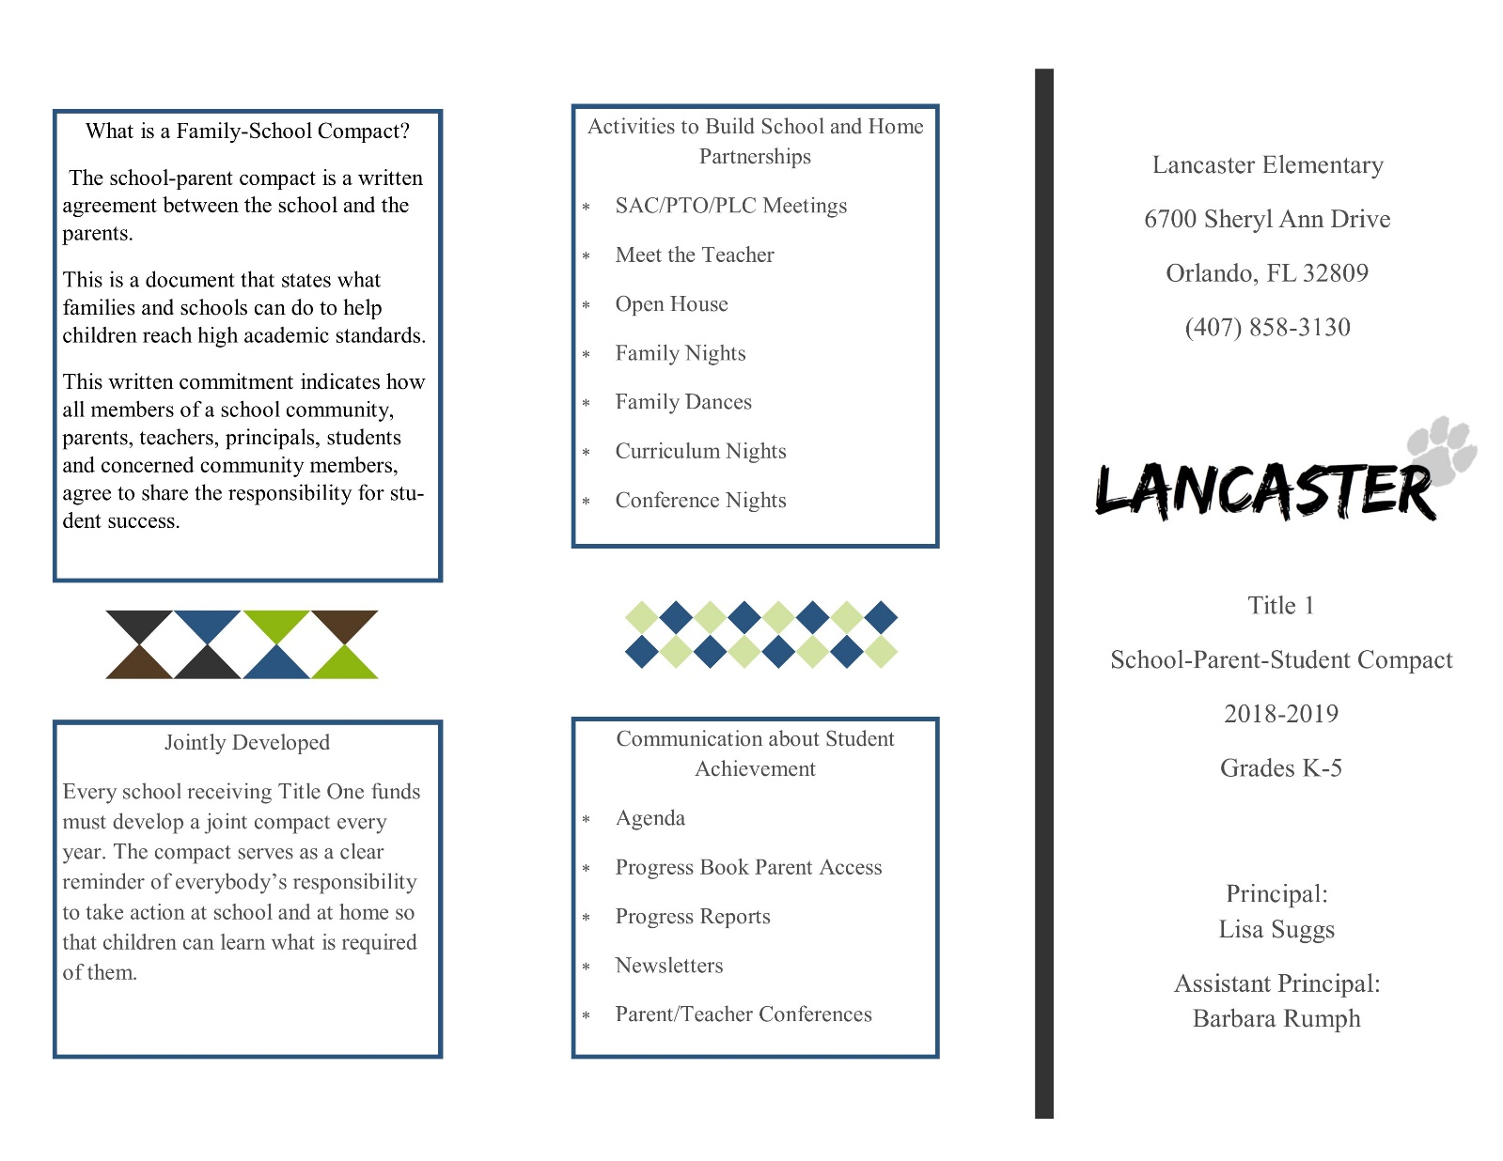

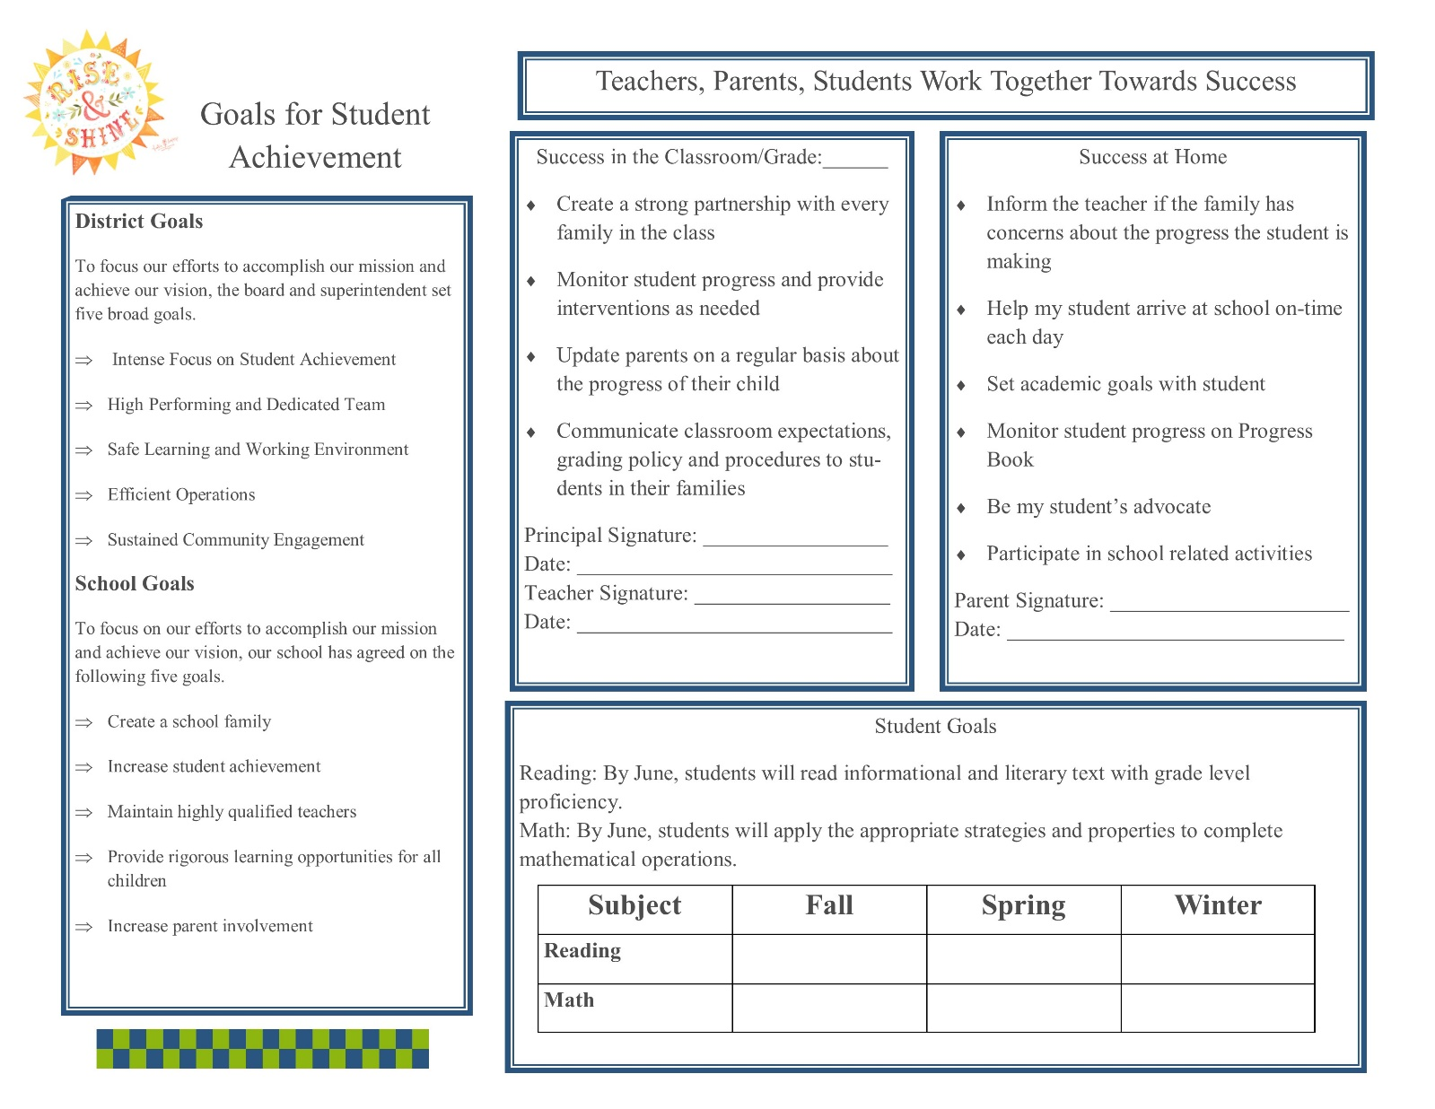

Adoption

The Parent and Family Engagement Policy has been developed jointly with, and agreed on with, parents of children participating in Title I, Part A programs, as evidenced by SAC meeting minutes.

This policy was adopted by the school on _________; and will be in effect for the period of 2018-2019.

The school will distribute this policy to all parents of participating Title I, Part A children on or before _______2018.

Signature of Authorized Personnel
Date

Provide evidence that this policy has been developed with input from parents based on the review of the previous school year's Parent and Family Engagement Plan, if applicable. (Previously referred to as the Parent Involvement Plan - PIP)

The following documents can be scanned with this document and submitted as evidence:
❑ Parent surveys of previous year's events and activities.
❑ Any SAC and/or PTA artifacts with Title 1/PFE topics on the agenda.
❑ Parent Feedback Summary of PFEP Evaluation.
❑ Parent and Family Engagement Activities Tracking Form.

