

* Talk with your child’s teachers and administrators to find out how you and MAE can work together to improve your child’s performance.
* Review your child’s performance frequently and know how your child is progressing in reading, writing, mathematics and science.
* Become OASIS approved and volunteer at MAE.
* Take part in after school events, attend open house and parent nights.
* Support your child’s future; demonstrate to your child (ren) that education is important.
* Attend School Advisory Council (SAC) and PTO meetings.
* Complete the parent involvement surveys sent home each year and at the end of each parent event.
* Visit our Title I mobile resource center that comes to Michigan Avenue from 12:00-2:00 p.m. on the second and fourth Thursday of each month. At this mobile service you will be able to speak with our Title I liaison and borrow various educational resources to help your child at home.

## Coordination with Federal Programs

### **2018-2019**

### Mrs. Diane Crook-Nichols

### *Principal*

### Ms. Erin Williams

### *Assistant Principal*



Title I

Parent Involvement Plan

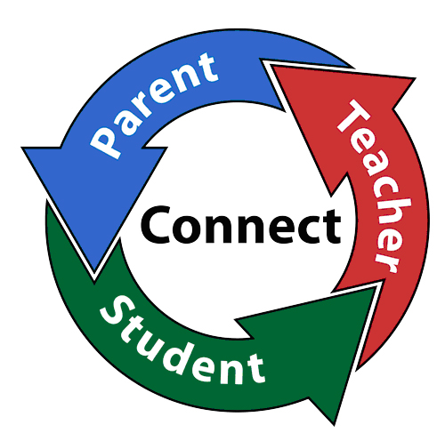

*Michigan Avenue Elementary is proud to be a Title I School of Osceola County, FL*



* **Title III** provides resources to parents of students who are learning English as a second language. This includes instructional resources as well as translation services for all meetings and events.
* **Title II** provides resources for teachers and staff to learn strategies and resources to promote parent involvement with the school.
* **Title IX** provides assistance to Families in Transition (FIT) including transportation, health and social services to those who are in need.
* **IDEA** provides assistance to parents who have students with special needs.

**January – March**

**FSA & Curriculum Information Night:** Provide parents information about Grade Level Curriculum (K-5th) and the Florida Standards Assessment (FSA).

**February**

**Literacy/Multicultural Night:** Learn strategies and activities in reading that you can work on with your child at home.

**Science STEM Night:** Parents and students will be able to tour the STEM bus and work through various standards based science stations. STEM= Science, Technology, Engineering and Mathematics



Family Night events may incorporate performances by our Chorus and Strings Club. Each family event is designed to build parent capacity (knowledge) in the following areas:

iReady – sign in

Parent Portal

OASIS Orientation – fieldtrip requirement for parent/guardian chaperones.

Parent involvement is key to student success. Michigan Avenue Elementary School developed the Parent Involvement Plan to describe how we involve parents in the development of policy, activities, and notification of resources to make sure parents of all students can participate in their education. This plan was developed with the assistance and approval of the parents of our students, as well as teachers, community members, administrators and county office personnel.

If you would like to view the Parent Involvement Plan in its entirety, you may request a copy from the school’s front office or view it on our website at http://maes.osceolaschools.net/

Michigan Avenue Elementary makes every attempt to provide information in multiple languages. All information will be sent home in English and Spanish. If you require translation in another language for any notices, please contact your child’s teacher or the school at 407-891-3140.

**August/September**

**Annual Title I Parent Meeting & OPEN HOUSE:** Receive information on your rights as a Title I parent and what resources are available to you and child. Meetings will be offered both in the morning and in the evening.

**September/October**

**Fall Literacy Night & Science Gross Out Night:** Learn strategies and activities in reading and science that you can work on with your child at home.

**November**

**Parent Report Card Conference Night:** Parents will have the opportunity to conference with their child’s teacher, learn about the 2018-2019 report card and receive their child’s first quarter report card.

**Math Night:** Parents and students will explore and work through various standards based Math stations.

## Parent Involvement Meetings and Family Nights

Parent Involvement at Michigan Avenue Elementary