McIntosh Area Charter School Title I, Part A Parent and Family Engagement Plan
Mission Statement (Optional)
Describe how the parent and family engagement plan is a shared responsibility.
MAS will hold an annual Title One meeting to get input from parents. After the initial meeting the Parent Engagement Plan will be sent home in student home folders at which time parents will again be able to provide input. The final plan will be sent home in home folders following the final updates.

Describe how the parent and family engagement will assist in providing high quality instruction for all learners.
Our parent and family engagement plan will increase the number of parents engaged in their child’s education. Feeling welcome and accepted into the MAS family of educators will help to facilitate an environment of learning for all parties involved. Our goal is, through the parent engagement plan, all involved realize the power of a free quality public education and how parental support is one way to ensure success.

Engagement of Parents
Describe how the school will engage the parents and families in an organized, ongoing, and timely manner, in the planning, review and improvement of Title I programs, including involvement in decision making of how funds for Title I will be used.
McIntosh Area School believes that parental engagement is an integral part of student success. McIntosh Area School believes in involving parents in all aspects of its Title I, program.
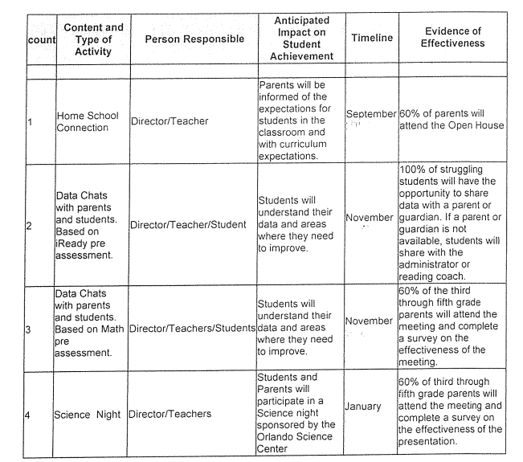

Coordination and Integration with Other Federal Programs
Describe (in the table below) how the school will coordinate with other federal programs and integrate parent and family engagement activities that teach parents how to help their child(ren) at home.
Title I Part A | The school will offer a Title I Informational Meeting to inform parents about the school’s academic progress, curriculum, and available resources offered through Title One.
Title I Part C (Migrant) | The school will access resources for students in the migrant program. Students will be identified through the school enrollment process. Once students are identified the administrator will work with the district migrant coordinator to schedule support services.
Title I Part D (Neglected & Delinquent)
Title II | Teachers and administrators will participate in training to ensure recruiting and retaining highly qualified teachers and administrators.
Title III - ESOL | Students and teachers will have access to resources for English Language Learners. The ESOL coordinator will coordinate with school personnel to provide support to teachers and students.
Title IV Part A
Title IV Part B (21st CCLC) | [Enter text here or N/A]
Title IX Part C - Homeless | The school data entry clerk will identify possible homeless students during the enrollment process. Parents will be given the district forms to fill out and return. Once students are identified as homeless the school will work with district personnel to ensure families have access to local support services.
Home Instruction for Parents of Preschool Youngsters (HIPPY) | The school will distribute HIPPY Program brochures and display the HIPPY Poster throughout the summer.
Individuals with Disabilities Education Act (IDEA) | IEP meetings take place annual and more often if requested to meet with parent and review their child’s strengths and weaknesses. At these meetings we share with parents on ways to assist and encouraging their child in the academic world.
Voluntary Pre-Kindergarten Program | We provide information about the VPK's located in our area and encourage parents to have their children attend. We are exploring the options of having an on-site VPK Program.

Annual Parent Meeting (Stand Alone)
Provide a description of the specific steps the school will take to conduct the annual meeting to inform parents and families of participating children about the school’s Title I program.
Paper invitations will be sent home to parents at least one week in advance. The event will be advertised on the Marquis, Facebook, and Remind text. We will begin the year with a scavenger hunt for parents. They will gather different pieces of information as they tour the campus. During this event parents will have a chance to review the Parent Engagement Plan and Parent/Student/School/Teacher Compact. Then we will have an additional Meeting on Sept. 17th with flexible hours. Morning and Afternoon which is scheduled around student drop off and parent pick up.

Provide a description of the nature of the Title I program that is shared with parents (school wide or targeted assistance).
At the Please sign in the office and pick up the Title One Scavenger paper. (You will need one for each of your children, as the papers will qualify them for a prize.) We will begin a classroom rotation at 1:00 pm. After you visit your child’s classroom please come to the media center for addition school opportunities. BEST of all the Title One Van will be on campus that day! This van offers fun ideas to help engage your child in learning at home. AND it is FREE! Once you have completed the scavenger paper you will need to take it back to the office and turn it in. This will make your child eligible to win a prize on Monday morning.
Annual Title One Meeting
Gather the clues as you go from room to room, person to person! Fill in where each clue was found, then return to front office and turn it in!
Make sure you complete one for each of your children, so they have a chance at the drawing Monday morning!

Parent Name ________________________________ Student Name ____________________________________
Title I provides federal funding to support equitable academic supports and learning opportunities for students.  ________________________ | Every Title I school, in collaboration with parents, MUST prepare a site level parent family engagement policy.  The Parent Family Engagement Policy describes how the school will: engage the parents and family members in an organized, ongoing, and timely way regarding the planning, review, and improvement of the Title I program at their school.  _______________________ | Volunteer  - Classroom  - Home  - Lunch  PTO  Field Trips  Other School Activities  ____________________________
Ask for meetings and trainings  Review the results of annual parent/family engagement effectiveness survey  Review the school’s achievement data  Review the Parent Family Engagement plan in the School Improvement Plan  Review and modify the Title I Parent Family Engagement Policy and Home/School Compact  ______________________ | The school must collect and analyze data that effects student achievement.  The school must develop a comprehensive site plan and annually review the effectiveness of the plan.  The school uses Title I funds to upgrade the entire educational program of the school.  Title I funds are used to serve all students to raise academic achievement.  Title I funds will be used to provide additional assistance to all students who experience difficulties in meeting the State’s performance targets.  _________________________ | The School Advisory Committee (SAC) provides parents and families with an opportunity to be involved in the academic program of the school. The SAC develops, monitors, and evaluates the School Improvement Plan for our school to implement programs and services that support students.  __________________________
The Home/School Compact describes the responsibilities of the school, the parent, and the student to help improved student achievement.  Communication between family members and school staff should occur on a regular basis in a language that family members can understand.  Developed in collaboration among parents, teachers and students  Updated periodically  Distributed with site Title I Parent Family Engagement Policy  ___________________________ | School allocation is based on the number of students that meet the required eligibility.  Funds will support the following efforts  Professional development for staff members, parents, and family members  Home-based programs that reach parents and family members at home, community, and school  Strategies for increasing engagement  Collaborating with community-based organizations  Activities that align with the parent and family engagement policy  _____________________________________ | Provide additional assistance to all students who experience difficulties in meeting the State’s performance targets  Increase academic achievement  Provide professional development for teachers  Promote parent education and engagement  _____________________________

Provide a description of how the meeting will cover yearly progress, school choice, and the rights of parents.
The parent right to know letters went home the first week of school, in child home folders. We will review the SIP (to include yearly progress) plan and school choice during the Sept. 17 meetings.

Flexible Parent Meetings
Describe how the school will offer a flexible number of meetings, such as meetings in the morning or evening.
In an effort to accommodate as many parent schedules as possible, all parent meetings will be offered initially right after school as all of our children are car riders. The next morning the same presentation/information opportunity will be available through the director. If parents cannot attend either session of face to face training, the information will be shared through the school website, upon request a packet with the presentation will be sent home in student backpacks or emailed to a parent, and packets of information with the presentation will be kept on file for parents to review in the office.

Describe how will the school provide, with Title I funds, transportation, childcare or home visits, as such services relate to parent and family engagement.
N/A

Building Capacity
Describe how the school will implement activities that will build the capacity for meaningful parent/family engagement.
MAS offers an open-door policy and encourages parents to volunteer in the classrooms. We provide activities (Book Character Day, Thanksgiving Feast (including school performance), Winter Carnival, Science Night, Award Ceremonies, Graduations, Field Trips, etc.) where parents are encouraged to participate and even join in. With every opportunity comes a chance to bond and learn something new.

Describe how the school will implement activities that will build relationships with the community to improve student achievement.
We have a volunteer coordinator that is an important part of our community. She will continue the commitment to involve the community as we have in the past. The Friends of McIntosh donate resources and time to our school through promoting the Eagle Bucks store. Center State Bank helps fifth graders with learning a bank account. The Garden Club helps donate time and resources for students to engage in science projects. We have a community member that runs our Media Center for our students check out books. We celebrate their willingness to support our school with a tea and a breakfast to thank them.

Describe how the school will provide materials and trainings to assist parents/families to work with their child(ren).
Parents will be trained on the use of Skyward to access their child’s achievement. MAS will also share with parents the use of i-Ready Math and Reading. The Marion County Title One van visits our campus 4 times a year to provide parents the opportunity to gather materials to help facilitate their child’s learning.

Describe how the school will provide other reasonable support for parent/family engagement activities.
Teachers all available in the mornings, afternoons and evenings, by appointment, to assist parents with academics that are happening in the classroom.

Staff Development
Provide a description of the professional development activities the school will provide to educate the teachers, specialized instructional support personnel, principals, other school leaders and other staff with the assistance of parents/families, in the value and utility of contributions of parents/families.

count |  | Content and  Type of Activity |  | Person  Responsible |  | Anticipated Impact on Student Achievement |  | Timeline |  | Evidence of  Effectiveness
1 |  | i-Ready |  | Administrator/i-  Ready trainer |  | Teachers will use i-Ready to help differentiate their classroom instruction |  | August |  | MTSS documentation will be reviewed and adjustment made based on student progress.
2 |  | MTSS |  | Administrator/teachers/  Interventionist/ Lab tech |  | Adjustments will be made to instruction based on student’s needs. |  | Quarterly |  | MTSS documentation will be reviewed and adjustment made based on student progress.
3 |  | Unify |  | District Staff/Administrator |  | Teachers will be trained on the use of Unify |  | August |  | MTSS documentation will be reviewed and adjustment made based on student progress.
4 |  | Parent Portal |  | Administrator |  | Parents will use the portal to access information regarding grades and classroom progress. |  | as needed |  | Parents' utilization of the portal.
 | 5 |  | Effective  Conferencing |  | Teachers |  | Effective communication on student curriculum requirements will allow parents to help support classroom efforts at home. |  | October and  March |  | Conference notes from school wide conferences and parent feedback from conferences.

Provide a description of the professional development activities the school will provide to educate teachers, specialized instructional support personnel, principals, other school leaders and other staff with the assistance of parents/families, in how to reach out to, communicate with, and work with parents/families as equal partners.
Our school is unique as our teachers are well versed in including families in the education of their students. They frequently, text parents or parents text them. Parents pick up children daily, so there is communication during pick-up. Classroom newsletters go home monthly. And teachers and staff will arrange to meet with parents at a parent’s reasonable request.

Provide a description of the professional development activities the school will provide to educate teachers, specialized instructional support personnel, principals, other school leaders and other staff with the assistance of parents/families, in implementing and coordinating parent/family programs, and in building ties between parents/families and the school.
Our school is unique as our teachers are well versed in including families in the education of their students. They frequently, text parents or parents text them. Parents pick up children daily, so there is communication during pick-up. Classroom newsletters go home monthly. And teachers and staff will arrange to meet with parents at a parent’s reasonable request.

Other Activities
Describe other activities (ex: parent resource center) the school will conduct to encourage and support parents and families in more meaningful engagement in the education of their child(ren).
McIntosh Area School will promote the Title I Resources available, as well as schedule the Title I Resource Van from Marion County Public School System for parental use of the materials. We will provide literature/handouts about the Resource Center and Van Schedule.
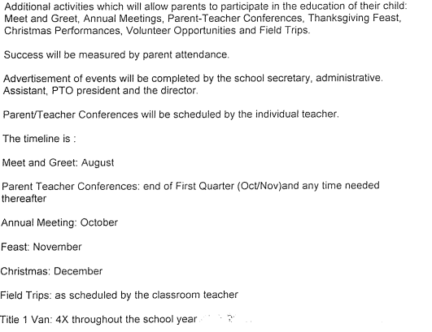

Communication
Describe how the school will provide timely information about the Title I programs.
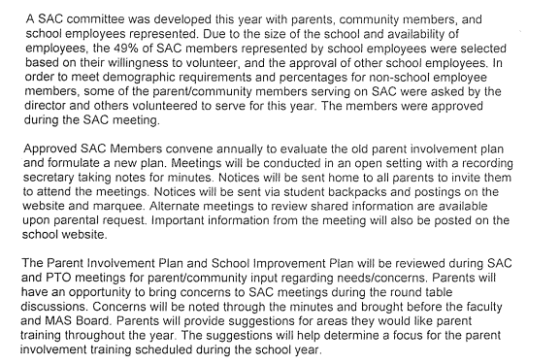

Describe how the school will describe and explain the curriculum at the school, the forms of assessment used to measure student progress and the achievement levels students are expected to obtain.
This will be completed at Open House and through distribution of letters that will be sent home with students through-out the school year. The letters will explain the purpose of assessment and when they will be administered. Teachers will discuss the results with parents at conferences schedule throughout the year. Parents will have access to Skyward where assessment results will be housed.

Describe how, if requested by parents, the school provides opportunities for regular meetings to formulate suggestions and to participate, as appropriate, in decisions relating to the education of their child(ren).
Parents are always welcome to visit the Director in the office or by phone. We have our School Board meetings posted for the school year and we send a reminder each month. Parents are invited to become a part of SAC meetings which are also advertised and posted. PTO is always encouraging parents to become active members. We would like to see if we could set up a meeting online for parents that cannot be physically present at school

Describe how the school will submit parents/family’s comments if the school wide plan is not satisfactory to them.
Parents are encouraged to put ideas and suggestions in writing, then send them in with their child. They can call the school directly. The school surveys are well received by our parents and we usually have very closed to 100% return rate. This information will then be relayed to the school lead team to determine next steps.

Accessibility
Provide a description of how the school will provide full opportunities for participation in parent/family engagement activities for all parents/families.
Activities happen at all different times of the day. Some events are during the school day. Some are scheduled for right after school and others in the evenings. We try to provide enough notice for parents to be able to make arrangements ahead of time.

Provide a description of how the school will share information related to school and parent/family programs, meetings, school reports, and other activities in an understandable, uniform format, and in languages that the parents/families can understand.
Information is provided to parents in different formats, letters, facebook, text messages and phone calls. There is always someone available during the school day to meet with parents and explain information that is not understood. If we have non-English speakers we will us an internet program to translate information.

Discretionary Activities (Optional)
Describe any activities that are not required, but will be paid for through Title I, Part A funding (for example, home visits, transportation for meetings, activities related to parent/family engagement, etc.).
During our Awards Ceremony we will host a make-it-take meeting for parents and another parent informative meeting between ceremonies.

Barriers
Describe the barriers that hindered participation by parents during the previous school year.
Many parents are working two jobs to make things work. They are tried when they finally arrive at home. Others have children that are involved in sporting events, 4H, church activities, etc. this keeps them very busy and with little to no time to participate in school activities.

Provide description of the steps the school will take during the upcoming school year to overcome the barriers (with particular attention paid to parents/families who are disabled, have limited English proficiency, and parents/families of migratory children).
MAS meets all the federal and state requirements to make our campus available to all parents. From the moment the parents register their child we make sure parents have access to the campus. We are only a phone call away.

