Melrose Elementary School - Title I, Part A Parental and Family Engagement Plan
Title I, Part A, Section 1116 of the Every Student Succeeds Act (ESSA) requires that each school served under Title I, Part A, develop jointly with, agree on with, and distribute to parents and family members of participating children a written parent and family engagement policy/plan.

I, Leah Lundy, do hereby certify that all facts, figures, and representations made in this application are true, correct, and consistent with the statement of assurances for these waivers. Furthermore, all applicable statutes, regulations, and procedures; administrative and programmatic requirements; and procedures for fiscal control and maintenance of records will be implemented to ensure proper accountability for the expenditure of funds on this project. All records necessary to substantiate these requirements will be available for review by appropriate state and federal staff. I further certify that all expenditures will be obligated on or after the effective date and prior to the termination date of the project. Disbursements will be reported only as appropriate to this project, and will not be used for matching funds on this or any special project, where prohibited.
Assurances
- The school will be governed by the statutory definition of parental involvement, and will carry out programs, activities, and procedures in accordance with the definition outlined in Section 9101(32), ESEA;
- Involve the parents of children served in Title I, Part A in decisions about how Title I, Part A funds reserved for parental involvement are spent [Section 1116(b)(1) and (c)(3)];
- Jointly develop with, and distribute to, parents and family members of participating children a written parent and family engagement policy, agreed on by parents, that shall describe the means for carrying out the requirements of subsections (c) through (f) and make available the parental involvement plan to the local community and updated periodically to meet the changing needs of parents and the school. [Section 1116(b)(1)];
- Involve parents, in an organized, ongoing, and timely way, in the planning, review, and improvement of programs under this part, including the planning, review, and improvement of the school parental involvement policy and the joint development of the schoolwide program plan under section 1114(b)(2) [Section 1116(c)(3)];
- Use the findings of the parental involvement policy review to design evidence-based strategies for more effective parental involvement, and to revise, if necessary, the school’s parental involvement policy [Section 1118(a)(E)];
- If the plan for Title I, Part A, developed under Section 1112, is not satisfactory to the parents of participating children, the school will submit parent comments with the plan when the school submits the plan to the local educational agency [Section 1116(c)(5)];
- Provide to each parent an individual student report about the performance of their child on the state assessment in at least mathematics, language arts, and reading [Section 1111(h)(6)(B)(i)];
- Provide each parent timely notice when their child has been assigned or has been taught for four (4) or more consecutive weeks by a teacher who is not highly qualified within the meaning of the term in 34 CFR Section 200.56 [Section 1111(h)(6)(B)(ii)]; and
- Provide each parent timely notice information regarding their right to request information on the professional qualifications of the student's classroom teachers and paraprofessionals [Section (h)(6)(A)].

Signature of Principal or Designee | Date Signed

Mission Statement:
- How the parent and family engagement plan is a shared responsibility between home and school.
- How parent and family engagement supports high quality instruction for all learners.

Response
The parent and family engagement plan is created and edited by school personnel and parents. Parent input is given via School Advisory Council (SAC)meetings, parent questionnaires, and the 5 Essential parent questionnaire. All stakeholders work together to provide the best possible education for our students through communication and collegiality. Through shared responsibility (school and parents) we will ensure that all students are provided a high quality of education by continuous progress monitoring of PFEP.

Involvement of Parents
Describe what actions the school will take to involve parents in an organized, ongoing, and timely manner, in the planning, review, and improvement of Title I programs including involvement in the decisions regarding how funds for parental involvement will be used [Sections 1116(c)(3), 1114(b)(2), and 1118(a)(2)(B)].

Response:

All parents are invited to School Advisory Council meetings where the team will ask for parent input on planning, reviewing, and improvement of Title I programs including involvement in the decision making on how the funds will be used. Meetings will be advertised in our monthly newsletter and are documented by agendas, minutes, and sign in sheets that are kept in the Title I audit box.

Annual parent surveys are sent home in April. The results from the surveys are used to help Melrose Elementary review the school’s parent involvement practices and see where improvements can be made. Four parent involvement activities have been scheduled for the 2018-2019 school year. Parents are invited to take part in these activities, to volunteer at any time during the school day or for school functions, to serve as active participants in our safety patrol programs, field trips, etc.

Coordination and Integration
Describe how the school will coordinate and integrate parental involvement programs and activities that teach parents how to help their children at home, to the extent feasible and appropriate, with other Federal, State, and local programs, including public preschool programs, and conduct other activities, that encourage and support parents to fully participate in the education of their children. [Section 1116(e)(4)].

Response:

count | Program | Coordination
1 | Voluntary PreK | Parent workshops/engagement programs and literacy packets throughout the school year that teach parents how to help their children at home.
2 | Title I | Funding for parent workshops that teach parents how to help their children at home.
3 | Title I part C | Works with LEP students and migrant students/district provides advocates for LEP and migrant students.
4 | Title X Project Praise Federal Programs | Provides home visits, school supplies, transportation, translating services, medical care assistance, etc. to students who qualify as homeless
5 | Title III | District provides advocates for LEP and migrant students

Annual Parent Meeting
Describe the specific actions the school will take to conduct an annual meeting, at a convenient time, and encourage and invite all parents of participating children to attend, to inform them about the Title I program, the nature of the Title I program (schoolwide or targeted assistance),and the rights of parents to be involved [Section 1116(c)(1)].

Response:

count | Activity/Tasks | Person Responsible | Timeline | Evidence of Effectiveness
1 | Title I Annual Meeting to  Inform parents of Title I and parental rights | Administration | August 30, 2018 | Sign in sheets, agenda, Title I flyer

Flexible Parent Meetings
Describe how the school will offer a flexible number of meetings, such as meetings in the morning or evening, and how Title I funds will provide transportation, child care, or home visits, as such services related to parental involvement [Section 1116(c)(2)].

Response:

The Melrose School Advisory Council meets during the school year at 7:15 am or 2:45 pm. Parent nights are usually 6:00 – 7:00 pm. Most parent nights are family oriented enabling the entire family to participate. The school is prepared to offer childcare for parent nights if the activity warrants it. Individual Education Plans and MTSS meetings are scheduled during school hours and parents are welcome to bring younger children with them. Administrators and the guidance counselor are more than willing to transport parents if there is a need. The Title I Annual parent meeting has a start time of 6:00 pm to ensure parents who typically work day hours can attend. Fifth grade safety patrol parents are given opportunities to meet on weeknights and Saturdays. Likewise, parent-teacher conferences can be scheduled during morning and afternoon hours as well as during any convenient planning time during the day.

Building Capacity
Describe how the school will implement activities that will build the capacity for strong parental involvement, in order to ensure effective involvement of parents and to support a partnership among the school involved, parents, and the community to improve student academic achievement [Section 1118(e)].

Describe the actions the school will take to provide materials and training to help parents work with their child to improve their child’s academic achievement [Section 1118(e)(2)].Include information on how the school will provide other reasonable support for parental involvement activities under Section 1116 as parents may request [Section 1116(e)(14)].

Response:

count | Content and Type of Activity | Person Responsible | Anticipated Impact on Student Achievement | Timeline | Evidence of Effectiveness
1 | Title I Annual Meeting | Administration | Parents will be more informed and aware of the services Title I offers and will become more involved with their child’s education (via SAC, for example) which will improve student success. | 8/30/18 | Sign in sheets, Power point notes, Title I flyer
2 | Grade Level data informative nights | Administration | Parents will be more informed about assessments by each grade level (iReady diagnostic, FSA, K-BIT). | Various nights | Increased test scores, increased parental awareness
3 | Bingo for Books and strategies for helping with reading homework | Administration | More students will be reading on grade level, will have better iReady reading scores, and better standardized test scores as a result of participating and receiving free books. Parents will be more aware of the importance of nightly reading and support the reading practice at home. Community members are invited to participate as well. | 11/1/18 | Engaged parents=academically motivated students
4 | Make and Take art projects | Administration,  Classroom teachers | Following multi-step directions, parents will work with their child(ren) to read directions and make holiday-oriented projects with their child(ren), community members, and school staff. This is foster better parent-school-community relations and in turn improve student success in school | 12/13/18 | Engaged parents=academically motivated students

Staff Training
Describe the professional development activities the school will provide to educate the teachers, pupil services personnel, principals, and other staff in how to reach out to, communicate with, and work with parents as equal partners, in the value and utility of contributions of parents, and in how to implement and coordinate parent programs, and build ties between parents and schools [Section 1116(e)(3)].

Response:

count | Content and Type of Activity | Person Responsible | Anticipated Impact on Student Achievement | Timeline | Evidence of Effectiveness
1 | Beginning of year faculty meeting where 2-way parent/teacher communication is discussed | Administration | With parent/teacher communication, students should have increased positive behavior and better academic success. Likewise, parents should feel well-informed as noted through the district parent surveys. | 8/7/18 | Sign-in sheets; behavior intervention logs, conference forms/planner notes yielding 100% 2-way parent/teacher communication (both equal partners).
2 | School Advisory Council Meetings | SAC Chair | With parents assisting in making decisions and voting on important school-related issues, they should feel more involved and therefore take a more active role in their child’s education which should in turn improve academic success for students at school. This will also increase valuable input from parents and increase ties between parents and school. | 9/21/18 and monthly thereafter | Sign-in sheets, meeting minutes showing parent input and grades/scores of students whose parents participate in SAC
3 | MTSS Training | Sarah Wylie | Teachers will provide interventions to students working below grade level to close academic learning gaps that have been identified and monitored through the MTSS process. Throughout the process, teachers will assure that parents are involved and aware of established interventions and progress regarding it. This will also increase ties between parents and school.

Other Activities
Describe the other activities, such as parent resource centers, the school will conduct to encourage and support parents in more fully participating in the education of their children [Section 1116 (e)(4)].

Response:
There is a parent resource center at the Federal Programs building in Palatka that parents are made aware of at the Annual Title I meeting. Throughout the year, parents have the option to take advantage of the provided resources.

A small group of our Melrose parents attend PIDAC meetings on a regular basis at the Federal Programs building, and in turn bring back the information learned there to our school-based SAC.

Parents are also active members of our school-based SAC and offer input and suggestions related to decision-making for school functions.

Parents are encouraged to use our media center internet stations to read the Putnam County School’s website and browse for school related information, sign students up for Kids Care health insurance, and access Parent Portal.

Additionally, we have a “pamphlet center” to offer information to help parents deal with various issues their children may be facing. This center is updated throughout the year as needed.

Communication
Describe how the school will provide parents of participating children the following [Section 1118(c)(4)]:
- Timely information about the Title I programs [Section 1116(c)(4)(A)];
- Description and explanation of the curriculum at the school, the forms of academic assessment used to measure student progress, and the proficiency levels students are expected to meet [Section 1116(c)(4)(B)];
- If requested by parents, opportunities for regular meetings to formulate suggestions and to participate, as appropriate, in decisions relating to the education of their children[Section 1116(c)(4)(C)]; and
- If the schoolwide program plan under Section 1114 (b)(2) is not satisfactory to the parents of participating children, the school will include submit the parents’ comments with the plan that will be made available to the local education agency [Section 1116(c)(5)].
Response:

Information about the Title I program is shared with parents the first week of school and more specifically at the Title I Annual Meeting in August.

Also, Melrose Elementary sends home a monthly newsletter informing parents about assessments, Title I information, and parent activities that are coming up.

Every four and a half weeks a progress report or report card is sent home informing parents on the academic progress of their children.

Traditionally, a parent conference was set up with each parent/guardian of a child receiving a Standards-Based report card to explain the changes between those and traditional report cards.

Every Thursday a team is set up to meet with parents to discuss individual education plans and Wednesdays a MTSS team is set up to discuss strategies for students having difficulty with academics and/or behavior. Parent input and attendance is welcome in both IEP and MTSS meetings.

The PFEP will be uploaded to our school’s website to solicit any changes that parents feel are needed to make the plan satisfactory. Parent input will be utilized to update this plan.

Finally, Melrose will use the messenger call-out program to inform families about school-wide events or pertinent and emergency information via phone or text message. Accessibility

Describe how the school will provide full opportunities for participation in parental involvement activities for all parents (including parents with limited English proficiency, disabilities, and migratory children). Include how the school plans to share information related to school and parent programs, meetings, school reports, and other activities in an understandable and uniform format and to the extent practical, in a language parents can understand [Section 1116(e)(5) and 1116(f)].
Response:
Melrose will have a translator available for LEP meetings. A translator will also be available to assist with translated documents, home/school communication and phone conversations.

Likewise, many district forms are available in the home language of the parent. Migrant advocates are available for students and parents which can be accessed at the district level as well.

Finally Melrose campus is wheelchair accessible for students, parents, and staff.

Discretionary Activities - Indicate which (if any) of the following discretionary school level parental involvement policy components the school will implement to improve parental involvement.

- XX Involve parents in the development of training for teachers, principals, and other educators to improve the effectiveness of that training;
- XX Provide necessary literacy training for parents from Title I, Part A funds, if the school has exhausted all other reasonably available sources of funding for that training;
- XX Pay reasonable and necessary expenses associated with parental involvement activities, including transportation and child care costs, to enable parents to participate in school-related meetings and training sessions;
- Train parents to enhance the involvement of other parents;
- XX In order to maximize parental involvement and participation in their child’s education, arrange school meetings at a variety of times or conduct in-home conferences with teachers or other educators who work directly with participating children and parents who are unable to attend conferences at school;
- XX Adopt and implement model approaches to improving parental involvement;
- XX Establish a schoolwide parent advisory council to provide advice on all matters related to parental involvement in Title I, Part A programs;
- XX Develop appropriate roles for community-based organizations and businesses, including faith-based organizations, in parental involvement activities.

Evidence of Input from Parents
- Attach documentation of parent input into the plan. (Agenda, sign-in sheet, minutes)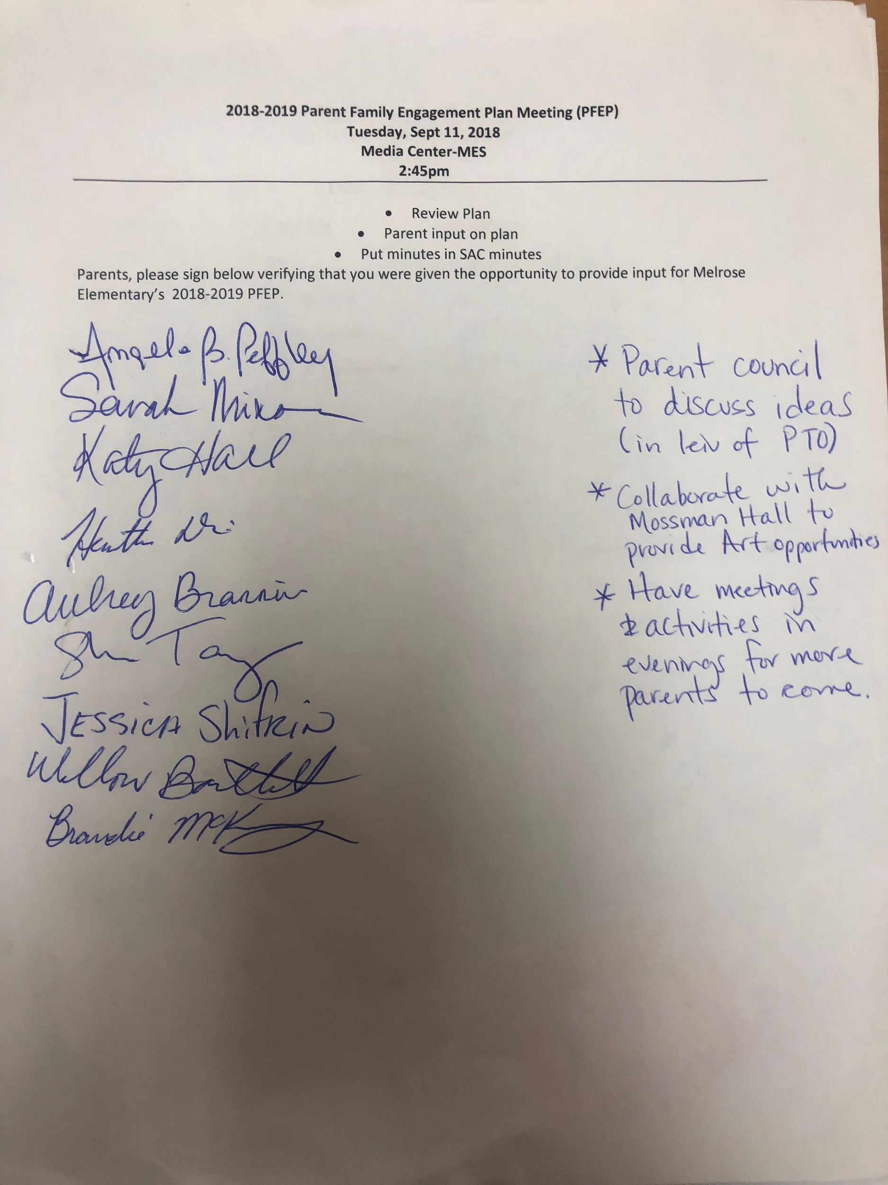

Parent-School Compact
- Attach a copy of the 2018-2019 Parent-School Compact

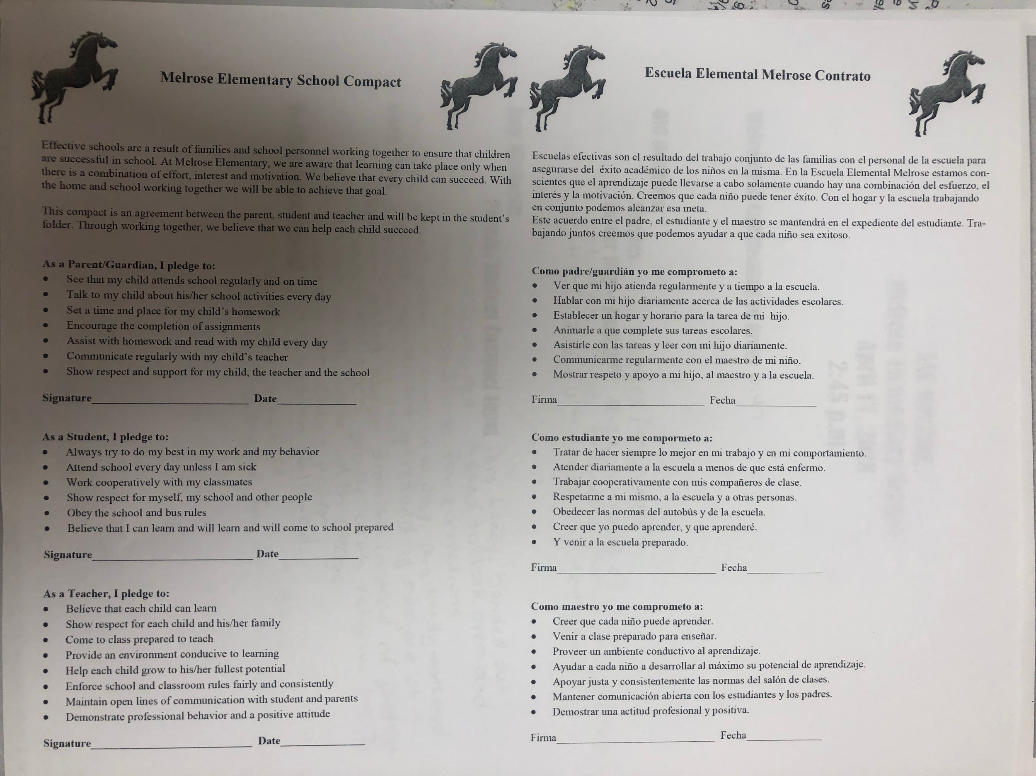
Evidence of Parent Involvement in Development of Parent-School Compact
- Attach documentation of parent input into the compact. (Agenda, sign-in sheet, minutes)
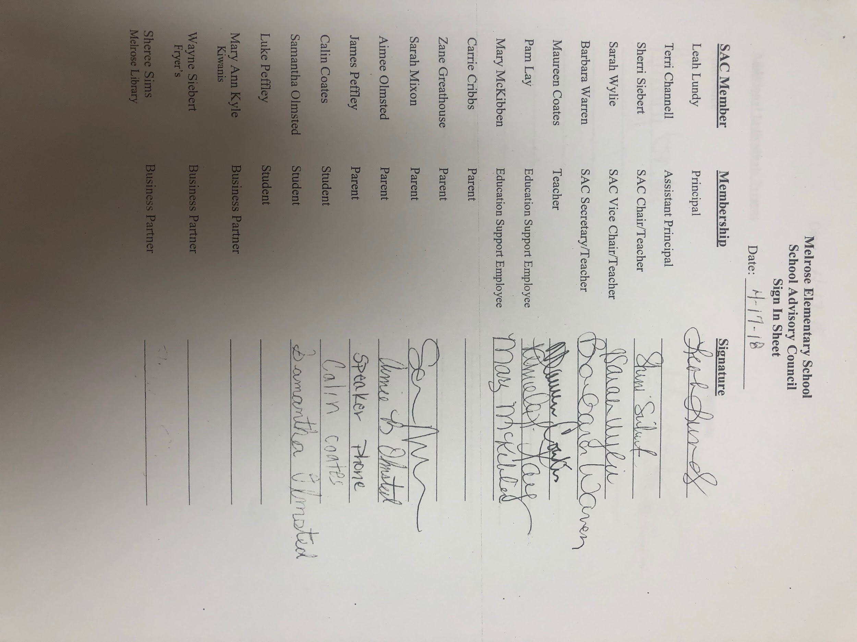
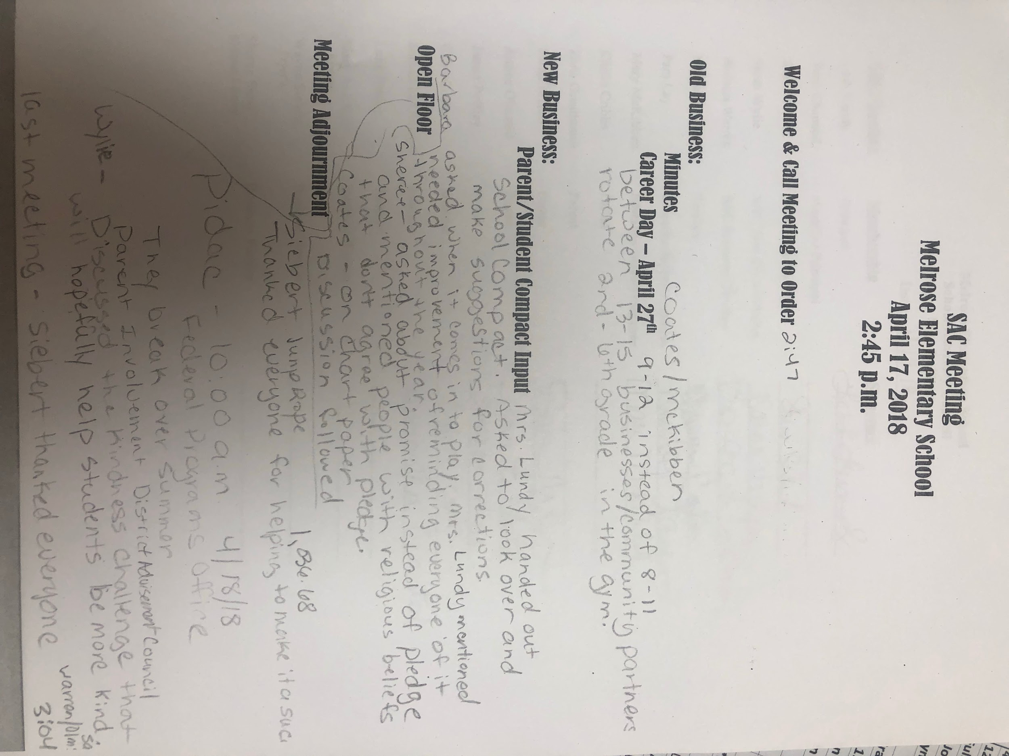
Evidence of a stand alone Title I Annual Meeting
- Attach documentation of the Annual Title I Meeting (Agenda, sign-in sheet, minutes)

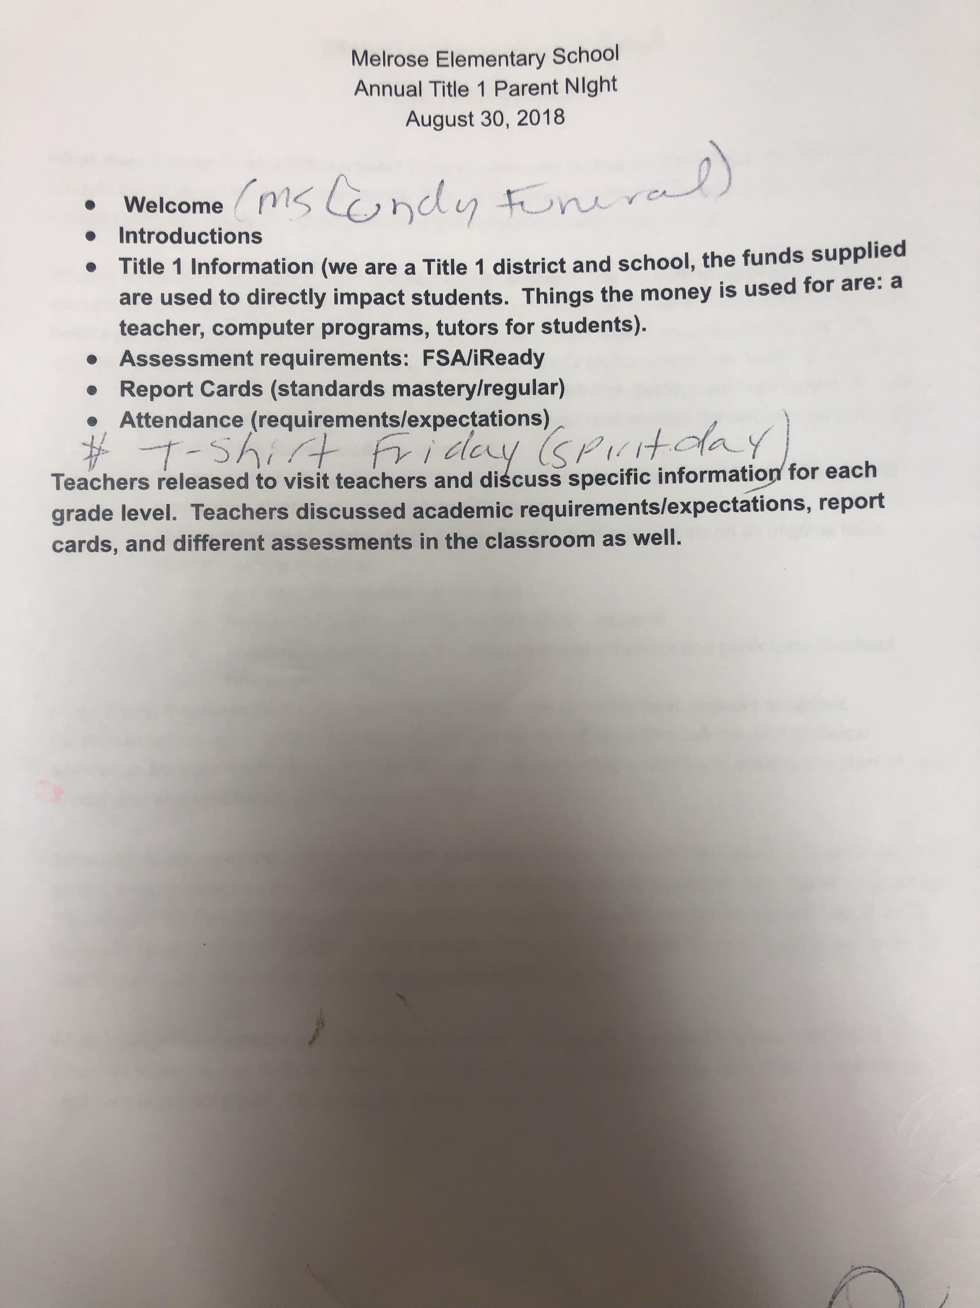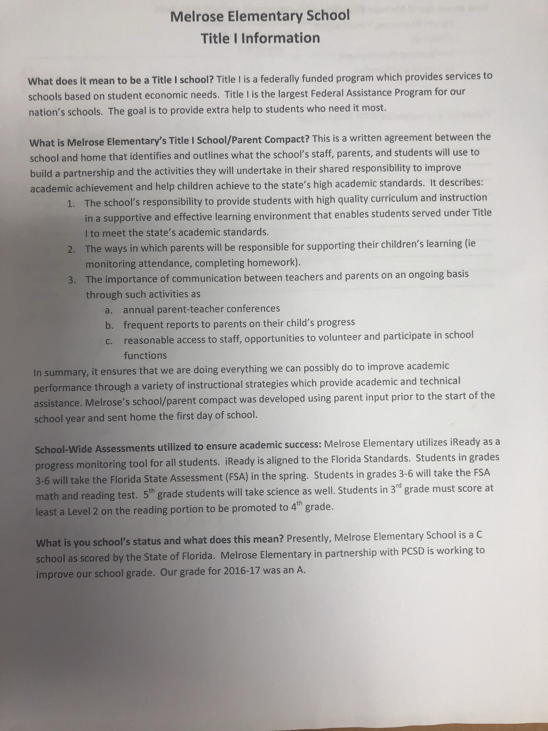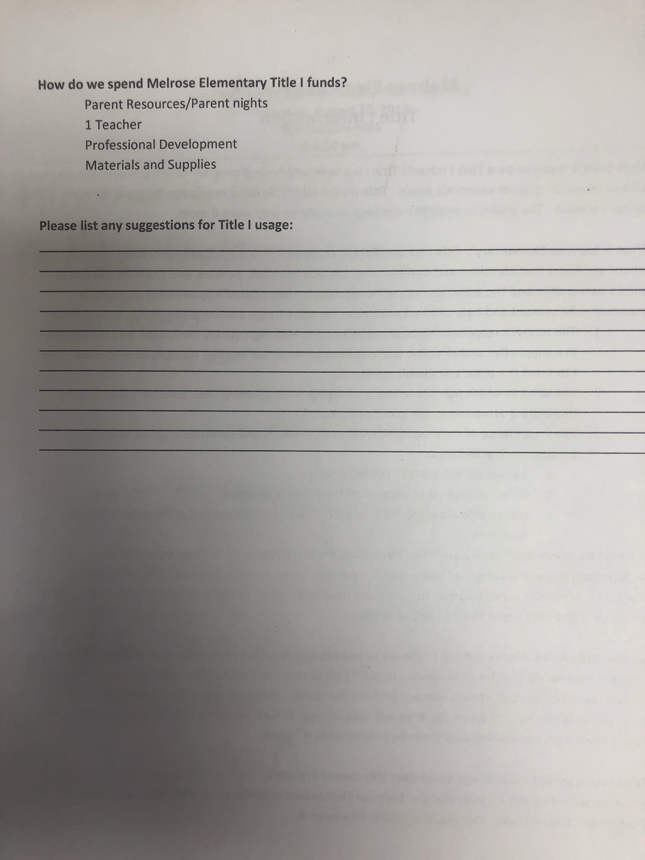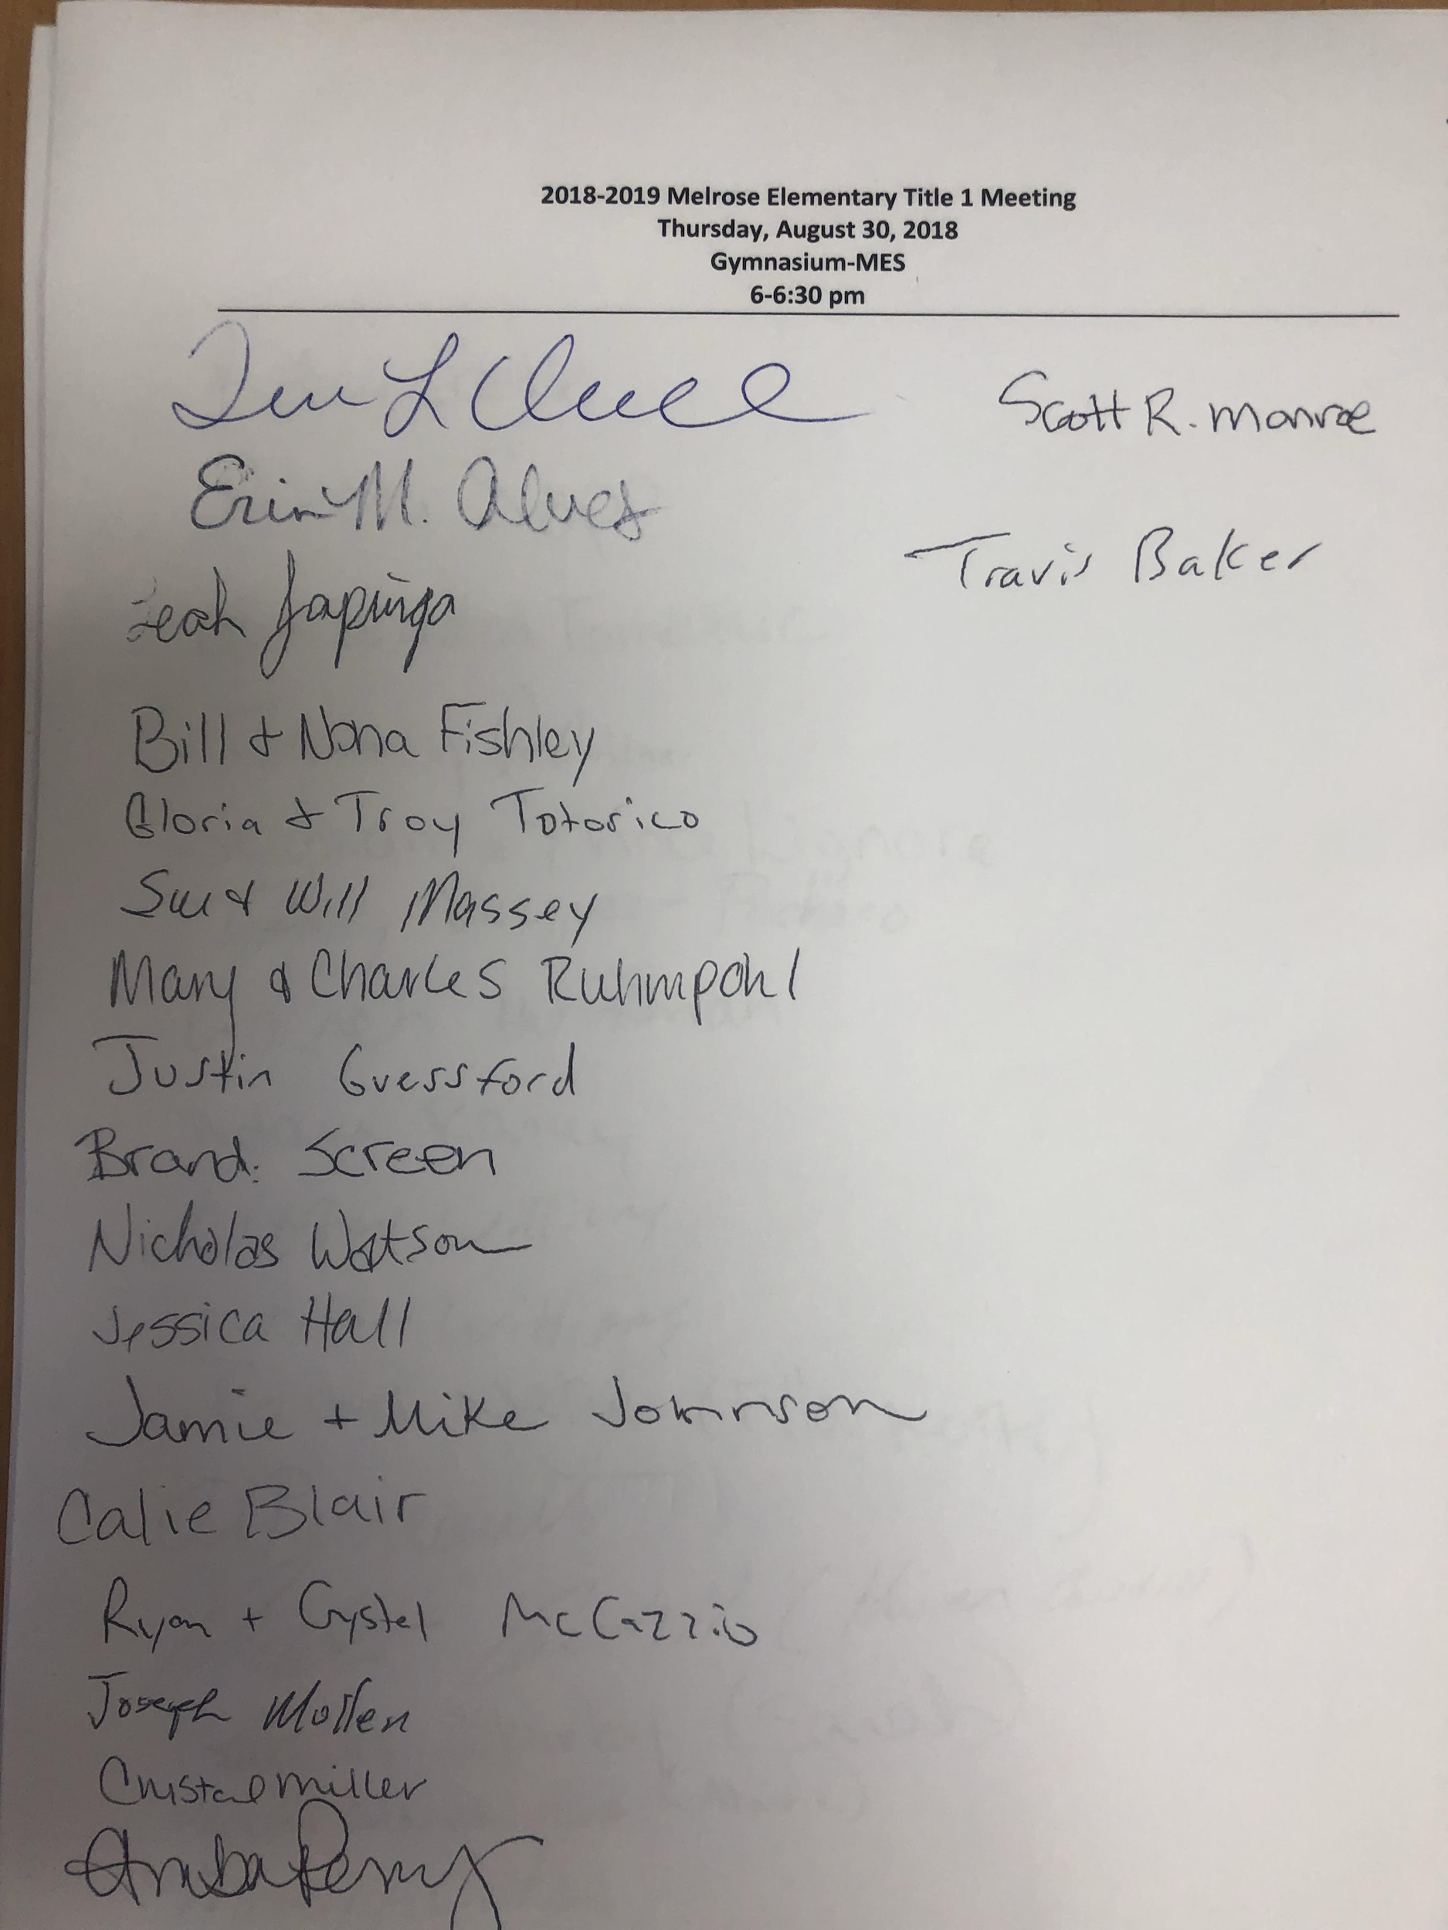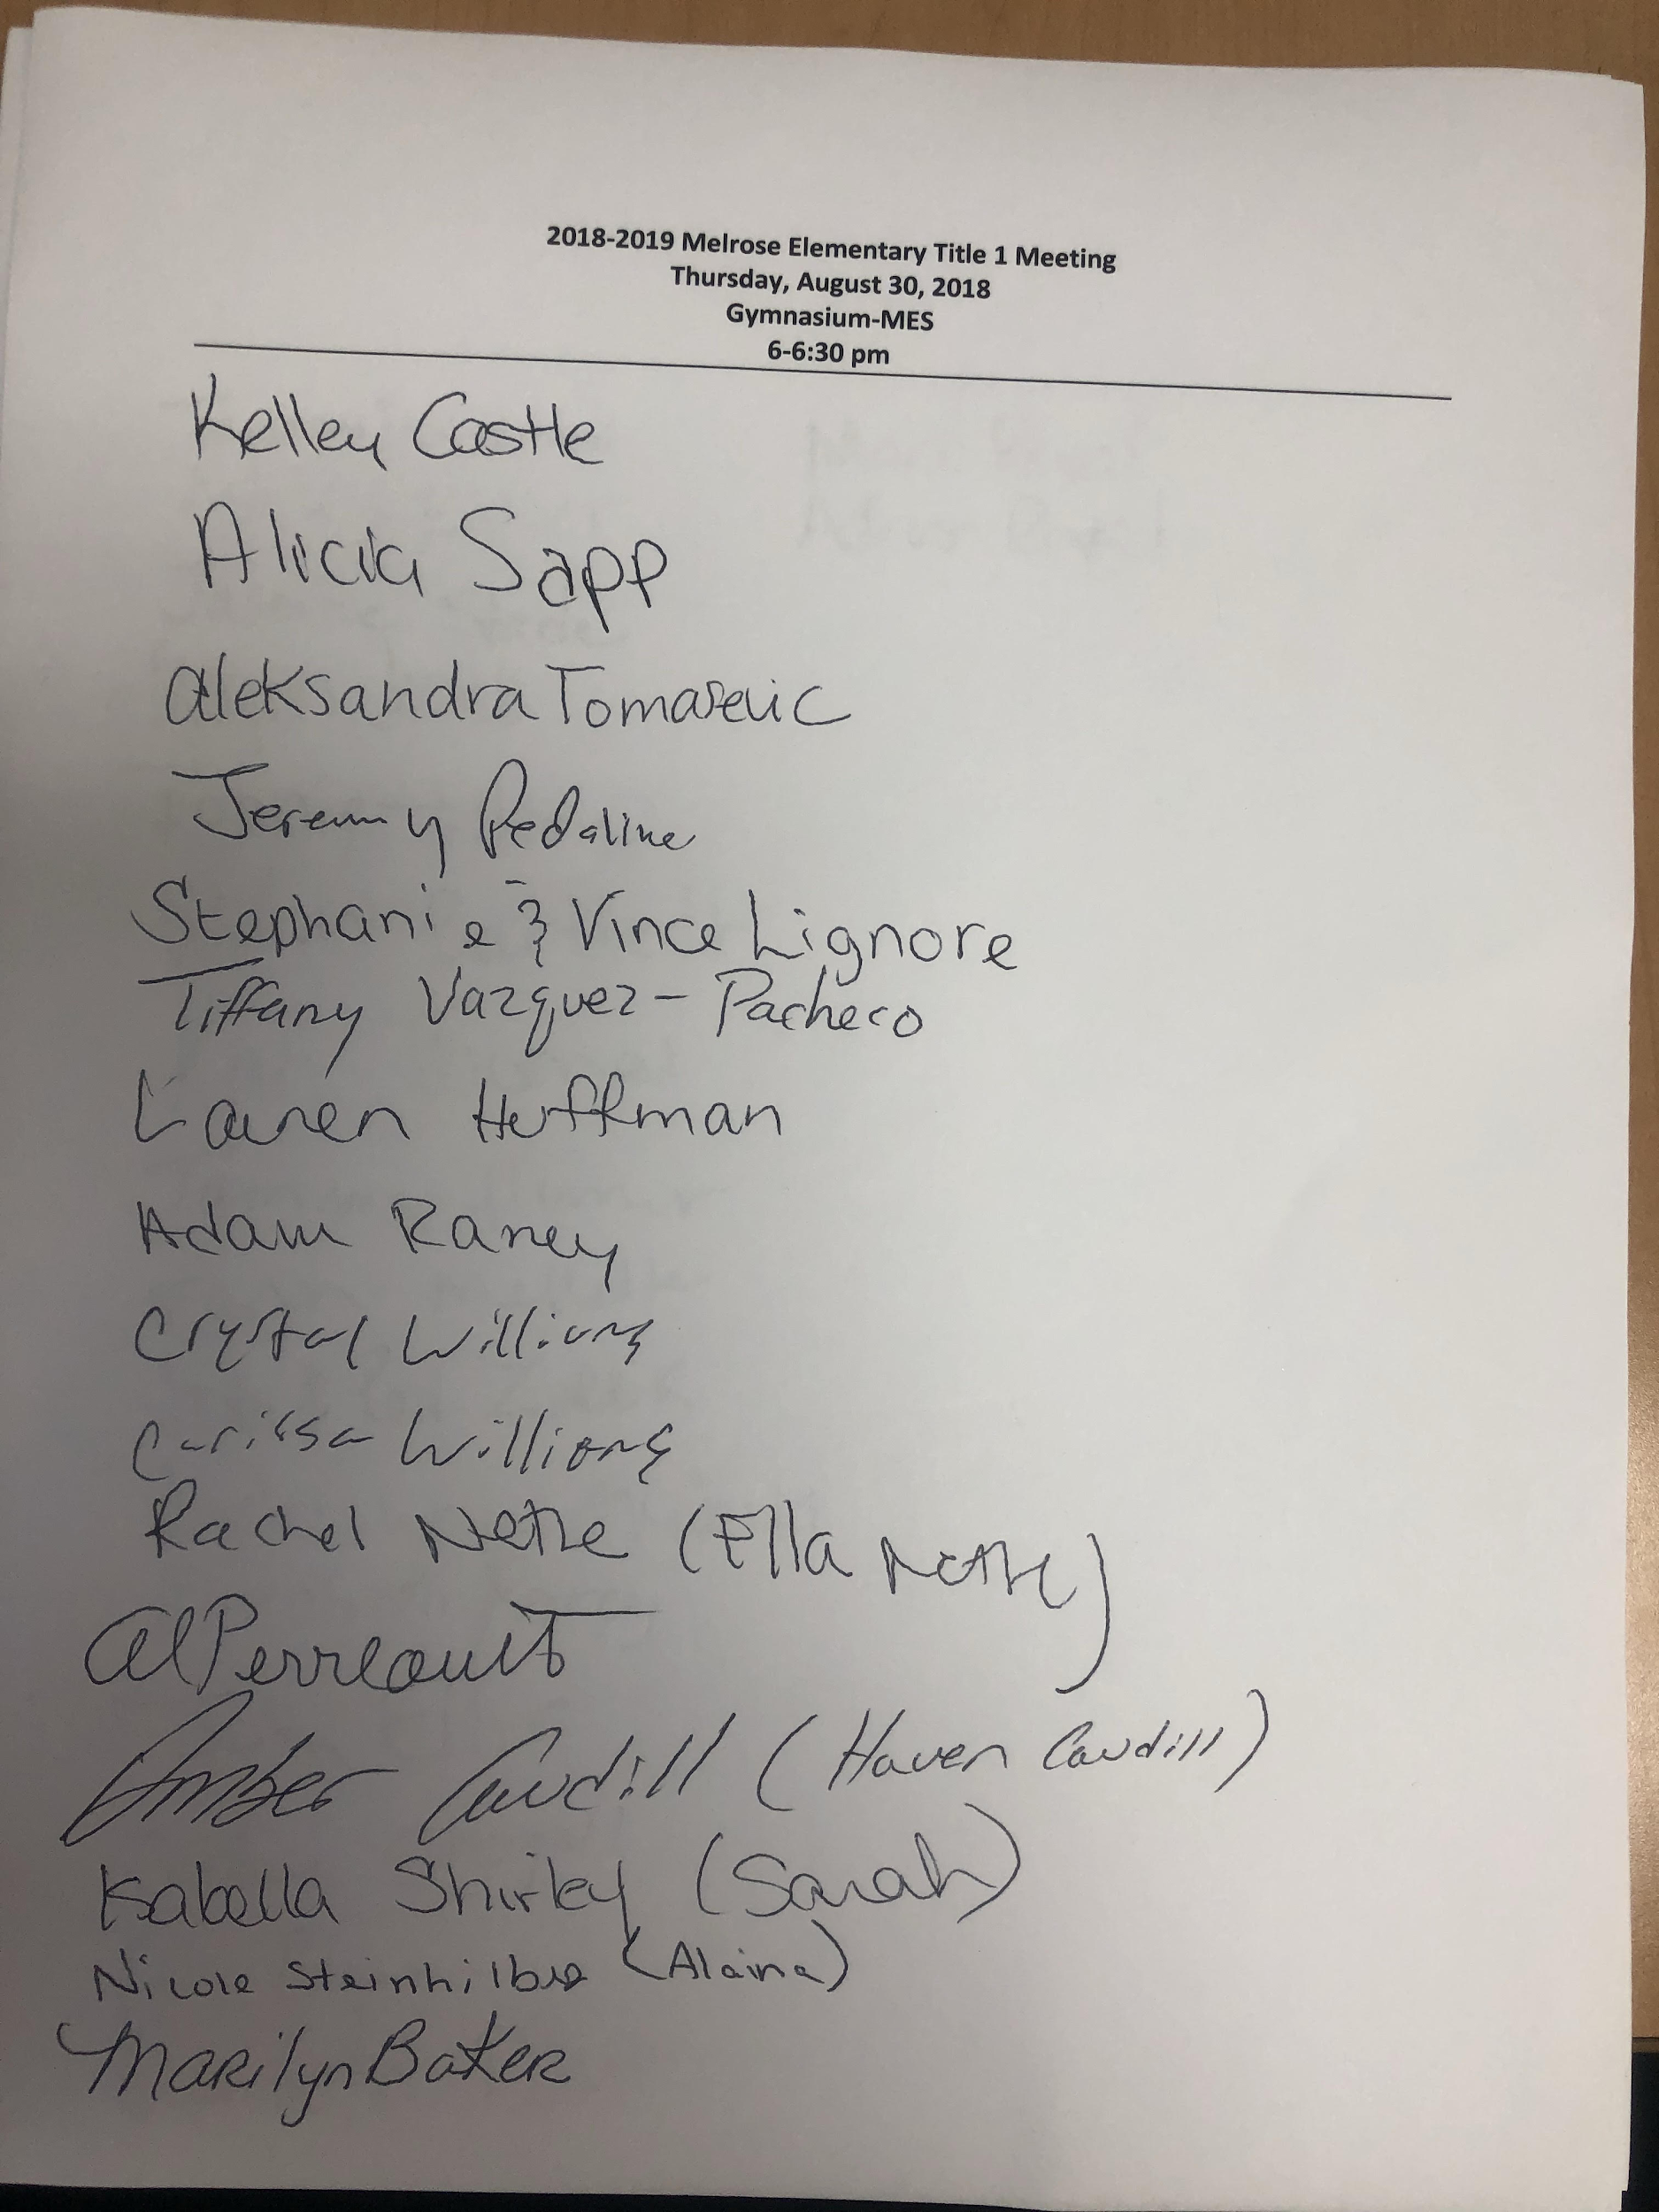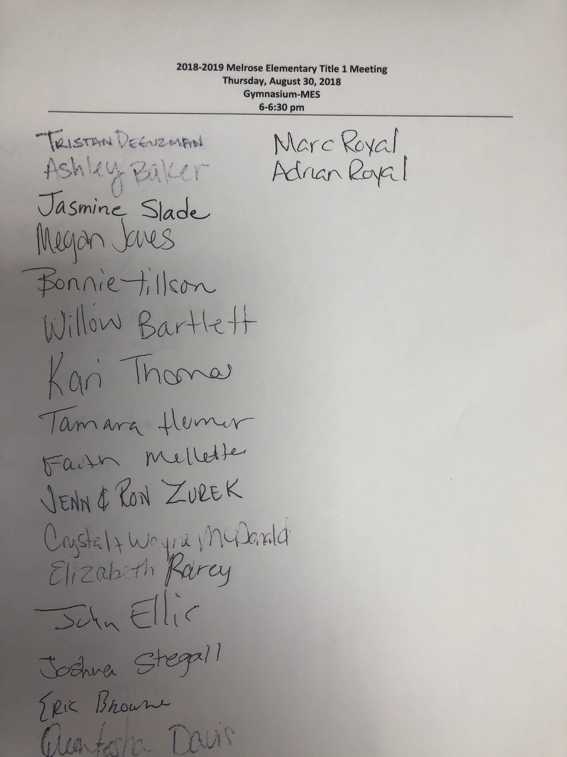
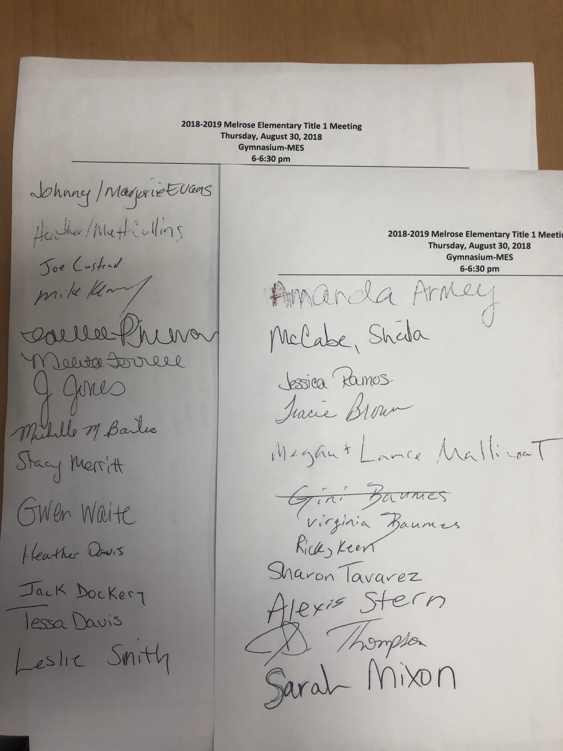
Evaluation of the previous year's Parental Involvement Plan

Building Capacity Summary
Provide a summary of activities provided during the previous school year that were designed to build the capacity of parents to help their children [Section 1118 (e)(1-2)]. Include participation data on the Title I annual meeting.

Response:
Melrose Elementary held a Title 1 Annual meeting, Bingo for Books, Make and Take, Kindergarten informative meeting.

Staff Training Summary
Provide a summary of the professional development activities provided by the school during the previous school year to educate staff on the value and utility of contributions of parents; how to reach out to, communicate with, and work with parents as equal partners; the implementation and coordination of parent programs; and how to build ties between parents and the school [Section 1118 (e)(3)].

Response: Pre-planning staff meeting, monthly PLC’s

Barriers N/A
Describe the barriers that hindered participation by parents during the previous school year in parental involvement activities. Include the steps the school will take during the upcoming school year to overcome the barriers (with particular attention to parents who are economically disadvantaged, are disabled, have limited English proficiency, have limited literacy, or are of any racial or ethnic minority background) [Section 1118(a)(E)].
Response: Barriers included times of meetings so we made an effort to hold parent conferences and SAC meetings in the mornings as well as the afternoons and evenings.

Best Practices (Optional)
Describe the parental involvement activity/strategy the school implemented during the previous school year that the school considers the most effective. This information may be shared with other LEAs and schools as a best practice. (Optional)

Response:

