Riverdale Elementary School
Orange County Public Schools

The following is to ensure school-level parent and family engagement plans meet the requirements of Section 1116(b) of the Elementary and Secondary Education Act (ESEA), as amended by the Every Student Succeeds Act (ESSA).
Assurances
The above named school agrees to the following assurances:
- Involve parents of children served in Title I, Part A in decisions about how Title I Part A funds are spent;
- Carry out the programs, activities, and procedures in accordance with the definitions in Section 8101 of ESEA;
- Jointly develop/revise plan with parents and make available to the local community;
- Involve parents and families in planning, reviewing, and improving schoolwide program plan;
- Use the findings of the parent and family engagement plan review to design strategies for more effective engagement, and to review, if necessary, the school’s parent and family engagement plan;
- Provide each family with timely notice information regarding their right to request information on the professional qualifications of the student’s classroom teachers and paraprofessionals;
- Notify each family, in a timely manner, when their child has been assigned, or has been taught for four or more consecutive weeks, by a teacher(s) who is out of field;
- Provide each family with an individualized student report about the performance of their child(ren) on the State assessments [ESEA Section 1116]

Mission Statement
1. Does the mission statement include:  How the parent and family engagement plan is a shared responsibility?  How the parent and family engagement plan will assist in providing high quality instruction for all learners? | The mission of Riverdale Elementary School is to lead our students to success with the support and involvement of families and the community. Riverdale Elementary feels strongly that parent involvement is a driving force in a child's education. Riverdale Elementary is committed to working in tandem with parents to provide quality education for all students. We are committed to working jointly with parents and family to develop a plan for activities and workshops that support high quality instruction needed for all learners to be successful. We will host multiple curriculum nights aligned to grade level standards to model instructional strategies for home and school.

Involvement of Parents
2. Does the plan include:  How the school will involve the parents and families in an organized, ongoing, and timely manner in the planning, review and improvement of Title I programs, including involvement in decision making of how funds for Title I will be used [ESEA Section 1116]? | Riverdale Elementary will ensure the organized, ongoing and timely manner of involving parents the following methods:  - Home-to-school and school-to-home communication in English and/or other languages  - Student planners  - Flyers  - Newsletters  - SchoolMessenger phone messages  - School Website, Facebook, Twitter, and Instagram  - Email  - Home Visits  - And other best practices as needed  At Riverdale Elementary parents and families are involved in the planning, review and improvement of Title I programs, including involvement in the decision making of how funds for Title I funds will be used by:  Attending  - School Advisory Council (SAC) meetings,  - Multilingual Parent Leadership Council (MPLC) meetings  - Annual Title I meeting  Participating In  - Parent/Teacher Association (PTA) activities  Reviewing  - Academic data for funding decisions  - Previous school year Parent and Family Engagement Plan

Coordination and Integration with Other Federal Programs
3. Does the plan include:  How the school will coordinate and integrate parent and family engagement programs and activities?  How the school will coordinate and integrate parent and family activities that teach parents how to help their child(ren) at home [ESEA Section 1116]? | Riverdale Elementary will coordinate and integrate parent and family engagement programs and activities through several planned events throughout the school year. These activities will teach parents how to help their child(ren) at home through the implementation of various best practices that are linked to learning. Below you will find the delineated program and coordination for each school-based program.
Program | Coordination
Pre-K Varying  Exceptionalities ESE - IDEA | Supplemental instructional support provided by Title 1 will be discussed with parents during the development of each student’s IEP.  The VPK instructors will work together with the Title 1 office to coordinate programs for the students to prepare them for public school. Activities may include meetings with parents and Kindergarten teachers to discuss educational support for the children.
Title I | The Principal, Parent Engagement Liaison and Title 1 contact will coordinate with the Title I office to provide opportunities for parental involvement at home, at school and in the community.
Title II | Professional Development will provide teachers with pertinent trainings to be Highly Qualified teachers to best meet the academic needs of students.
Title III | Services are provided through the district for educational materials and ELL district support to improve the education of Immigrant and English Language Learners
Title X | Services are provided to students identified as homeless through the school, county, and federal funding.

Annual Parent Meeting
4. Does the plan include:  A description of the specific steps the school will take to conduct the annual meeting to inform parents and families of participating children about the school’s  Title I program?  A description of the nature of the Title I Program that is shared with parents (schoolwide or targeted assistance)?  A description of how the meeting will cover adequate yearly progress (AYP), school choice, and the rights of parents are covered at the annual meeting? | Riverdale Elementary will host an annual Title I meeting to inform parents and families of children participating in Title I program at the beginning of the school year. We will host a single meeting to educate parents via the following methods:  - Annual Yearly Progress (AYP) via PowerPoint Presentation and handouts  - School Choice via district handouts and policies  - The rights of parents via brochure and other resources  Parents and families are informed of the nature of the Title I program by the following statement:  Title I schools receive services from the largest federal educational aid program in existence. Title I has been in existence since 1965 and continues to level the academic playing field for children victimized by poverty. Title I funds provide services and educational programs to help students achieve. Title I/Migrant Programs administer in excess of $500 million in federal funds to school districts and agencies in Florida for high quality supplemental instruction and support services for educationally disadvantaged children. Our mission is to provide leadership and technical assistance to local education agencies (LEAs) and local operating agencies (LOAs) to implement programs and services that ensure that all children have a fair, equal and significant opportunity to obtain a high-quality education and reach, at a minimum, proficiency on challenging state academic achievement standards and state academic assessments. We provide service to local school districts, agencies, private schools and local neglected and delinquent institutions for Title I, Migrant, and Homeless Programs.  For more information please visit the Florida Department of Education, Office of Title I Programs and Academic Intervention Services at http://www.fldoe.org/bsa/title1/title_compile.asp.  Below are the specific steps that Riverdale Elementary will take to conduct the Title I Annual Meeting.
Activity/ Task | Person Responsible | Timeline | Evidence of Effectiveness
Notices sent home in Parent English and Spanish | Parent Liaison | September 2019 | Copy of notice with date of dissemination
Annual Meeting date posted on the Marquee | Parent Liaison | September 2019 | Picture and date posted
Develop sign-In sheets | Parent Liaison | September 2019 | Sign In sheets for classrooms and individual classrooms
Agenda and Power point developed | School Administrator | September 2019 | Copies of Agenda
School Messager phone message Sent | School Administrator | September 2019 | Copy of message
Conduct Title 1 Annual Meeting | Administrator and Parent Liaison | September 2019 | Copies of Agenda and handouts

Flexible Parent Meetings
5. Does the plan include:  How will the school offer a flexible number of meetings, such as meeting in the morning or evening?  How will the school provide, with Title I funds, transportation, child care or home visits, as such services relate to parent and family engagement [ESEA Section 1116]? | Riverdale Elementary will conduct parent meetings and parent involvement activities at varying times during the day. Some meetings for PTA Board, SAC, and PLC are held, before, during, or right after school ends making these meetings convenient to parents who walk and drive their students to and from school. Most family nights are held after 6:00 pm to encourage working parents to attend. Grade level parent conference nights for each marking period will be held from 7:00 am to 7:00 pm by grade levels. Childcare will be provided for these meetings. In addition, parents can request meetings with teachers and faculty before school, during teacher planning, and after the school day as needed. Telephone conferences also provide flexible options. Bus passes are obtained from the MVP liaison for parents who need transportation to meetings.  A master calendar consisting of the meetings and trainings that are offered to parents will be developed at the beginning of the school year. This calendar will be available on the school website. Upcoming meetings, dates, and times will be included in school and team quarterly and monthly newsletters. In addition, the school will advertise meetings through flyers, the school marquee, and SchoolMessenger.

Building Capacity
6. Does the plan include:  How the school will implement activities that will build the capacity for meaningful parent/family engagement?  How will the school implement activities that will build relationships with the community to improve student achievement?  How the school will provide material and training to assist parents/families to work with their child(ren)?  How the school will provide other reasonable support for parent/family engagement activities [ESEA Section 1116]? | Riverdale Elementary takes pride in building the capacity of all key stakeholders who play a vital role in the academic success of our students. We provide both internal and external workshops and activities that strengthen these relationships throughout the school year. Our doors are open to the community through the implementation of activities during and after school that community members and organizations can volunteer to support through our Partners In Education (PIE) coordinators as well as our ADDitions coordinators.  Our Parent Engagement Liaison (PEL) will be a main point of contact for parents to receive resources, support, and information about activities that engage parents and family.  Below are the specific steps that Example Elementary will take to build capacity for meaningful parent and family engagement.
Activity/ Task | Person Responsible | Correlation to Student Achievement | Timeline | Evidence of Effectiveness
Academic Parent Partnership Night | Support Team and all teachers | Parents are given information on teacher expectations and learning goals for the year. Parents will be given information on websites to track student progress. They are also given websites connected to reading and math curriculum that provides help with homework, interventions, and additional practice. | September 2019 | Copy of Agenda, Sign In Sheets
ADDitions Volunteer program | ADDitions Contact | Encouraging parents to come and volunteer in the school makes them feel in partnership with the school. They are more likely to attend the parent trainings if they feel they are part of the school environment. | Ongoing | Measured by participation
Partners in Education | PIE coordinator | Community partners are encouraged to come to all parent nights. By doing this, they educate parents to services they provide that can be helpful to their students and to them. Participation builds a community between the school, partners, and parents. | Ongoing | Measured by participation
Technology Night | Support Team | Increase Student Achievement scores and meet SIP goals. Parents will be introduced to all websites available to students at home. | September 2019
Grade Level Report Card Conference Nights | Support Team and Teachers | Teachers will conduct individual conferences to discuss each child’s assessment results, expectations, and goals for the year. Parents will be given information on websites to track student progress. They are also given websites connected to reading and math curriculum that provides help with homework, interventions, and additional practice | October 2019  January 2020  March 2020 | Conference logs
Literacy Night (Reading and Writing | Media Specialist and Support Team | Student Achievement scores and SIP reading goal. Parents will be given strategies to help build their child’s fluency and comprehension | October 2019 | Parent Participation/Sign In Sheets, Reading Benchmark Comparisons, Feedback forms
Math Night | Support Team | Increased Student Achievement scores and meet SIP goals. Parents are given strategies to help build math skills and interest. Math night is also tied in to math careers to connect College and Career preparedness | November 2019 | Attendance/ Sign in Sheets
STEM Night | Support Team | Increased Student Achievement scores and meet SIP goals. Parents are given strategies to help build math and science skills and interest. STEM night is also tied in to math and science careers to connect College and Career preparedness. | January 2020 | Attendance/ Sign in Sheets
FSA Night | Support Team | Increased Student Achievement scores and SIP goals being met. Parents are given test taking strategies. They also get samples of types of test questions. Parents are given website information for students to sign on and take practice tests | February 2020 | Attendance/ Sign In Sheets, Feedback forms

Staff Development
7. Does the plan include:  A description of the professional development activities the school will provide to educate the teachers, specialized instructional support personnel, principals, other school leaders and other staff:  - with the assistance of parents/families, in the value and utility of contributions of parents/families?  - in how to reach out to, communicate with, and work with parents/families as equal partners?  - in implementing and coordinating parent/family programs, and in building ties between parents/families and the school [ESEA Section 1116]? | Riverdale Elementary strives to build the capacity of all school staff. Throughout the year, various professional development activities are provided to educate the teachers, specialized instructional support personnel, administrators, other school leaders and other staff to build capacity in parent and family engagement.  Below are the specific activities and tasks that Example Elementary will implement to build capacity for meaningful parent and family engagement.
Activity/ Task | Person Responsible | Correlation to Student Achievement | Timeline | Evidence of Effectiveness
Parent and Family Engagement Professional Development Module 1 - Building Strong Partnerships with Parents and Families | Parent Liaison | Improved school staff resources to create a welcoming school environment, understand and value the importance of parent and family engagement, and maintain strong school to home partnerships | October 30 2019 | Sign-in sheets, exit  slips
Parent and Family Engagement Professional Development Module 2:  Building Ties  Between Home and  School | Parent Liaison | Improved ability of staff to work with parents and families | November 2019 | Sign-in sheets, exit  slips
Parent and Family Engagement Professional Development Module 3:  Implementation and  Coordination of  Parent and Family Engagement  Programs | Parent Liaison | Increased parent and family participation in school activities which support student achievement | February 2020 | Sign-in sheets, exit  slips
Parent and Family Engagement Professional Development Module 4:  Communicating  and Working with  Parents as Equal Partners | Parent Liaison | Improved relationship, communication and collaboration between  parents and school | April 2020 | Sign-in sheets, exit  slips

Other Activities
8. Does the plan include:  How other activities, such as the parent resource center, the school will conduct to encourage and support parents and families in more meaningful engagement in the education of their child(ren) [ESEA Section 1116]? | Riverdale has a guidance counselor and social worker to assist with parent needs. They maintain a list of resources for parents. The ESE and Guidance office has a resource center that includes information on Homeless Education, Retention, Counseling services, Exceptional Education Services, Behavioral Support Services, and other resources available within and outside of the school.  The media center is also has a parent resource center that includes books on parenting, language acquisition for parents, GED resources, and other resources. The media center also has computers set up for parent and student use after normal school hours. The media center has extended hours on Tuesdays.  District Parent Academy and Virtual Academy events offered throughout the year.  Below are the specific activities and tasks that Example Elementary will use to encourage and support parents and families in more meaningful engagement in the education of their child(ren) .
Activity/ Task | Person Responsible | Timeline | Evidence of Effectiveness
Resource Center | Guidance Counselor, ESE Contact, Parent Engagement Liaison | Ongoing | Sign-in Sheets
Media Center | Media Specialist, Parent Engagement Liaison | Ongoing | Sign-in Sheets
Virtual Academy | Parent Engagement Liaison, Media Specialist | October 2019  February 2020  May 2020 | Parent registration, Media Center Sign-in sheet
Parent Academy | Parent Engagement Liaison | Saturday, September 2019  Saturday, November 2019  Saturday January 2020  Saturday, March 2020  Saturday, May 2020 | Pictures, Parent Registration, Flyers

Communication
9. Does the plan include:  How the school will provide timely information about the Title I programs?  How the school will describe and explain the curriculum at the school, the forms of assessment used to measure student progress and the achievement levels students are expected to obtain?  How, if requested by parents, the school provides opportunities for regular meetings to formulate suggestions and to participate, as appropriate, in decisions relating to the education of their child(ren)?  How the school will submit parents/ families comments if the schoolwide plan is not satisfactory to them [ESEA Section 1116]? | At the Title 1 Annual Meeting in September, parents will be informed of Title 1 programs. The school will also provide a variety of "family nights" that will help parents understand curriculum and provide training so that they may help their child at home. Teachers will maintain sign-in sheets from parent conference nights and Open House. All school activities are advertised on the school marquee, the school calendar, flyers home and SchoolMessenger. Riverdale also has a website where parents can access school information and the school calendar. This website also has links to the OCPS website and the FLDOE website. Parents can access information on county programs as well as standards on the county and state websites.  Progress reports and report cards are sent home to inform parents of their child's academic progress. The parents also have access to Progress Book where they can get information about their students' academics, attendance, and homework daily. All students have planners or Take-Home folders that are sent home daily as a means of communication between home and school. Parents may schedule meetings with teachers and administration as needed. Translation is provided for any parents that request it.  Surveys are sent home to the parents on the SIP and the PFEP. All parents are invited to SAC meetings where plans are developed and reviewed. The opportunity for suggestions and comments is given in these meetings and through the surveys that are sent out.  The parent liaison will maintain sign-in forms for the Annual Meeting as well as documentation of the dissemination of information, distribution methods, and timelines. Copies of the school calendar, monthly newsletters sent home by grade levels, agendas, parent sign in and feedback information are all collected and maintained by the Title 1 staff.

Accessibility
10. Does the plan include:  A description of how the school will provide full opportunities for participation in parent/family engagement activities for all parents/families?  A description of how the school will share information related to school and parent/family programs, meetings, school reports, and other activities in an understandable, uniform format, and in languages that the parents/families can understand? | A variety of parent involvement activities will be planned to ensure that each parent has ample opportunity to participate. Multiple sources will be used to communicate opportunities for involvement to parents. Riverdale will send home information pertaining to meetings and "family nights" in both English and Spanish. Other languages will be available at the parents' request. Information will be disseminated to parents using newsletters, student planners, school website, school marquee, and/or School Messenger phone calls in English and Spanish. Translators and childcare will be available at parent nights and meetings as requested by parents. The school is fully wheelchair assessable. For parents who have audio logical needs, the school is equipped with an enhanced audio system. Sign language interpreters can be obtained from the county for events when requested by the parent.

Discretionary Activities (optional)
11. Does the plan include:  Any activities that are not required, but will be paid for through Title I, Part A funding (for example: home visits, transportation for meetings, activities related to parent/family engagement, etc.) | Riverdale Elementary will utilize Title I, Part A funding for additional activities to support student achievement. Although not required, these activities support student achievement.  Below are additional activities and tasks that Example Elementary will implement that are funded by Title I, Part A.
Activity/ Task | Person Responsible | Correlation to Student Achievement | Timeline | Evidence of Effectiveness
Involving parents in the development of training for teachers, principals, and other educators to improve the effectiveness of that training [Section 1118(e)(6)];and | Parent Liaison, Administration and SAC/PTA Members | Student Achievement increases with more parental and community support and input. | Monthly | Meeting Notes and student data
Training parents to enhance the involvement of other parents [Section 1118(e)(9)]; | Parent Leadership Committee and PTA | Student Achievement increases with more parental and community support and input. | Monthly | Meeting Notes and student data
Maximizing parental involvement and participation in their children’s education by arranging school meetings at a variety of times, or conducting in-home conferences between teachers or other educators, who work directly with participating children, with parents who are unable to attend those conferences at school [Section 1118(e)(10)]; | Parent Liaison and School Leadership | Student Achievement increases with more parental and community support and input. | October, January, March | Sign-ins and student data
Developing appropriate roles for community-based organizations and businesses, including faith-based organizations, in parental involvement activities [Section 1118(e)(13)]. | Parent Liasion will partner with community organizations to provide ELL courses to adults as well as parenting skills classes. | Student Achievement increases with more parental and community support and input. | Year Round | Number of organizations partnering with the school, family and student data

Barriers
12. Does the plan include:  A description of the barriers that hindered participation by parents/families during the previous school year?  A description of the steps the school will take during the upcoming school year to overcome the barriers (with particular attention paid to parents/families who are disabled, have limited English proficiency, and parents/families of migratory children [ESEA Section 1116]? | Riverdale Elementary, after reviewing the previous years’ Parent and Family Engagement Plan and accompanying feedback, acknowledges the existence of the following barriers to parent and family engagement:  - Transportation  - Language  - Education  - Economically disadvantaged  Below are the specific steps that Riverdale Elementary will take to address barriers that existed in the previous year.
Barriers (Including the Specific Subgroup) |  | Steps the School will Take to Overcome
Language barrier (ELL) |  | Provide Spanish and sign language translation as needed.
Education barrier (FRL, SWD, ELL) |  | Open House – preview of the grade level expectations for the year. Explain education terminology in a way that all are able to understand (i.e. Instead of just using the words fluency, fact family, etc.) we will accompany these terms with a definition and model strategies accordingly.
Economically disadvantaged (FRL)  Provide |  | Provide food during some evening events, free lunch for all students, Food Pantry, clothing, Thanksgiving food baskets, Christmas gifts and food. PTA purchases a book for every child.

School-Parent Compact
13. Does the plan include:  As a component of the school-level parent and family engagement policy/plan, each school shall jointly develop, with parents for all children served under this part, a school-parent compact that outlines how parents, the entire school staff, and students will share the responsibility for improved student academic achievement? | The compact for the 2019-2020 school year has been attached. In addition, the agenda and notes from the SAC meeting to review the compact have been scanned and attached.  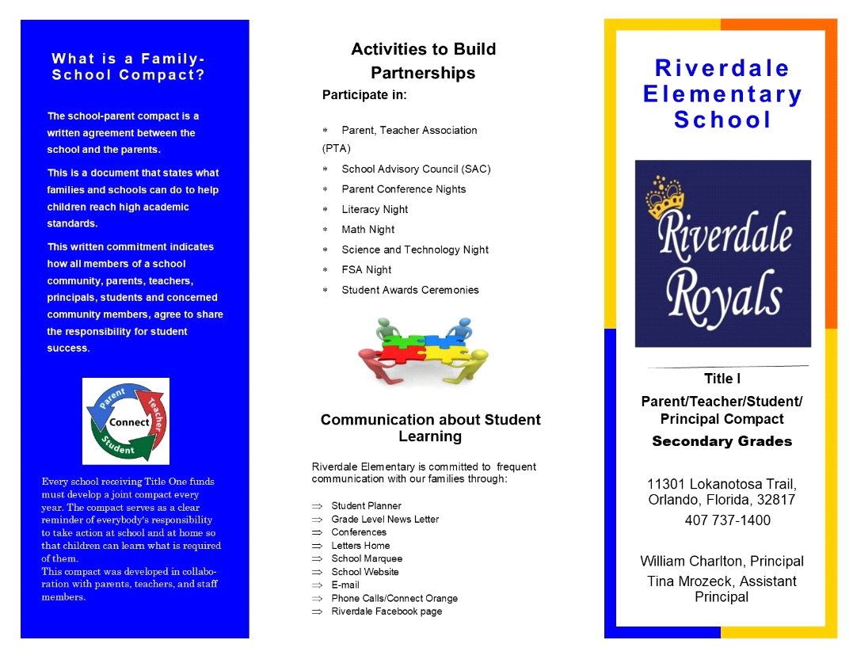  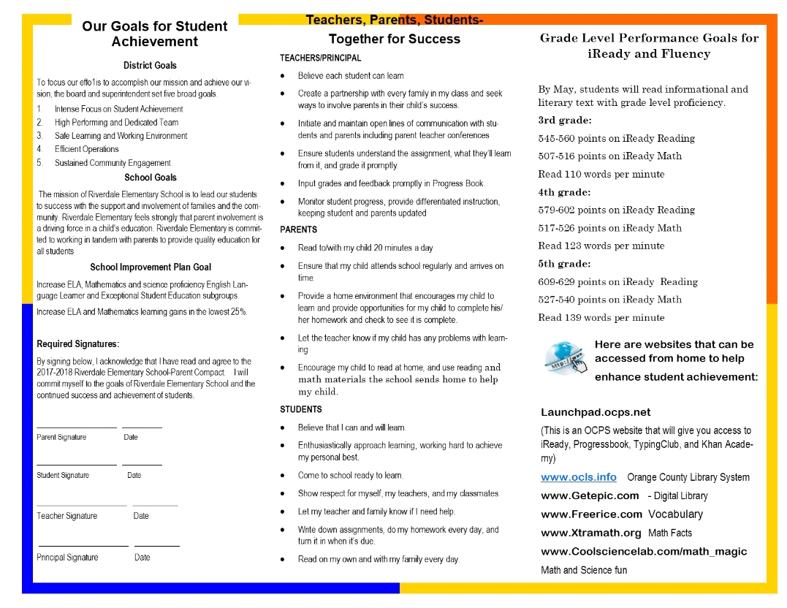

Adoption
The Parent and Family Engagement Policy was developed jointly with, and agreed on with, parents of children participating in Title I, Part A programs, as evidenced by SAC notes and agenda. This policy was adopted by the school on ______and will be in effect for the period of one school year .
The school will distribute this policy to all parents of participating Title I, Part A children on or before October 1, 2019.

Signature of Authorized Personnel
Date

Provide evidence that this policy has been developed with input from parents based on the review of the previous school year’s Parent and Family Engagement Plan, if applicable. (previously referred to as the Parent Involvement Plan – PIP)
The following documents can be scanned with this document and submitted as evidence:
- Parent surveys of previous year’s events and activities
- Any SAC and/or PTA artifacts with Title I/PFE topics on the agenda
- Parent Feedback Summary of PFEP Evaluation
- Parent and Family Engagement Activities Tracking Form

