The following is to ensure school-level parent and family engagement plans meet the requirements of Section 1116(b) of the Elementary and Secondary Education Act (ESEA), as amended by the Every Student Succeeds Act (ESSA)
Assurances
The above named school agrees to the following assurances:
- Involve parents of children served in Title I, Part A in decisions about how Title I Part A funds are spent;
- Carry out the programs, activities, and procedures in accordance with the definitions in Section 8101 of ESEA;
- Jointly develop/revise plan with parent and make available to the local community;
- Involve parents and families in planning, reviewing, and improving school-wide program plan;
- Use the findings of parent and family engagement plan review to design strategies for more effective engagement, and to review, if necessary, the school’s parent and family engagement plan;
- Provide each family with timely notice information regarding their right to request information on the professional qualifications of the student’s classroom teachers and paraprofessionals;
- Notify each family, in a timely manner, when their child has been assigned, or has been taught for four or more consecutive weeks, by a teacher(s) who is out of field;
- Provide each family with an individualized student report about the performance of their child(ren) on the State assessments [ESEA Section 1116]
Mission Statement
1. Does the mission statement include:  How the parent and family engagement plan is a shared responsibility?  How the parent and family engagement plan will assist in providing high quality instruction for all learners? | Dover Shores Elementary is committed to facilitating communication to parents about ongoing educational methods, and working in collaboration to plan and review meaningful and enriching Title I school-wide programs. In an effort to align our endeavors, our school hosts an Annual Title I Meeting to provide specific information about how a Title I school functions and operates. Throughout the year, parents are encouraged to take part in PTA, SAC and differentiated parent workshops. Parents and community members are able to sign-up to become board members of the SAC and Title I Committee. Administration and staff work closely with the Title I Committee and the SAC to correlate expectations and build programs directly related to parent interest and needs for parental involvement. They provide tailored meeting notifications, agendas, and minutes in order to promote ongoing, sustained engagement. Communication is kept fluid through school issued and online parent newsletters, the school marquee, connect school, flyers and agendas; and information is provided in English, Spanish and other languages or accessibilities as needed. The website and marquee are updated regularly, with timely information relative to parent and student necessities. Parent input is also gathered and analyzed through the school effectiveness survey as well as surveys at regularly scheduled meetings and events. All survey results and suggestions are discussed with possible implementation ideas among the Title I committee, in an effort to better our school.

Involvement of Parents
2. Does the plan include:  How the school will involve the parents and families in an organized, ongoing, and timely manner in the planning, review and improvement of Title I programs, including involvement in decision making of how funds for Title I will be used [ESEA Section 1116]? | Dover Shores Elementary will ensure the organized, ongoing and timely manner of involving parents through the following methods:  - Home to school and school to home communication  - Student Planners  - Flyers  - Newsletters  - School Website  - Email  - Canvas  - Skyward  - Different practices if needed  At Dover Shores families are involved in the planning, review and how to improve the Title I programs which is also includes involvement in decision making of how funds for Title I will be used by:  Attending  - School Advisory Council (SAC) meetings  - Title I Annual Meeting  Participating in  - Parent and family engagement capacity building activities  Reviewing  - Academic data  - Previous school year Parent and Family Engagement Plan

Coordination and Integration with Other Federal Programs
3. Does the plan include:  How the school will coordinate and integrate parent and family engagement programs and activities?  How the school will coordinate and integrate parent and family activities that teach parents how to help their child(ren) at home [ESEA Section 1116]? | Dover Shores Elementary create and integrate parent and family engagement programs and activities through planned events throughout the school year. We create different activities that teach parents how to help our students at home with practices that are connected with learning.
Program | Coordination
Title I | The Title I department will provide technical assistance to school staff, in compliance and parental involvement. Title I funds will also be used to support student learning (i.e. tutoring, additional staff and technology).
Title II | Title II funds will be used to provide professional development modules on parental involvement and specifically designed to build capacity.
Title III | Provides funding for our ELL students to support their oral language development.
Title X | McKinney Vento Program provides support to our homeless students.

Annual Parent Meeting
4. Does the plan include:  A description of the specific steps the school will take to conduct the annual meeting to inform parents and families of participating children about the school’s  Title I program?  A description of the nature of the Title I Program that is shared with parents (school-wide or targeted assistance)?  A description of how the meeting will cover adequate yearly progress (AYP), school choice, and the rights of parents are covered at the annual meeting? | Dover Shores Elementary will host our Title I meeting to inform parents and families of children participating in Title I program at the beginning of the school year. The single meeting to educate our parents through different methods:  - Handouts at our Annual Yearly Progress(AYP)  - District handouts and policies  - Brochure and resources for parents  Title I schools receive services from the largest federal aid to education program in existence. Title I has been in existence since 1965 and continues to level the academic playing field for children victimized by poverty. Title I funds provide services and educational programs to help students achieve. Title I/Migrant Programs administer in excess of $500 million in federal funds to school districts and agencies in Florida for high quality supplemental instruction and support services for educationally disadvantaged children. Our mission is to provide leadership and technical assistance to local education agencies (LEAs) and local operating agencies (LOAs) to implement programs and services that ensure that all children have a fair, equal and significant opportunity to obtain a high-quality education and reach, at a minimum, proficiency on challenging state academic achievement standards and state academic assessments. We provide service to local school districts, agencies, private schools and local neglected and delinquent institutions for Title I, Migrant, and Homeless Programs.  For more information please visit the Florida Department of Education, Office of Title I Programs and Academic Intervention Services at http://www.fldoe.org/bsa/title1/title_compile.asp and le our district’s Title I website https://www.ocps.net/departments/title_i.
Activity/ Task | Person Responsible | Timeline | Evidence of Effectiveness
Develop presentation, materials, and agenda for required Title 1 components | Assistant Principal/  Parent Engagement Liaison | August 2019 | Copies of agenda, power point and handouts
Notification of the Annual Meeting will be sent home in both English and Spanish invitations | Parent Engagement Liaison | September 2019 | Meeting flyer dissemination
Develop sign-in sheets and advertise meetings | Parent Engagement Liaison | August 2019 | Sign in sheets for meetings and individual classrooms
Facilitate Annual Title 1 Meeting | Assistant Principal/  Parent Engagement Liaison | September 2019 | Parent feedback and surveys

Flexible Parent Meetings
5. Does the plan include:  How will the school offer a flexible number of meetings, such as meeting in the morning or evening?  How will the school provide, with Title I funds, transportation, child care or home visits, as such services relate to parent and family engagement [ESEA Section 1116]? | Dover Shores Elementary acknowledges the importance of parental participation. School staff is flexible when scheduling parent meetings throughout the school year and during Conference Night. For instance, teachers are available for conferences through-out the week of conference night and at various times of the school day. Teacher utilized varying approved technology to maintain communication with parents in the areas of student achievement and academics.  As it pertains to services related to parent and family engagement, the school will provide the following:  - Transportation to a minimum of 1 Parent Academy

Building Capacity
6. Does the plan include:  How the school will implement activities that will build the capacity for meaningful parent/family involvement?  How will the school implement activities that will build relationships with the community to improve student achievement?  How the school will provide material and training to assist parents/families to work with their child(ren)?  How the school will provide other reasonable support for parent/family engagement activities [ESEA Section 1116]? | Dover Shores Elementary really enjoys to continue to build the capacity of all the vital roles to our academic success of our students. We have a strong relationships due to the different workshops that we hold. Through the Partners In Education (PIE) and ADDitions coordinators we are able to implement our activities during school and after school.  Our Parent engagement Liaison (PEL) will be a main point of contact for parents to receive different resources, rapport, support and information about the activities that we hold at our school.
Activity/ Task | Person Responsible | Correlation to Student Achievement | Timeline | Evidence of Effectiveness
Meet the Teacher | Instructional staff | Teachers will introduce classroom expectations, routines, and establish a relationship with the families. | August 2019 | Flyers/ Hand-outs/Sign-in sheet
Report Card Conference Night | Instructional Staff | Teachers will have individual conferences to discuss child’s test results, expectations, progress toward the benchmark and their individual needs. | October 2019 | Conference/Parent Communication logs and sign- in sheets
Curriculum workshops | Instructional Staff | Teachers will plan and discuss the grade level skills in reading, writing and math. Parents will be given resources. | Winter/ Spring | Handouts/ flyers/ Sign-In Sheet
Newsletter, website, daily planners, email communication | Principal and Instructional Staff | Parents and students will have access to information about school events/ activities | Ongoing | Website, resources, feedback and emails
Book Fair/ Black History month door decorations | Admin Team & PTA | Exposure and training on curriculum content, reading readiness and test taking skills will raise parent and student expectations | February 2020 | Parent Feedback, Surveys, Common Assessments
Academic Night | Admin Team /Instructional  Committee | Exposure and training on curriculum content, reading readiness and test taking skills will raise parent and student expectations. | March 2020 | Parent Feedback, Surveys, Common Assessments

Staff Development
7. Does the plan include:  A description of the professional development activities the school will provide to educate the teachers, specialized instructional support personnel, principals, other school leaders and other staff:  - with the assistance of parents/families, in the value and utility of contributions of parents/families?  - in how to reach out to, communicate with, and work with parents/families as equal partners?  - in implementing and coordinating parent/family programs, and in building ties between parents/families and the school [ESEA Section 1116]? | Dover Shores Elementary always tries to build of the capacity of all school staff. Many professional developmental activities are organized to help educate and support our staff to continue to build strong parent and family engagement.
Activity/ Task | Person Responsible | Correlation to Student Achievement | Timeline | Evidence of Effectiveness
Module 1: The Importance of Parental Involvement | Parent Engagement Liaison | Data shows that better communication between home and school improves student academic achievement levels and behavior. | Fall 2019 | Staff Feedback and Surveys
Module 2: Building Ties Between Home and School | Parent Engagement Liaison | By implementing these planned trainings we will educate our faculty and staff on strategies and interventions that could be used to better meet the needs of our school population. | Fall 2019 | Staff Feedback and Surveys
Module 3: Implementation and Coordination of Parental Involvement Programs | Parent Engagement Liaison | Providing teachers with the tools and understanding to communication with parents more effectively, improves student achievement. | Spring 2020 | Staff Feedback and Surveys
Module 4: Implementation and Coordination of Parental Involvement Programs | Parent Engagement Liaison | Data shows that better communication between home and school improves student academic achievement levels and behavior. | Spring 2020 | Staff Feedback and Surveys

Other Activities
8. Does the plan include:  How other activities, such as the parent resource center, the school will conduct to encourage and support parents and families in more meaningful engagement in the education of their child(ren) [ESEA Section 1116]? | Dover Shores is committed to providing parents with the necessary resources to support student learning. Activities occur throughout the year, with the support of the community, volunteers, and partners. Activities include food drives, book drives, clothing and school supply donations and distributions. We also sponsor a gift drive for students in need.
Activity/ Task | Person Responsible | Timeline | Evidence of Effectiveness
Resource Center | Parent Engagement Liaison, Guidance Counselor | Ongoing | Sign-in sheets

Communication
9. Does the plan include:  How the school will provide timely information about the Title I programs?  How the school will describe and explain the curriculum at the school, the forms of assessment used to measure student progress and the achievement levels students are expected to obtain?  How, if requested by parents, the school provides opportunities for regular meetings to formulate suggestions and to participate, as appropriate, in decisions relating to the education of their child(ren)/  How the school will submit parents/ families comments if the schoolwide plan is not satisfactory to them [ESEA Section 1116]? | Dover Shores is committed to informing parents of opportunities at school and abroad, in a timely manner. The school informs parents of curriculum, academic assessments, meetings and Title I programs at the beginning of the year, during our Annual Title I Meeting. This occurs in September, in conjunction with Open House. Curriculum, assessment, student progress and proficiency levels are also discussed with parents at the following events: Open House, Conference Nights and IEP Meetings, Student Agenda, Canvas, Skyward, Curriculum Night, PTA & SAC Meetings and other meetings per parent request. Parent newsletters are sent home prior to the first of each month which also include events for the upcoming month. Administration advertises all events in multiple formats, including flyers, the marquee, school website and School Messenger.  Dover Shores Elementary School will inform our parents of academic assessments, student progress and proficiency levels students are expected to meet through parent teacher conferences, Canvas or notes sent home via the student's planner.  Dover Shores Elementary School will hold meetings during times that parents will have the opportunity to attend regular meetings, formulate suggestions and participate in the decision making process.

Accessibility
10. Does the plan include:  A description of how the school will provide full opportunities for participation in parent/family engagement activities for all parents/families?  A description of how the school will share information related to school an parent/family programs, meetings, school reports, and other activities in an understandable, uniform format, and in languages that the parents/families can understand? | Dover Shores Elementary will establish a host of opportunities for parents and families to participate in school activities through ensuring multiple levels of access for parents and families. The following methods will be used:  - Family nights will be presented in multiple languages to service our ELL families.  - Offer activities at multiple times throughout the day for parents and families to participate during the morning, evening and afternoon.  We will share information through various ways in different languages in order to reach to the highest number of parents and families. Methods such as:  - School Website  - Canvas  - Skyward  - Flyers  - Newsletters  - Email  - Home to school and school to home communication

Discretionary Activities
11. Does the plan include:  Any activities that are not required, but will be paid for through Title I, Part A funding (for example: home visits, transportation for meetings, activities related to parent/family engagement, etc.) | Dover Shores Elementary will utilize Title I, Part A funding for additional activities to support student achievement. Although not required, these activities support achievement.
Activity/ Task | Person Responsible | Correlation to Student Achievement | Timeline | Evidence of Effectiveness
Maximizing parental involvement and participation in their children’s education by arranging school meetings at a variety of times, or conducting in-home conferences between teachers or other educators, who work directly with participating children, with parents who are unable to attend those conferences at school | Administration & School Staff | Data shows that better communication between home and school improves student academic achievement levels and behavior. | ongoing | Sign-in sheets
Developing appropriate roles for community-based organizations and businesses, including faith-based organizations, in parental involvement activities | Administration, ADDitions coordinator, PIE coordinator | Data shows that better communication between school and home/community improves student academic achievement levels and behavior. | Ongoing | Sign-in sheets

Barriers
12. Does the plan include:  A description of the barriers that hindered participation by parents during the previous school year?  A description of the steps the school will take during the upcoming school year to overcome the barriers (with particular attention paid to parents/families who are disabled, have limited English proficiency, and parents/families of migratory children [ESEA Section 1116]? | Dover Shores Elementary, after reviewing the previous years’ Parent and Family Engagement Plan and accompanying feedback, acknowledges the existence of the following barriers to parent and family engagement.  - Language
Barriers (Including the Specific Subgroup) |  | Steps the School will Take to Overcome
Language (Hispanic) |  | The school will provide a translator at all Parental Involvement activities.
 |  | .

School-Parent Compact
13. Does the plan include:  As a component of the school-level parental involvement policy/plan, each school shall jointly develop, with parents for all children served under this part, a school-parent compact that outlines how parents, the entire school staff, and students will share the responsibility for improved student academic achievement? | 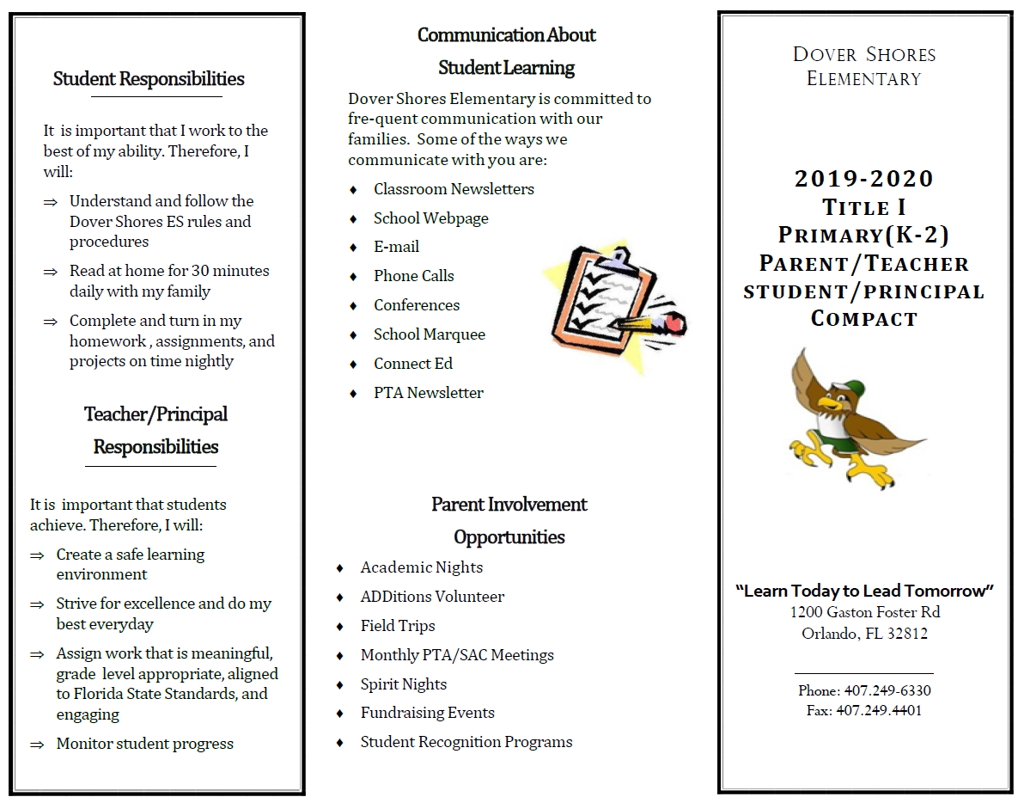  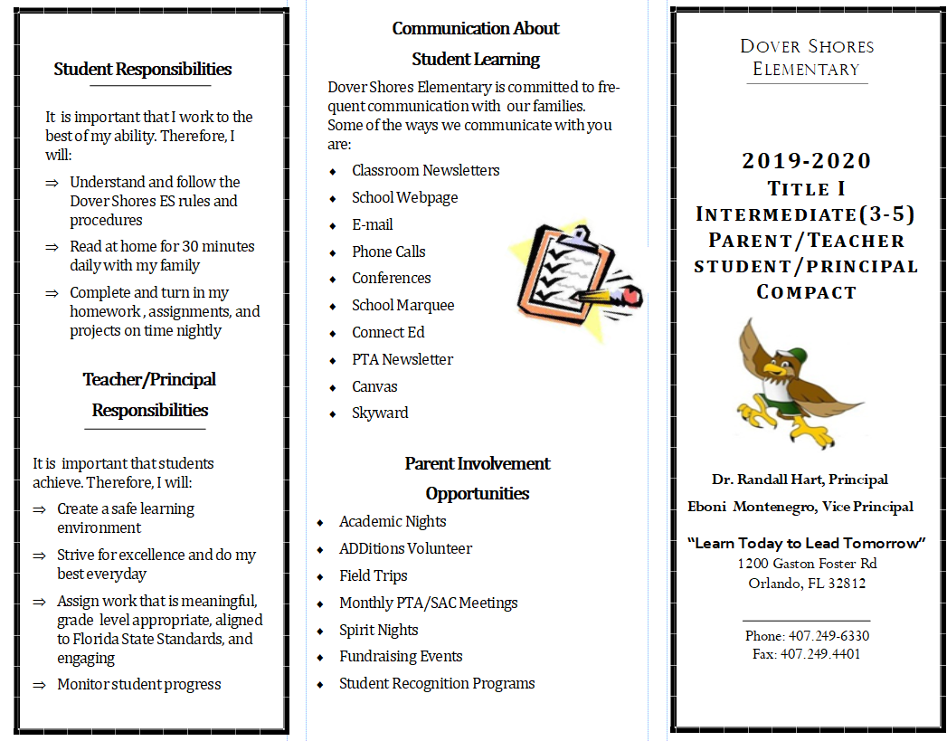

Adoption
The parental involvement policy/plan has been developed jointly with, and agreed on with, parents of children participating in Title I, Part A programs, as evidence by
This policy/plan was adopted by the school on and will be in effect for the period of .
The School will distribute this policy to all parents of participating Title I, Part A children on or before .

Signature of Authorized Personnel
Date

Provide evidence that this policy/plan has been developed with the input from parents based on the review of the previous school years Parent and Family Engagement Plan if applicable.
The following documents can be submitted as evidence:
- Parent survey of previous year’s events and activities
- Any SAC and PTA artifacts where Title I/PFE topics were on the agenda
- Parent Feedback Summary of PFEP Evaluation
- Parent and Family Engagement Activities Tracking Form

