The following is to ensure school-level parent and family engagement plans meet the requirements of Section 1116(b) of the Elementary and Secondary Education Act (ESEA), as amended by the Every Student Succeeds Act (ESSA)
Assurances
The above named school agrees to the following assurances:
- Involve parents of children served in Title I, Part A in decisions about how Title I Part A funds are spent;
- Carry out the programs, activities, and procedures in accordance with the definitions in Section 8101 of ESEA;
- Jointly develop/revise plan with parent and make available to the local community;
- Involve parents and families in planning, reviewing, and improving schoolwide program plan;
- Use the findings of parent and family engagement plan review to design strategies for more effective engagement, and to review, if necessary, the school’s parent and family engagement plan;
- Provide each family with timely notice information regarding their right to request information on the professional qualifications of the student’s classroom teachers and paraprofessionals;
- Notify each family, in a timely manner, when their child has been assigned, or has been taught for four or more consecutive weeks, by a teacher(s) who is out of field;
- Provide each family with an individualized student report about the performance of their child(ren) on the State assessments [ESEA Section 1116]
Mission Statement
1. Does the mission statement include:  How the parent and family engagement plan is a shared responsibility?  How the parent and family engagement plan will assist in providing high quality instruction for all learners? | Hiawassee Elementary School’s mission is to lead our students to success with the support and involvement of families and the community. The Title 1 Committee will work jointly with the newly elected School Advisory Council (SAC) to review, develop, and adopt the (2019-2020) Parent and Family Engagement Plan and evaluation of school programs. The members of the School Advisory Council will be selected on a volunteer basis and then voted upon by the body. The 2019-2020 Parent and Family Engagement Plan will assist in providing a guide to how funds and grade level standards based activities will be implemented during the school year to ensure that all learners are provided high quality instruction.

Involvement of Parents
2. Does the plan include:  How the school will involve the parents and families in an organized, ongoing, and timely manner in the planning, review and improvement of Title I programs, including involvement in decision making of how funds for Title I will be used [ESEA Section 1116]? | The Title 1 Committee will engage parents in discussion during School Advisory (SAC) and Parent Teacher Organization (PTO) on how to implement and utilize the budget allocated for parental involvement. Parents will be able to vote on decisions made regarding Title 1 funds during the SAC and PTO meetings. During these meetings, planning and review of the program will take place and feedback will be asked as to how our Title 1 programs can be improved. Information in regards to Title 1 and other activities on our campus will be sent in the following methods:  - Newsletter  - Flyer  - Labels  - Marque  - Lobby Kiosk  - Connect Orange (English/Creole  - School Website  Hiawassee will involve the parents and families in the planning, review and implementation of the Title 1 programs, including involvement in the decision making of how funds for Title 1 will be used by:  Attending  - School Advisory Council (SAC) Meetings  - Title 1 Annual Meeting  Participating in  - Parent and Family Engagement capacity-building activities  Reviewing  - Academic Data  - Previous school year Parent and Family Engagement Plan

Coordination and Integration with Other Federal Programs
3. Does the plan include:  How the school will coordinate and integrate parent and family engagement programs and activities?  How the school will coordinate and integrate parent and family activities that teach parents how to help their child(ren) at home [ESEA Section 1116]? | Hiawassee will coordinate and integrate parent and family engagement programs and activities through the hiring of our Parent and Family Engagement Liaison and school staff.  The Parent and Family Engagement Liaison will coordinate sessions and activities that will help to teach parents how to help their child(ren) at home. This plan outlines below the listed delineated program and coordination for each school-based
Program | Coordination
Pre-K Varying Exceptionalities ESE-IDEA | Hiawassee and the VPK program work together to assist with transition programs for parents and families as students are entering a public school program. Information is given to parents regarding parent involvement.
Title 1 | Funds from Title 1 will be used to provide professional development to staff and resources to students as it relates to parents’ involvement.
Title II | Funds from Title II are used to provide support and services to all students. Teachers are provided with four OCPS Professional Modules throughout the year to address Parent Involvement with the school staff.
 | Funds from Title III are used to provide support and services to immigrant and English Language Learner parents.
Title X | McKinney Vento Program (MVP) students are identified by the Student Residency Questionnaire at the beginning of each school year. Parents are informed of the services and outlined by the MVP Department. MVP students receive district support through funding for school supplies, food, clothing, and field trips. Students in this program may qualify for school transportation.

Annual Parent Meeting
4. Does the plan include:  A description of the specific steps the school will take to conduct the annual meeting to inform parents and families of participating children about the school’s  Title I program?  A description of the nature of the Title I Program that is shared with parents (schoolwide or targeted assistance)?  A description of how the meeting will cover adequate yearly progress (AYP), school choice, and the rights of parents are covered at the annual meeting? | Parents will also be informed of the September 17, 2019 Annual Meeting through a variety of communication methods to include: Connect Orange, labels, marque, and poster that will be advertised. The Parent and Family Engagement Liaison will present a power point and handouts regarding the Title 1 Program at the Annual Meeting.  Parents will receive answers to the following questions:  - How does our school receive Title 1 funds?  - What will Title 1 do for the success of my child?  - What can I do to help my child succeed?  The meeting will also cover the following topics:  - School choice via district handouts and policies  - Annual Yearly Progress (AYP) via PowerPoint Presentation  - The rights of parents via brochure and other resources  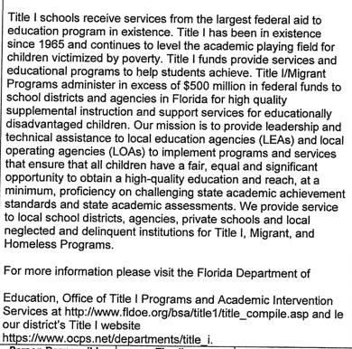
Activity/ Task | Person Responsible | Timeline | Evidence of Effectiveness
Annual Meeting Flyer/Label sent home | Parent Liaison | September 10, 2019 | Title I Sign-in Sheets
Annual Meeting  Connect Orange Message | Principal, Parent Liaison | September 10, 2019 | Title 1 Sign-in Sheets
Annual Meeting Message on Marquee | Support Staff, Parent Liaison | September 10, 2019 | Title 1 Sign-in Sheets
Annual Meeting on Kiosk and Subject Website | Principal, Secretary | September 10, 2019 | Website
Title 1 Annual Meeting Power Point Presentation | Parent Liaison | September 17, 2019 | Title 1 Sign-In Sheets
Annual Meeting Documentation Maintained | Title 1 Documentation Contact | September 10-June 1, 2020 | Information Maintained on-site.

Flexible Parent Meetings
5. Does the plan include:  How will the school offer a flexible number of meetings, such as meeting in the morning or evening?  How will the school provide, with Title I funds, transportation, child care or home visits, as such services relate to parent and family engagement [ESEA Section 1116]? | During the 2019-2020 school year, parent conferences will be held to discuss student progress. The scheduled times will be flexible to accommodate our parents. Title I Meet the Teacher will be held in the afternoon to accommodate working parents while also allowing other flexible options to be given for those parents that need to have a meeting in the morning on after school, Title 1 Parental Involvement meetings will be held on the same day as our monthly PTO and SAC meetings. This will give more parents the opportunity to be in attendance.  Regarding services related to parent and family engagement, the school/district will provide the following:  - Transportation to (1) Parent Academy  Parent Academy is a district held parent and family engagement event that takes place once a month on a Saturday at a designated high school.

Building Capacity
6. Does the plan include:  How the school will implement activities that will build the capacity for meaningful parent/family involvement?  How will the school implement activities that will build relationships with the community to improve student achievement?  How the school will provide material and training to assist parents/families to work with their child(ren)?  How the school will provide other reasonable support for parent/family engagement activities [ESEA Section 1116]? | 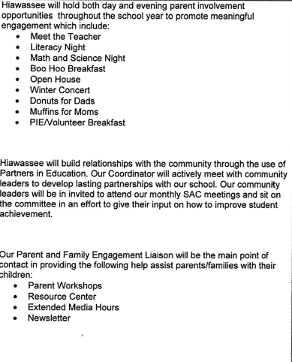
Activity/ Task | Person Responsible | Correlation to Student Achievement | Timeline | Evidence of Effectiveness
Meet the Teacher | Instructional Staff | Teachers will introduce classroom expectation, routines, and establish rapport. | August 2019 | Connect Orange, Marquee
Report Card Conference Night | Classroom Teachers | Teachers will conduct individual conferences to discuss child’s test results, expectations, progress towards benchmarks, and individual needs. | October 2019 | Conference/Parent Communication logs, signed compacts
Parent Workshops/Family Engagement Activities | Family Engagement Liaison | Parents will be given strategies and resources to assist their students in developing these skills at home | Fall/Spring Sessions | Sign-in sheets, handouts, flyers
Curriculum/Literacy Nights (Reading, Math, Writing, Science, Arts) | Instructional Staff | Parents will have opportunity to learn about and engage in activities to support the academic growth of their children. | January 2020-March 2020 | Flyers, sign-in sheets
Connect Orange Messages | Principal | Increased parental awareness of school events and participation | Ongoing | Copies of messages on file
Newsletter, website, daily planners, email communication | Principal, Parent Engagement Liaison | Parents and students will have access to information about school events/activities | Ongoing | Website resources, survey feedback, copies of newsletters/emails
Regularly scheduled SACT/PTA/PLC meetings | Principal, Assistant Principal, Parent Representatives | Parents will actively participate in decision-making process for school | Monthly | Meeting Minutes.

Staff Development
7. Does the plan include:  A description of the professional development activities the school will provide to educate the teachers, specialized instructional support personnel, principals, other school leaders and other staff:  - with the assistance of parents/families, in the value and utility of contributions of parents/families?  - in how to reach out to, communicate with, and work with parents/families as equal partners?  - in implementing and coordinating parent/family programs, and in building ties between parents/families and the school [ESEA Section 1116]? | Hiawassee strives to build the capacity of all school staff. Throughout the year, various professional development activities are provided to educate the teachers, specialized instructional support personnel, administrators, other school leaders, and other staff to build capacity in parent and family engagement.
Activity/ Task | Person Responsible | Correlation to Student Achievement | Timeline | Evidence of Effectiveness
Parent and Family Engagement Professional Development Module 1-Building Strong Partnership with Parents and Families | Parent Engagement Liaison | Improved school staff resources to create a welcoming school environment, understand and value the importance of parent and family engagement, and maintain strong school to home partnerships | October 2019 | Sign-In sheets, Exit slips
Parent and Family Engagement Professional Development Module 2: Building ties Between Home and School | Parent Engagement Liaison | Improved ability of staff to work with parents and families. | January 2020 | Sign-In sheets, Exit slips
Parent and Family Engagement Professional Development Module 3: Implementation and Coordination of Parent and Family Engagement Programs | Parent Engagement Liaison | Increased parent and family participation in school activities which support student achievement. | March 2020 | Sign-In sheets, Exit slips
Parent Engagement Professional Development Module 4:  Communication and Working with Parents as Equal Partners | Parent Engagement Liaison | Improved relationships,communication and collaboration between parents and school | May 2020 | Sign-In sheets, Exit slips

Other Activities
8. Does the plan include:  How other activities, such as the parent resource center, the school will conduct to encourage and support parents and families in more meaningful engagement in the education of their child(ren) [ESEA Section 1116]? | Hiawassee will use various school resources to assist parents and families with their needs. The following are some of the school resources available to parents and families:  - The Guidance Office will have resources that include information about:  - Homeless Education  - Retention  - Counseling Services  - Exceptional Education Services  - Behavioral Support Services  - And other resources outside the school  The Media Center offers computer access to allow students and parents to access district applications and other materials during extended hours weekly.  District Parent Academy and Virtual Academy Events offered throughout the year.  Below are the specific activities and tasks that Hiawassee will use to encourage and support parents and families in more meaningful and engaging ways for the education of their children.
Activity/ Task | Person Responsible | Timeline | Evidence of Effectiveness
Extended Media Hours | Admin, Media Specialist | Tuesday and Thursday | Sign-in sheets, feedback
Collaboration between PTO/SAC | Admin, PTO, SAC, Family Engagement Liaison, Teachers | Every 2nd Tuesday of the month | Sign-in sheets, meeting minutes
Resources Center | Guidance Counselor, ESE contact, Parent Engagement Liaison | Ongoing | Sign-in sheets
Food Angel Pantry | Guidance Counselor, Parent Engagement Liaison | Ongoing | Sign-in sheets, labels
Virtual Academy | Parent Engagement Liaison, Media Specialist | TBD | Parent Registration, Media Center sign-in sheets
Parent Academy | Parent Engagement Liaison | TBD | Pictures, Parent Registration, Flyers

Communication
9. Does the plan include:  How the school will provide timely information about the Title I programs?  How the school will describe and explain the curriculum at the school, the forms of assessment used to measure student progress and the achievement levels students are expected to obtain?  How, if requested by parents, the school provides opportunities for regular meetings to formulate suggestions and to participate, as appropriate, in decisions relating to the education of their child(ren)/  How the school will submit parents/ families comments if the schoolwide plan is not satisfactory to them [ESEA Section 1116]? | 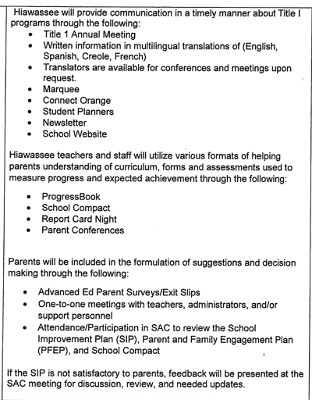

Accessibility
10. Does the plan include:  A description of how the school will provide full opportunities for participation in parent/family engagement activities for all parents/families?  A description of how the school will share information related to school an parent/family programs, meetings, school reports, and other activities in an understandable, uniform format, and in languages that the parents/families can understand? | 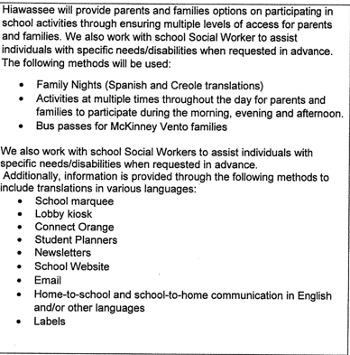

Discretionary Activities
11. Does the plan include:  Any activities that are not required, but will be paid for through Title I, Part A funding (for example: home visits, transportation for meetings, activities related to parent/family engagement, etc.) | Hiawassee will utilize Title I, Part A funding for additional activities to support student achievement. Although not required, these activities support student achievement.
Activity/ Task | Person Responsible | Correlation to Student Achievement | Timeline | Evidence of Effectiveness
Maximizing parental involvement and participation in their children’s education by arranging school meetings at a variety of times, or conducting in-home conferences/home visits between teachers or other educators, who work directly with participating children, who are unable to attend those conferences at school {Section 1118(e) (10)} | Pre-K Teacher, Administration, Parent Liaison | Parent Involvement increases student achievement | August 2019-May 2020 | Sign-in sheets, meeting notes

Barriers
12. Does the plan include:  A description of the barriers that hindered participation by parents during the previous school year?  A description of the steps the school will take during the upcoming school year to overcome the barriers (with particular attention paid to parents/families who are disabled, have limited English proficiency, and parents/families of migratory children [ESEA Section 1116]? | 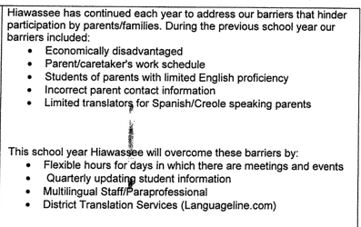
Barriers (Including the Specific Subgroup) |  | Steps the School will Take to Overcome
Economically disadvantaged parent/caretaker’s work schedule |  | Flexible hours for days for meeting times and events
Students of parents with limited English proficiency have student contact information not up to date |  | Quarterly student information updates
Language Communication for Spanish/Creole |  | Increase translations for all school activities

School-Parent Compact
13. Does the plan include:  As a component of the school-level parental involvement policy/plan, each school shall jointly develop, with parents for all children served under this part, a school-parent compact that outlines how parents, the entire school staff, and students will share the responsibility for improved student academic achievement? | Provide a scanned copy with this document of the School-Parent Compact and evidence of parent input in the development of the compact.

Adoption
The parental involvement policy/plan has been developed jointly with, and agreed on with, parents of children participating in Title I, Part A programs, as evidence by
2019-2020
This policy/plan was adopted by the school on and will be in effect for the period of .
The School will distribute this policy to all parents of participating Title I, Part A children on or before .

Signature of Authorized Personnel
Date

Provide evidence that this policy/plan has been developed with the input from parents based on the review of the previous school years Parent and Family Engagement Plan if applicable.
The following documents can be submitted as evidence:
- Parent survey of previous year’s events and activities
- Any SAC and PTA artifacts where Title I/PFE topics were on the agenda
- Parent Feedback Summary of PFEP Evaluation
- Parent and Family Engagement Activities Tracking Form

