St. Lucie Public Schools
2019-2020 School Level Parent and Family Engagement Plan (PFEP)

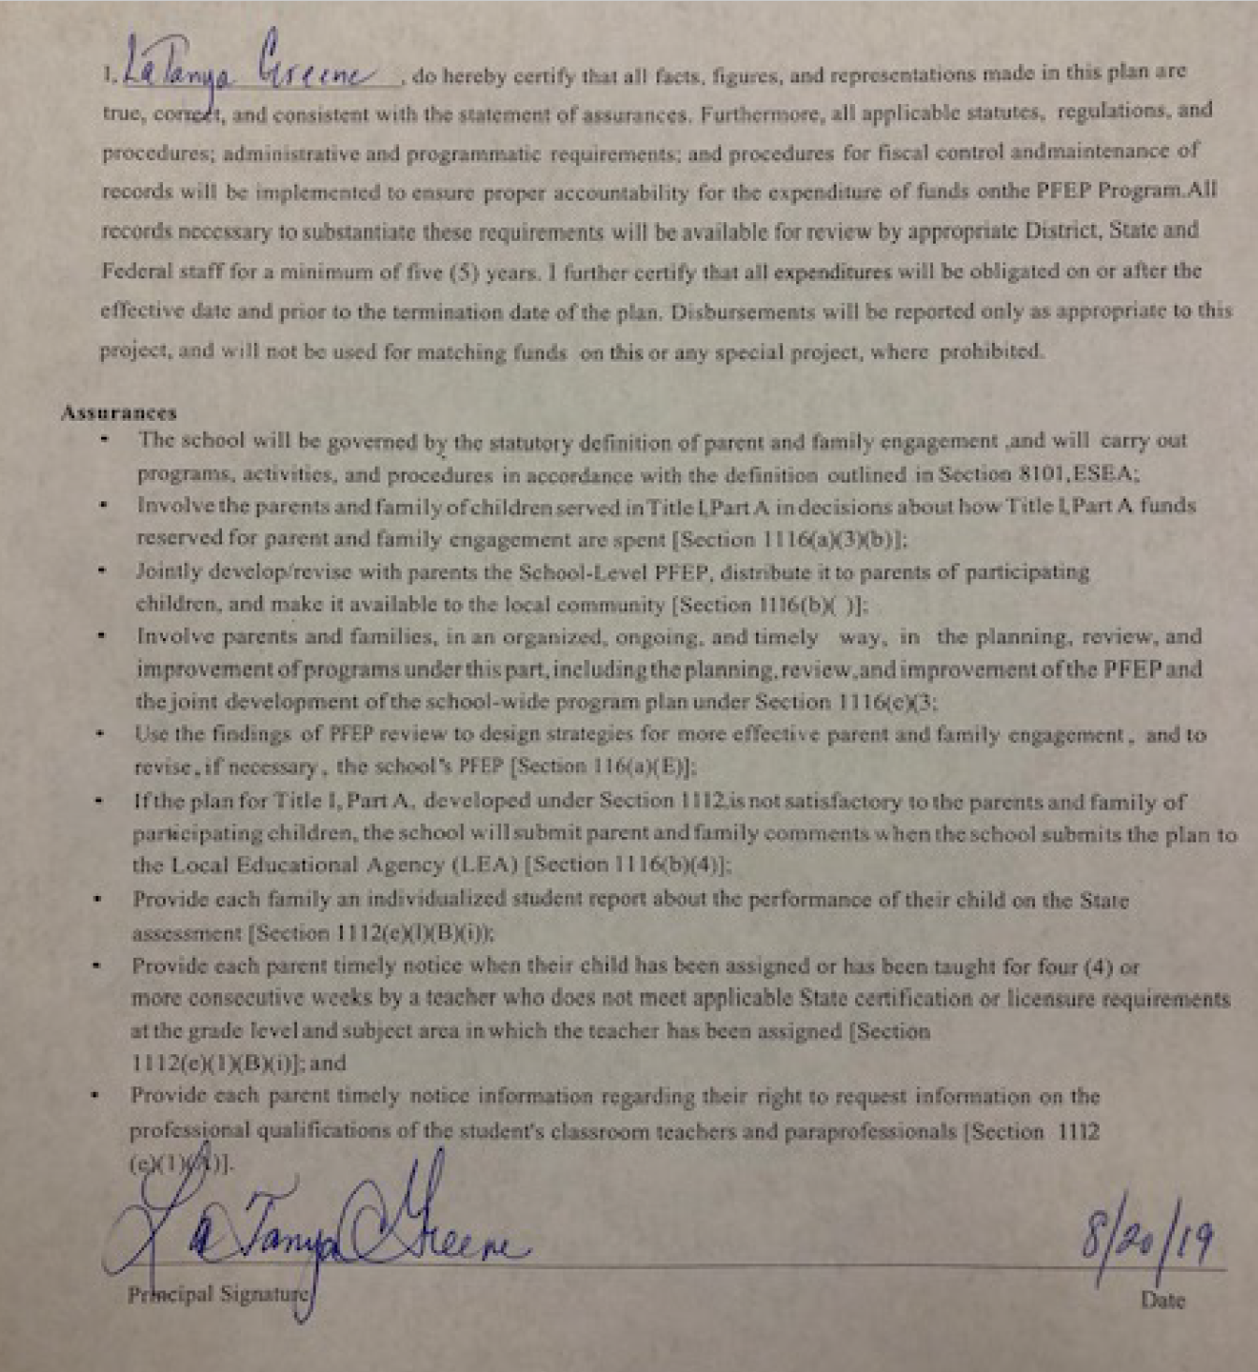

Parent and Family Engagement Mission Statement (optional)
Parkway Elementary School’s mission is to provide opportunities for parents and families to participate in activities at the school and in the community that will increase their involvement and support students’ social, emotional, behavioral, and academic success.

Involvement of Parents/Families
Describe how the school involves the parents/families in an organized, ongoing and timely manner, in the planning, reviewing and improvement of Title I programs including involvement in decision making of how funds for Title I will be used [ESEA Section 1116].

Parkway Elementary School involves the Parent-Teacher Organization (PTO) and the School Advisory Council (SAC) in decisions regarding the use of Title I funds. SAC reviews the budget and makes recommendations for usage at monthly meetings.

Coordination and Integration with Other Federal Programs
Describe how the school will coordinate and integrate parent and family engagement programs and activities with other programs. Explain how these activities will teach parents how to help their child/children at home [ESEA Section 1116)
Program | Coordination
PTO-Sponsored School Events | Kicking off the year with a Back-to-School Dance, regular family events allow students’ families to become a part of the school community. Through such events, families can feel connected to Parkway in a positive, social atmosphere, opening up lines of communication and creating a collaborative connection.
Student-Led Conferences | Held twice annually, Student-Led Conferences serve as an opportunity for students to share their academic goals and progress with parents and community members. This allows parents to see what their children are working toward in school and is a platform through which they can have meaningful conversations about academic progress.
Academic Family Nights | Starting with the Title I Family Night, Parkway Elementary regularly hosts family nights to involve stakeholders in the academic success of students. Parkway hosts a Literacy Night, a Math Publix Math Night, a CSI Science Night, and FSA Night to share information and strategies to support students in their learning at home.
Other Family Events | In addition to events at school, Parkway Elementary engages parents in celebratory events, such as the Winter Show (in which students showcase what they have been learning in music), Barnes and Noble Night (where students perform and parents are encouraged to build their home libraries), Grandparents’ Day, Dads Bring Your Kids to School Day, and Scholastic Book Fairs.

Annual Parent Meeting
Provide a brief description of the following:
- Specific steps your school will take to conduct the Title I Annual Meeting to inform parents and families of participating children about the school’s Title I program.
- The nature of the Title I program that is shared with parents (school-wide or targeted assistance).
- How the school, at the annual meeting, will inform parents of school performance data and the right of parents.

The Title I Annual Meeting is held in conjunction with our Annual Spaghetti Dinner. It will start right after 21st Century to appeal to more parents so they can stay at school and be provided dinner rather than having to return to the school. The standard PowerPoint presentation will be used to guide the conversation.

Flexible Parent Meetings
Describe how the school will:
- Offer a flexible number of meetings, such as meetings in the morning or evening.
- Provide, with Title I funds, transportation, childcare or home visits, as such services relate to parent and family engagement [ESEA Section 1116].

Events and meetings are held at various times to accommodate families’ schedules. Student-specific meetings are held during the school day or before or after school to meet the needs of the parents. Hand-outs from events are made available for those who were unable to attend.

Building Capacity
Describe how the school will:
- Implement activities that will build the capacity for meaningful parent/family engagement.
- Implement activities that build relationships with the community to improve student achievement.
- Provide materials and trainings to assist parents/families to work with their child/children.
- Provide other reasonable support for parent/family engagement activities [ESEA Section 1116].
Activity | Materials Provided | Person Responsible | Timeline | Evidence of Effectiveness
Back to School Dance | Calendar of Events | PTO | Sept 6 | Participation in future events
Grandparents’ Day | Supporting Learning at home | Instructional Coaches | Sept 10 | Increase in Student Achievement
Monthly SAC Meetings | Agendas / Handouts | SAC Chair | Monthly | Increase in Student Achievement
Monthly PTO Meetings | Agendas / Handouts | PTO Chair | Monthly | Increased Student Achievement
Title I Night / Spaghetti Dinner | Information on Parkway Goals | Administration | Sept 26 | Increased Student Achievement
Literacy Night | Reading and Writing Strategies | Instructional Coaches | Nov 7 | Increased Student Achievement
Student Led Conferences | Data Binders | Teachers | Oct 23-24 and May 20-21 | Increased Student Achievement
CSI/Science Night | Materials for Scientific Investigation | Media Specialist | Jan 22 | Increased Student Achievement
Publix Math Night | Math in the “Real World” | Instructional Coaches | March 11 | Increased Student Achievement
FSA Night | Strategies to support learning | Admin/ Instructional Coaches / Teachers | March 25 | Increased Student Achievement

Staff Development
Describe the professional development activities the school will provide to educate teachers, specialized instructional support personnel, principals, and other school leaders, as well as other staff with the assistance of parents/families in:
- The value of their contributions;
- How to reach out to, communicate with, and work with parents and families as equal partners; and
- How to implement and coordinate parent/family programs and build ties between parents/families and the school [ESEA Section 1116].
Activity | Person  Responsible | Area of Focus | Timeline | Evidence of Effectiveness
Thinking Maps Training | Administration | Writing | Ongoing | Increased Writing Scores
Math Conference | Administration | Math | October | Increased Math Scores
ELA Conference | Administration | English Language Arts | November | Increased ELA Scored
District Support in Collaborative Planning | Administration | ELA, Math, and Science | Ongoing | Increased Academic Achievement
PBIS /CHAMPS | Assistant Principal, Coaches and Guidance | Classroom Management Strategies | Ongoing | Increase in positive behaviors
iReady | Instructional Coaches | Differentiation in Math and Reading | Ongoing | Increase in Academic Achievement
LLI | Instructional Coaches and Assistant Principal | Reading | Ongoing | Program being used with Fidelity

Other Activities
Describe other activities, (such as a parent resource center) the school will conduct in order to encourage and support parents/families in more meaningful engagement in the education of their child/children [ESEA Section 1116].

Parkway Elementary School has the 21st Century program that includes a parent engagement component. We also host family events in the community like Chuck E. Cheese Night and Super Play Family Night.

Communication

Describe how the school will provide to parents of participating children the following:
- Timely information about the Title I program and activities;
- Description and explanation of the curriculum at the school, the forms of academic assessment used to measure student progress, and the proficiency levels students are expected to meet;
- If requested by parents, opportunities for regular meetings to formulate suggestions and participate, as appropriate, in decision relating to the education of their child/children [ESEA Section 1116].

Parkway Elementary publishes a monthly newsletter that includes information on how to support students’ school work. Social media is used as a forum to communicate with parents and celebrate accomplishments.

Accessibility

Parkway Elementary makes every effort to differentiate content and times to accommodate a variety of schedules and needs.

Discretionary Activities (Optional)
Describe any activities that are not required, but will be paid through Title I, Part A funding (for example, home visits, transportation for meetings, activities related to parent/family engagement, etc.)

Barriers
Provide a description of the:
- Barriers that hindered participation by parents during the previous school year
- Steps the school will take during the upcoming school year to overcome the barriers (with particular attention paid to parents/families who are disabled, have limited English proficiency, and parents/families of migratory children) [ESEA Section 1116].
Barrier (Including the Specific Subgroup) | Steps the School will Take to Overcome Barrier
Transportation to the school can serve as a barrier, as well as other family obligations (such as work schedules, extra-curricular activities, etc.) | Provide resources through various means and formats. Be mindful of participation and ask for feedback.

